OpenHoldem 2.0 Project
Manual and Documentation

Last updated:

Table of Contents

1 What is OpenHoldem? 6
1.1 What OpenHoldem is not 6
1.2 WinHoldem heritage 7
1.3 References 8
2 A (few) word(s) of caution 9
2.1 Effort 9
2.2 Scams 9
2.3 Gray area 9
3 How to begin 11
3.1 Choosing an operating system 11
3.2 Configuring the operating system 11
3.3 Installing the software 12
3.4 Finding a Table Map 13
4 Creating a Table Map 14
4.1 First thing’s first: connect to the poker window 14
4.2 Familiarizing yourself with OpenScrape 15
4.3 Size Records 18
4.4 Symbol Records 19
4.5 Region Records 25
4.6 Font Records 34
4.7 Hash Point Records 37
4.8 Hash Records 39
4.9 Image Records 40
5 Creating the logic for your bot 43
5.1 Familiarizing yourself with OpenHoldem 43
5.2 The Formula Editor 47
5.3 OH-Script 54
5.4 Perl 77
5.5 User DLL 79
5.6 Hand Lists 84
5.7 How the “Green Circle Button” finds tables 85
5.8 Preferences 85
5.9 Locking Blinds 98
5.10 The Iterator 99
5.11 Weighted prwin 101
5.12 Enhanced prwin 103
5.13 Starting Hand Ranking 106
5.14 The Scrape Cycle (or “Heartbeat”) 108
5.15 The Autoplayer 109
5.16 Replay Frames 110
5.17 PokerPro 110
5.18 PokerTracker 112
5.19 Memory Symbols 115
5.20 f$chat 117
5.21 Validator 118
5.22 Log Files 120
5.23 Command Line Options 122
5.24 Advanced Topics 122
6 ManualMode & OHReplay 123
6.1 ManualMode 123
6.2 OHReplay 125
7 Stealth 127
7.1 OpenHoldem Single System Configuration 127
7.2 OpenHoldem Dual System Configuration 127
7.3 Registry 127
7.4 Obscure Preferences 127
7.5 Bring 127
7.6 Ninja Folders 128
7.7 VMWare 130
7.8 Rootkits 140
8 Automation 142
9 Extensions 143
9.1 User DLL 143
9.2 Mouse DLL 143
9.3 Keyboard DLL 144
9.4 Scraper Override DLL 144
10 Appendix A – OpenScrape Font collection example 146
11 Appendix B – Future TODOs 152

Table of Figures

Figure 3.3-1 OpenHoldem directory 12
Figure 4.1-1 Arranged OpenScrape windows 14
Figure 4.1-2 OpenScrape Green Circle Button selection window 15
Figure 4.1-3 OpenScrape connected to poker table 15
Figure 4.2-1 OpenScrape File menu 16
Figure 4.2-2 OpenScrape Edit menu 16
Figure 4.2-3 OpenScrape View menu 16
Figure 4.2-4 OpenScrape Main window toolbar 16
Figure 4.2-5 OpenScrape Table Map Editor window 17
Figure 4.4-1 OpenScrape New/Edit Symbol window 20
Figure 4.5-1 OpenScrape Rectangle Group Box 25
Figure 4.5-2 OpenScrape Rectangle drawing tool 26
Figure 4.5-3 OpenScrape Nudge group box 26
Figure 4.5-4 OpenScrape Region record parameters 27
Figure 4.5-5 OpenScrape Transform result preview 27
Figure 4.5-6 OpenScrape Pixel Separation display 27
Figure 4.5-7 OpenScrape Duplicate Region window 28
Figure 4.6-1 OpenScrape Create Font button 35
Figure 4.6-2 OpenScrape Add Font records window 35
Figure 4.7-1 OpenScrape New Hash Point record – textual 37
Figure 4.7-2 OpenScrape New Hash Point record – graphical 38
Figure 4.7-3 OpenScrape New Hash Point record – graphical with sample image 38
Figure 4.8-1 OpenScrape Create Hash Record buttons 39
Figure 4.8-2 OpenScrape New Hash record confirmation 40
Figure 4.9-1 OpenScrape Create Image button 41
Figure 4.9-2 OpenScrape New Image Record window 41
Figure 5.1-1 OpenHoldem File menu 43
Figure 5.1-2 OpenHoldem Edit menu 43
Figure 5.1-3 OpenHoldem View menu 44
Figure 5.1-4 OpenHoldem DLL menu 44
Figure 5.1-5 OpenHoldem Perl menu 44
Figure 5.1-6 OpenHoldem PokerPro menu 44
Figure 5.1-7 OpenHoldem Help menu 45
Figure 5.1-8 OpenHoldem Main toolbar 45
Figure 5.1-9 OpenHoldem Flags toolbar 46
Figure 5.1-10 OpenHoldem Status Bar 46
Figure 5.2-1 OpenHoldem Formula Editor 47
Figure 5.2-2 Formula Editor - File menu 51
Figure 5.2-3 Formula Editor - Edit menu 52
Figure 5.2-4 Formula Editor - View menu 53
Figure 5.2-5 Formula Editor - Debug menu 53
Figure 5.2-6 Formula Editor - Help menu 53
Figure 5.2-7 OpenHoldem Formula Editor toolbar 53
Figure 5.6-1 OpenHoldem Hand List Editor 84
Figure 5.8-1 OpenHoldem Preferences – Analyzer 86
Figure 5.8-2 OpenHoldem Preferences – Autoplayer 87
Figure 5.8-3 OpenHoldem Preferences – Chat 88
Figure 5.8-4 OpenHoldem Preferences - DLL Extension 89
Figure 5.8-5 OpenHoldem Preferences – ICM 90
Figure 5.8-6 OpenHoldem Preferences – Logging 91
Figure 5.8-7 OpenHoldem Preferences – Obscure 92
Figure 5.8-8 OpenHoldem Preferences – Perl 93
Figure 5.8-9 OpenHoldem Preferences - Poker Tracker 94
Figure 5.8-10 OpenHoldem Preferences - Replay Frames 95
Figure 5.8-11 OpenHoldem Preferences – Scraper 96
Figure 5.8-12 OpenHoldem Preferences – Symbols 97
Figure 5.8-13 OpenHoldem Preferences – Validator 98
Figure 5.9-1 OpenHoldem Lock Blinds window 99
Figure 5.10-1 Standard Deviation by Iterations 100
Figure 5.10-2 Probability by prwin 100
Figure 5.11-1 Weighted prwin model 101
Figure 5.17-1 OpenHoldem PokerPro control 111
Figure 6.1-1 ManualMode main window 123
Figure 6.1-2 ManualMode options 125
Figure 6.2-1 OHReplay main window 126
Figure 6.2-2 OHReplay options 126
Figure 9.4-1 Font collection example - notepad 146
Figure 9.4-2 Font collection example - region 147
Figure 9.4-3 Font collection example - add characters 148
Figure 9.4-4 Font collection example – “A” collected 149
Figure 9.4-5 Font collection example - "ABC" collected 150
Figure 9.4-6 Font collection example - collecting "D" 151

What is OpenHoldem?
OpenHoldem, and its supporting applications, OpenScrape, ManualMode and OHReplay, is an open source screen scraping framework and programmable logic engine for the online Texas Hold'em style poker game. This framework provides the capabilities to allow you to build your own Texas Hold'em robot (bot).

There are two major parts to any poker bot, the game state engine, and the action engine.

There are a number of approaches for getting the game state from a poker client, including directly reading the memory of the poker, injecting code into the client's address space, parsing the client's chat box, and interpreting the pixels presented on the screen by the client. OpenHoldem's game state engine uses the last approach - it provides a parameter driven method of interpreting the pixels ("screen scraping") presented by the poker client to determine the state of the game at any given time. Screen scraping is not a new approach to this kind of problem, poker botting or otherwise. Screen scraping has been a recognized approach for solving a specific set of computer problems almost since computers were invented. Screen scraping has been around for a longer period of time than most of you reading this have been alive! (http://en.wikipedia.org/wiki/Screen_scraping)

The action engine in OpenHoldem is called the Autoplayer. The Autoplayer will use logic that is provided by you to decide what poker action to take based on the current game state. The Autoplayer will then click the buttons and enter the text on the screen to make the poker client execute this action.

OpenHoldem is a framework. What that means is that you need to provide it with a couple of things to enable the game state engine and the action engine to operate correctly. The first is the parameters that instruct OpenHoldem how to interpret the pixels presented by the casino that you play at. Each casino presents these pixels in a slightly different manner, and thus these parameters need to be specific for each casino. Second is the logic to tell the action engine what to do - just like every person plays live/human poker in a different style, this logic will instruct OpenHoldem how to play the style that you want it to play.

OpenHoldem supports every casino in existence today, as far as we know. If you find a casino that does not work with OpenHoldem's game state or action model, please hit the forums and let us know. The developer team is very responsive to modifying OpenHoldem to work with the continually changing landscape of Texas Hold'em casino client software.

OpenHoldem also supports every sub-flavor of Texas Hold'em poker known to exist today. No-limit, fixed-limit, pot-limit, full ring, heads-up, 6-max, MTT, SNG, double or nothing, turbo, normal speed, whatever. Someone else has already made it work - you can make it work too.

What OpenHoldem is not
OpenHoldem is not a complete poker bot. There is much work you need to do to utilize the framework effectively, however this manual and the community on the forums can help you to do so. If you truly desire a poker bot that includes logic written by someone else, a quick Google search will turn up a number of likely candidates. Be aware, however, that a pre-packaged, complete, click-Setup.exe-and-go, poker bot is not a good way to be successful. Consistent and trusted positive results from these pre-packaged bots are impossible to find. If pre-packaged bots really worked, if we could have spent $20 to make $1000's, we certainly would have bought one ourselves, rather than spending the thousands of hours to create this framework!

OpenHoldem does not allow for automated collusion. Poker botting currently is in a gray area of legality and morality, with many strong perspectives on both sides of the argument. The OpenHoldem development team strongly believes that automated collusion is clearly illegal and immoral, and will not provide the facility to help you achieve these ends.

OpenHoldem is not a general-purpose poker botting engine for all styles of poker. It is intentionally suited only to the "Texas Hold'em" flavor of poker favored my the majority of online players today. Don't ask if it supports Omaha - it doesn't.

WinHoldem heritage
Reproduced from the original post by Matrix here: http://www.maxinmontreal.com/forums/viewtopic.php?p=28468#p28468

“For the first couple of years of its existence WH (WinHoldEm) was actively developed and developed an enthusiastic following. Although it was a commercial product Ray Bornert put in an astonishing amount of time answering queries on the WH BBS, and seemed to respond to opinions and requests there pretty quickly. One of the features he introduced were private forums (fora) which groups could request and then run their own discussions and developments within them. These must have been problem children for him. because there was a measure of falling-out, squabbling and bad blood within them. The biggest and most active of these was the infamous Lab1.

The first sign of Ray's movement away from the total nurture and support role was the introduction of Winscrape, a utility to enable the creation of profiles (Table maps). In principle WH users were then not completely dependent on him to generate table maps. This was probably motivated by the increasing tendency of pokersites to change their client display slightly at frequent intervals, and maintaining table maps must have been an increasing burden for Ray. After a period he then stopped creating table maps altogether, and threw the users onto their own abilities with Winscrape. A market economy around them was supposed to develop.

There were external WH groups by this time. Ray had closed down the labs, saying that he did not want to be in the position of one who could be accused of spying on their work, and forced them to find alternative homes. The only one which did this permanently and successfully was Lab1; ending up on a host run by a mysterious presence called MaxinMontreal. The external market economy for table maps did not work very well, because Ray had put no mechanism in WH to enable maps to be given an equivalent of DRM, and piracy and strife soon occurred.

Whilst all this was happening there was a third significant development – PBWC. [Ed: PBWC = PokerBot World Championship] Ray had always been more evangelical than commercial with regard to WH, and he shifted his energies to organising a pokerbot/human championship. Support and development of WH stagnated for a year, at least by comparison with the situation before.

These three threads combined to generate a lot of dissatisfaction amongst the dedicated WH users. The focus of this was in Lab1. The practical result was that a certain element produced a WH functional clone to seed an open source project called OpenHoldem. An open source equivalent of Winscrape followed.

This gamble seems to have paid off. There has always been a dichotomy in botters between their interests in collaborating to develop techniques, and their interest in protecting the final commercial results - the bots. Lab1 helped enormously by making their table maps non-commercial. This established the precedent that the infrastructure for a bot was a community responsibility and development. People seem to have accepted this as a good working model.

As to the hatred - the major OH protagonists acknowledge their debt to Ray for WH, and the only comment that Ray has made about OH is that you cannot compete with open source.”

References
Binary package download site: http://code.google.com/p/openholdembot/downloads

Source code download: http://code.google.com/p/openholdembot/source
- Source instructions: http://www.maxinmontreal.com/forums/viewtopic.php?f=113&t=3542)
- Source license, GPL v3: http://www.gnu.org/copyleft/gpl.html

Discussion forums: http://www.maxinmontreal.com/forums

Issue tracker: http://code.google.com/p/openholdembot/issues

Wiki: http://www.maxinmontreal.com/wiki/index.php5

Other open source projects used in the OpenHoldem project:
- Spirit parser library; http://www.boost.org
- HScrollListBox; Nebula Technologies, Inc.; http://www.nebutech.com
- Dynamic window resizng class; Paul DiLascia; MSDN Magazine -- July 2001
- PokerEval library; https://gna.org/projects/pokersource/
- Hashing algorithm from Bob Jenkins; http://burtleburtle.net/bob/hash/doobs.html
- Visual Leak Detector; http://dmoulding.googlepages.com/vld
- Normalized random distribution Java class; Indiana; http://pokerai.org/pj2/index.php
- Scintilla source code editing component; http://www.scintilla.org
- Scintilla MFC C++ wrapper class; Horst Brückner; http://www.codeproject.com/editctrl/scintillawnd.asp?select=1475770
- Progress Indicator Dialog; P. GopalaKrishna; http://www.codeproject.com/win32/UPDialog.asp
- Netscape-style preferences dialog; Chris Losinger; http://www.codeproject.com/KB/tabs/saprefs.aspx

A (few) word(s) of caution

Effort
This is a lengthy manual, and for good reason. This is a complicated hobby with a steep learning curve. If you are reading this and coming into this hobby for the first time, and you have the expectation of running a profitable poker bot tomorrow, then we kindly suggest you close this manual and look elsewhere. This hobby is very rewarding, intellectually, academically and monetarily, but that reward does not come without effort. Maybe one of the $20 pre-packaged bots will meet your needs, if truly all you want to do is to MakeMoneyFast.

Scams
There are people who will try to sell you partial or complete OpenHoldem-based poker bot solutions. The same warning applies to these offers as to the $20 click-Setup.exe-and-go poker bots. Ask yourself how much you would sell a complete poker bot for if it was profitable and made you money every day, even while you were sleeping? A simple calculation should clarify this point:
- Say you have a pokerbot that makes $2 per table per hour. Most sites allow you to run 4 tables simultaneously without issue. This equates to $8 per hour.
- Further assume you run your bot 6 hours per day to better model human play. That gives you $48 per casino per day.
- If you the run your bot 5 days per week, you stand to make $12,480 per year.

Multiply that by the number of casinos you play at, and you have a reasonable target selling price. Would you be willing to pay that amount of money for an unproven, "complete", "winning" poker bot? How much do you think a $100 or $500 "complete" poker bot is really worth?

There is a long history of people being scammed out of hard earned money for "winning" poker bot solutions. Sometimes lots of money. Don't be stupid...the age-old maxim applies here: if it sounds too good to be true, it probably is.

Gray area
The hobby of poker botting is arguably a legal and moral gray area. While other online real money activities actively allow and even encourage the use of bots (stock trading, currency speculation, sports betting, etc), online poker has taken a somewhat unusual stance on this topic. Some casinos will attempt to detect your bots with various means, including spyware-like actions of scanning your hard drives and taking screen shots, statistical analyses of mouse clicks, post-analyzing hand actions for consistent behaviors and so on.

What this means, however, is that one must take caution when poker botting to ensure that you protect yourself, your money balances, and your private information on your computer. All of these anti-bot detection attempts can be defeated, and this will be discussed further in the stealth section.

On the legality question, the legality of poker botting has not been court-tested to date. Even if it was, some of these casinos believe they operate above the law and can do whatever they want to your account at any time.

Elaboration on the fine points of these arguments is beyond the scope of this document, but a vigorous discussion can be found on forums online, including PokerAI, here: http://pokerai.org/pf3/viewforum.php?f=80

The truth is that as long as casinos need to display the game state on your computer screen, there will be a way to use a bot to play the game. Simple fact.

How to begin

Choosing an operating system
OpenHoldem has been designed to work best on the 32-bit versions of Microsoft’s Windows 2000 or Windows XP operating systems. Any service pack level on these two choices seems to be fine.

We recommend you avoid Vista or its dependents (Windows 7, etc). These operating systems add a lot of useless cruft and bloatware that is not useful in this hobby. Most of the poker botters you will interact with in the community use these systems as well, so as you learn and exchange ideas, it is useful to be on the same platform. This is especially true of Table Maps. A TableMap designed for Windows XP is not very likely to work on Vista.

Finally, as you scale your botting operation up, you want to keep things as lightweight as possible to best utilize the limited computing resources at your disposal. For this reason, Windows 2000 is often the choice of poker botters due to its very lean profile.

Configuring the operating system
OpenHoldem requires specific system settings in order to correctly intuit the game state from the pixels on-screen, and to correctly take poker actions.

Color depth
The display color depth must be set to 24-bit or 32-bit. Most Table Maps are designed for 32-bit color depth, so your display should be set to that for maximum compatibility with others’ work.

Display resolution
You need enough display resolution to contain both the poker client window and OpenHoldem at it smallest size (i.e. table view off). In general, the minimum acceptable display resolution is 1024x768. The smaller resolutions 800x600 and 640x480 do not have enough real estate to show both the poker client and OpenHoldem without overlapping windows.

Font smoothing
Font smoothing must be turned off in order to interpret fort pixels correctly. Our objective is to interpret the pixels as presented by the poker client, and not post-mangled by the operating system. To disable font smoothing, right click the desktop, and choose Properties-->Appearance-->Effects. Disable smoothed fonts in this dialog.

Window style (themes)
Windows 2000 only has one window style. There are no themes, there is no candy blue coloring around windows, so you are OK if you use Windows 2000. With Windows XP, it is suggested to use the “Classic” theme, which will present windows in the same style as Windows 2000. You are of course free to use whatever theme you want, but be aware that public Table Maps usually do not work unless they are used with the same theme that they were designed for. Most OpenHoldem botters use Windows 2000 or the Windows XP Classic theme.

Windows XP and ClearType
If you use Windows XP, it is recommended that you disable ClearType fonts, for the same reason that we suggest you disable font smoothing. Here is the link to the Microsoft web page on how to do this: http://www.microsoft.com/typography/cleartype/tuner/Step1.aspx

Installing the software
OpenHoldem and its supporting applications do not come with an installer. This is by design – installers tend to leave traces on your system, and in this hobby, the less traces, the better. Stealth will be discussed in greater depth in a later section, but this installer-less install is an important part of the stealth strategy.

Since you do not have an installer to do the work for you, there are several steps you need to take to correctly configure the software on your machine:

- Create your “OpenHoldem” base directory. For purposes of this walkthrough, we will create this directory as “c:\mpb” (“My Poker Bot” – clever, eh?). You can make this directory anything you want, however.
- Under c:\mpb, create another directory “c:\mpb\scraper”; this directory is used by the “Green Circle Button” to automagically connect OpenHoldem to a poker table. More on this later. There is a non-automagic way to connect to tables, but at this point, you probably want this directory.
- Download the compiled binary packages. They can be found at the links in the {References} section.
- Extract all the files from the compiled binary packages into the c:\mpb directory. When done, your directory should look something like this, depending or course, on which programs you chose to extract.

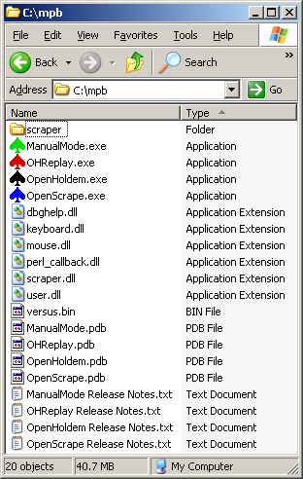
Figure 3.3-1 OpenHoldem directory

In this directory are the following files:
- ManualMode.exe, OHReplay.exe, OpenHoldem.exe, OpenScrape.exe – these are the main files for each of the programs in the OpenHoldem project. Details on how to use each of these are throughout this manual.
- dbghelp.dll – this is a Microsoft file that is used to produce memory dumps on critical errors. These memory dumps are useful for the developers to diagnose issues.
- keyboard.dll, mouse.dll, perl_callback.dll, scraper.dll, user.dll – these files are all extensions to OpenHoldem that you can use to customize the software. More detail on all of these are provided in this document.
- versus.bin – this file is the large lookup table that is used by the versus symbols that are described in this document. If you want to use versus symbols, you need this file.
- Files with .pdb extensions – these files contain the debug symbols that are required if you want to diagnose crashes or simply trace execution in a debugger. If you need these, you know how to use these. If you don’t know what these are, you can safely ignore or delete them.
- Files with .txt extensions – these are the release notes for each of the programs in the project. Feel free to peruse these if you have problems falling asleep some night.

Finding a Table Map
The “scraper” directory should be where your Table Map files are stored. Table maps provide the OpenHoldem game state engine the instructions for deriving the state of the game from the pixels on the screen. These files have the “.tm” extension on them. The challenge with table maps is that every casino needs its own map. In some cases, you might need different maps for different game flavors. NL vs. FL, SNG vs. Ring, 10-seat vs. Heads-Up, for example.

The OpenHoldem project team does not provide official Table Maps for any casino or any Texas Hold’em game flavor. The reason for this is that there are thousands of casinos out there, and tens- or hundreds- of thousands of map combinations when you consider the different game flavors. Adding to that is the fact that casinos regularly update their client software and make minor or comprehensive changes to the pixels as they are displayed on the screen. These changes most often require changes to the table map as well. The OpenHoldem Project development team is a group of volunteers – we do not get paid for this, we have real lives and real families, and do this as a hobby. Maintaining working Table Maps would be a more than full time job, and thus instead, we put the power in your hands; we provide Table Map creation tools and testing tools to allow you to be self-sufficient. An explanation of the “OpenScrape” program, which is key to this self-sufficiency, will be provided in more detail later in this document.

That said, there are a number of places you can find pre-created maps for use with OpenHoldem. There is a section on the Wiki (http://www.maxinmontreal.com/wiki/index.php5?title=Table_Maps) that contains user-contributed maps. These maps are likely to be more or less out of date, and would require some validation to ensure they are 100% correct. Consider these maps to be a starting point for learning how maps are constructed and how they work. The forums have a lot of discussion on maps, and you can likely find maps attached to posts; same caveats apply as to the Wiki maps. You can try buying or trading maps with other community members – be cautious with this, however, and make sure you protect your interests; the OpenHoldem development team cannot be held accountable if you do something foolish on your own. Caveat emptor.

Creating a Table Map
Creating a Table Map is not a difficult process, once you get the hang of it, but it does have a steep learning curve. The benefit is that once you learn how to create maps, you can quite quickly take your bot to any casino on the Internet.

OpenScrape is the program that is used to create Table Maps. It provides a graphical interface to provide a set of parameters that are stored in human-readable text files with the .tm extension. Try it – open any .tm file in Notepad and you can quite clearly see the way the file is laid out. Each Table Map has a set of parameters, grouped by record type. The following sections will discuss how to use each of these record types to create your map.

First thing’s first: connect to the poker window
Start a casino, and open up a play money table. You can even use “observer” mode for this activity if you like. Alternatively, once you learn how to use saved frames and OHReplay, you can also connect OpenScrape to these saved frames while offline from the casino.

For now, let’s keep it simple. Once you have a poker table setup, startup the OpenScrape program from the “c:\mpb” directory that you set up above. Arrange the casino table window and the OpenScrape windows on your screen in such a way that there is no overlap – OpenScrape needs a clear view of the poker table window to do its job.

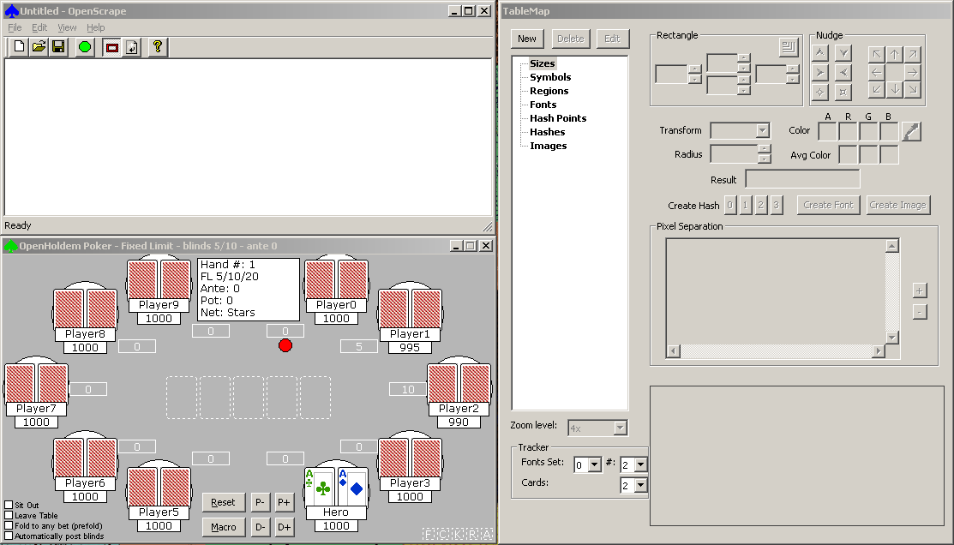
Figure 4.1-2 Arranged OpenScrape windows

Connect OpenScrape to the casino table by clicking on the Green Circle Button on the OpenScrape toolbar. A dialog with a list of top-level windows that are currently visible on your screen will appear. Select the one from the list that matches your casino table, and select OK. (Note, in this screenshot, we are connecting to a “ManualMode” window. You will learn more about ManualMode later in this document, but for now, just consider ManualMode to be a simulated, offline poker table).
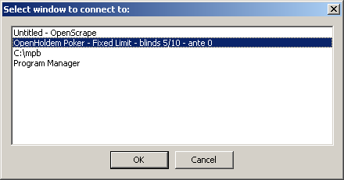
Figure 4.1-3 OpenScrape Green Circle Button selection window

A static image of the poker table window will be displayed in OpenScrape’s main window. Once OpenScrape has the poker table’s image displayed, you can minimize the poker table if you want, to give yourself more room to work. As the casino table changes state, and if you want to update the image that is displayed in the OpenScrape main window, you can do so at any time by clicking on the refresh button on the toolbar (Black and White arrows), or by choosing View/Refresh from the menu. When a refresh is requested, OpenScrape will bring the connected window to the front, grab the image, and then place it to the back again. Additionally, if you have OpenScrape connected to an OHReplay window, it automatically moves OHReplay to the next saved frame prior to grabbing the image.

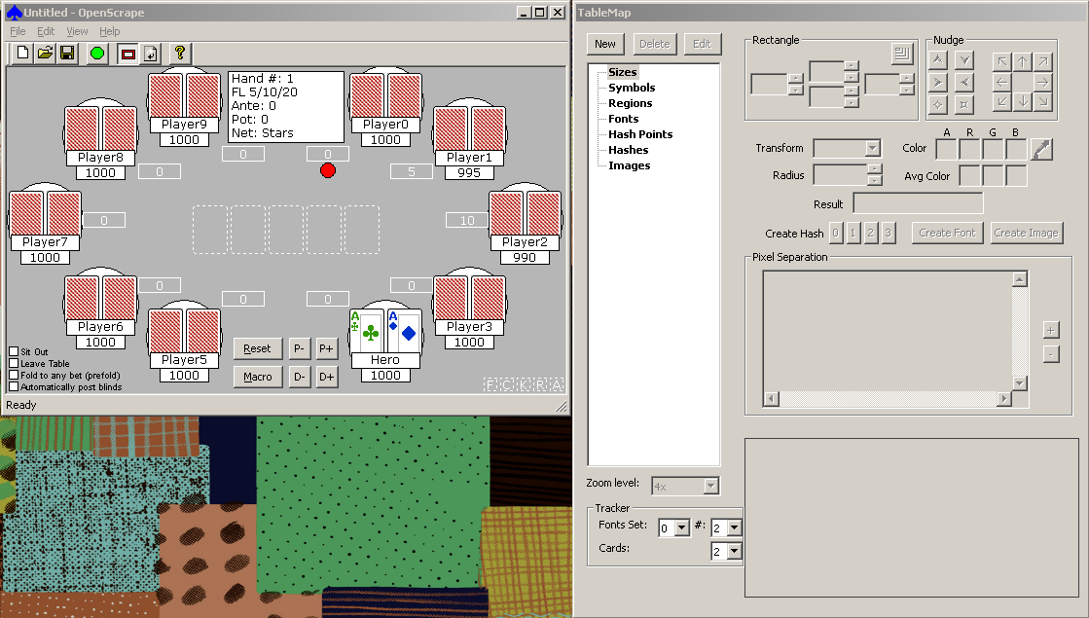
Figure 4.1-4 OpenScrape connected to poker table

Once we have the poker table image in OpenScrape, it is time to start building our Table Map, and providing the parameters that the OpenHoldem game state engine will use to “read” the poker table.

Familiarizing yourself with OpenScrape
When you started the OpenScrape program, two windows appeared. The “Main” window has the menu bar, the toolbar, and a display of the poker table image. The other window that appeared is the “TableMap Editor” window, and is where you will be doing most of your work with OpenScrape. The “TableMap Editor” window does not have a menu or toolbar, and has “TableMap” as its title.

Main: Menu Options

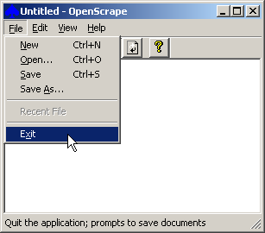
Figure 4.2-5 OpenScrape File menu

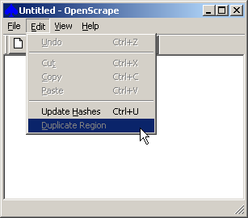
Figure 4.2-6 OpenScrape Edit menu

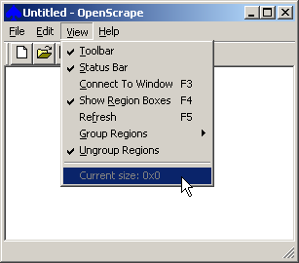
Figure 4.2-7 OpenScrape View menu

The File menu contains the standard Windows options to open and save Table Map files.

The Edit menu contains the standard Windows options, plus two options specific to OpenScrape:
- Update Hashes: This option will recalculate all the Hash records in the current map – useful if you have made changes to the underlying images, for example. More on Hashes later.
- Duplicate Region: This option will allow you to easily duplicate Regions. For example, once you have the player 1 card locations defined, you might want to copy those to players 2-10 to make things easier on yourself. More on Regions later.

The View menu has the standard Windows Toolbar/Status Bar options, plus the following specific OpenScrape options:
- Connect To Window: This option duplicates the “Green Circle Button” on the toolbar, and will bring up a dialog to allow you to select which window OpenScrape will copy an image from.
- Show Region Boxes: Allows you to toggle whether or not Region boxes are displayed on top of the poker table image in the main window.
- Refresh: This option duplicates the Black and White Arrow button on the toolbar, and will copy to current casino table image to the OpenScrape main window.
- Group Regions/Ungroup Regions: These options allow for customization of how Region records are displayed in the Table Map Editor window.
- Current size: Displays the client size of the window that OpenScrape is currently attached to. This is very useful when creating certain String records.

Main: Toolbar
Figure 4.2-8 OpenScrape Main window toolbar

The toolbar on the main window performs the following actions, from left to right:
- New Table Map
- Open Table Map
- Save Table Map
- Connect to window
- Toggle Region box display on or off
- Refresh the poker table image
- Display Help/About
Note: Keyboard shortcuts exist for many of these menu options and toolbar buttons, in addition to the standard Windows keyboard shortcuts:
F1 – Help/About
F3 – Connect to window
F4 – Toggle Region box display on or off
F5 – Refresh the poker table image
Control + U – Update Hashes

Table Map: Buttons/fields
The Table Map Editor window has a plethora of information on it, and various fields and controls will become enabled or disabled, depending on the type of map record selected.
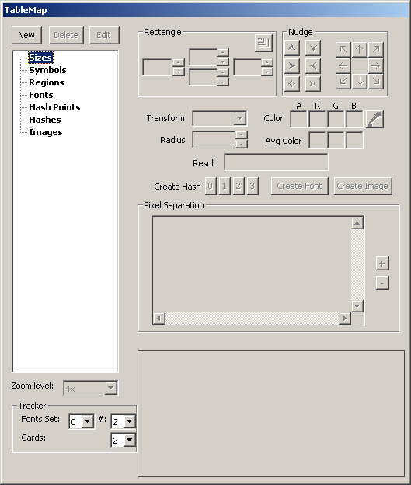
Figure 4.2-9 OpenScrape Table Map Editor window

On the top left of the window are three buttons, New/Delete/Edit, that allow you to add new records to the map, remove records from the map, or edit records in the map. The “New” button will prompt you to add a record of the type that is selected in the tree display directly below. For example, if you have a Region record selected, clicking New will prompt you to add a new region record to the map. The “Delete” and “Edit” buttons operate on the currently selected record.

Directly below the New/Edit/Delete buttons is the record tree display. This box displays all records that are currently present in the map, and groups them by type. The Region records within this tree can be further sub-grouped using the View menu options on the main window. There are a number of choices for sub-grouping Region records, and are intended to improve the productivity of Table Map creation. Experimentation of these sub-groupings is necessary to see if any meet your personal needs.

Below the tree display is a drop down to select the zoom level of the image that is displayed in the big box on the bottom right portion of the window. The image displayed is dependent on the record type selected.

Below the Zoom Level are various drop downs that are used to serve as checklists for capturing fonts and card images. Capturing fonts and card images will be discussed later.

On the top right of this window are a large group of controls, there is a “Rectangle” group, a “Nudge” group, and “Transform”, “Radius”, “Color”, “Avg Color” , and “Result” fields. These controls are used mainly for setting the parameters of Region records, and are only enabled when a Region record is selected in the record tree display on the left side of the window. The meaning of these fields will be described in the “Region” record section below. Some of these fields may display other relevant information, depending on the record type selected in the display tree.

Below this large group of controls are buttons to create Hash records, Font records and Image records. These buttons will be enabled/disabled appropriately depending on the record type that is selected in the display tree. For example, creating an Image record only makes sense if a Region record is selected in the display tree. Creating a Font record only make sense if a Region record with a text transform type is selected in the display tree.

The box below the Hash, Font and Image buttons is used to display “pixel separation”. The “+” and “-“ buttons to the right of this box control the size of the font used in this box. Pixel separation is used for regions that use font transforms. A good separation between foreground and background colors is imperative for good font recognition, and this box lets you preview that separation.

Size Records

Description
Size records are used for one purpose only, to allow OpenHoldem’s “Green Circle Button” to find windows of the correct size. More specifically, they provide the ability to specify the accepted sizes for the casino table that the scraper engine will recognize. Upon a click of the “Green Circle Button”, OpenHoldem will first search for poker table windows that match the exact size (clientsize) and if no match is found, will then look for poker table windows that are between the clientsizemin and clientsizemax sizes. In the majority of Table Maps, the only size record that is needed is the clientsize record. Use of clientsizemin and clientsizemax records should only be considered in unusual and exceptional cases.

Manipulating size records using OpenScrape
- To create a new size record, select the “Sizes” category in the record tree display on the Table Map Editor window, and click the “New” button. A window will be displayed that allows you to enter the width and height parameters for this new record.
- To edit an existing size record, select the record in the record tree display on the Table Map Editor window, and click the “Edit” button. A window will be displayed that allows you to adjust the width and height parameters for this record, or change the record name itself.
- To delete an existing size record, select the record in the record tree display on the Table Map Editor window, and click the “Delete” button. A window will be displayed asking for verification of this action.

A note about window client sizes: Microsoft Windows provides several different measures of a windows’ size, such as the complete window including frame and title bar, and an altogether different measure, the so-called “client area”, that lies inside the window frame and excludes frames and title bars. OpenHoldem references the Microsoft “client area” measurement for these “Size” records. To help you understand the size of the poker window that you have attached to (with the Green Circle Button), OpenScrape always displays the client size of the attached poker table in the “View” menu on the main OpenScrape window. The menu option is at the bottom of this menu and is preceeded by “Current Size: “. The width and height displayed in this menu can be entered directly into a clientsize record.

Technical reference
In the Table Map (.tm) file, these records will be preceded with the characters "z$”. Size records have the following format:

z$<name> <width> <height>

<name> is the name of the record (see table below)
<width> and <height> are integer values.
Valid size records and their descriptions:
Record | Description
clientsize | Specifies the exact client size of the poker table window.
clientsizemin | Specifies the minimum allowed client size of the poker table window.
clientsizemax | Specifies the maximum allowed client size of the poker table window.

Symbol Records

Description
Symbol records are a general purpose record type that serves many different purposes within OpenHoldem and OpenScrape. The common characteristic of these records is that they all contain a name and a free-form text field. The interpretation of that text field is different, depending on the name of the symbol record. The table in the technical reference section below describes how the free-form text is interpreted for each different Symbol record type.

Manipulating symbol records using OpenScrape
- To create a new symbol record, select the “Symbols” category in the record tree display on the Table Map Editor window, and click the “New” button. A window will be displayed that allows you to enter the free-form text for this new record.
- To edit an existing symbol record, select the record in the record tree display on the Table Map Editor window, and click the “Edit” button. A window will be displayed that allows you to adjust the free-form text for this record, or change the record name itself.
- To delete an existing symbol record, select the record in the record tree display on the Table Map Editor window, and click the “Delete” button. A window will be displayed asking for verification of this action.

Note: The Insert and Delete keys can also be used as a shortcut for adding and deleting Symbol records.

In the case of the “New” and “Edit” actions, the window that pops up also contains a field for “Titlebar text”, a button to parse the title bar text, and a field to display the parse results. These three controls are only relevant if the record name is one of the ttlimits types. If a ttlimits record type is selected, these fields will be enabled, otherwise they will be grayed out.

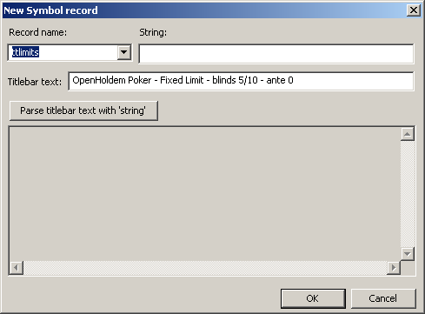
Figure 4.4-10 OpenScrape New/Edit Symbol window

These three fields allow you to test the parsing of the window’s title bar text with the parse string that is specified in the “String” field, and see the results of this parse in the results field at the bottom of the window. The “Titlebar text” field is initially populated with the titlebar text of the window that OpenScrape is attached to (via the “Green Circle Button”), but this text can be overridden with anything you want to test parse.

Technical Reference
In the Table Map (.tm) file, these records will be preceded with the characters "s$". Symbol records have the following format:

s$<name> <text>

<name> is the name of the record (see table below)
<text> is the content of the record
Valid symbol records and their descriptions:
Record | Description
titletext, titletext0 - titletext9 | When the “Green Circle Button” is pressed, OpenHoldem will look through each of these symbols and do a partial match of <text> to each window’s title bar text. If any substring provided in any of these symbols matches, then the window is considered a match.
!titletext,  !titletext0 -!titletext9 | When the “Green Circle Button” is pressed, OpenHoldem will look through each of these symbols and do a partial match of <text> to each window’s title bar text. If all substrings provided in all of these symbols do not match, then the window is considered a match.
ttlimits, ttlimits0 - ttlimits9 | These symbols are intended to provide a format string that is used to parse the window's titlebar text, and extract sblind, bblind, bigbet, ante and game type information. The syntax usage of the format string is very much like the standard C-language format strings for scanf and printf. The placeholders use the caret character as the indicator and have the following meanings:  ^h hand number  ^d dummy integer (read chars 0-9 only)  ^f dummy float (read chars 0-9 including decimal '.')  ^s sblind  ^b bblind  ^B bigbet  ^a ante  ^v sb or bb depending on limit type  ^V bb or BB depending on limit type  ^* skip all text up to the literal character following the *  ^R roman numeral as in "Level VIII" as typically seen in SNGs  ^L limit indicator  For the integer and float numerics, the scanner will automatically accept and skip a leading dollar sign “$” or leading/trailing cent sign “¢” (ascii 162 hex a2). In the case of the cent sign the target number will be divided by 100. The scanner will also recognize the standard trailing metric unit multipliers of “k” and “m” (1000 and 1000000 respectively).  The following case-insensitive strings are recognized for the ^L limit indicator:  no limit, no-limit, nolimit, nl  pot limit, pot-limit, potlimit, pl  fixed limit, fixed-limit, fixedlimit, fl, limit  As an example, this title bar text "NL SNG Level VI 25/50 (2)" could be parsed with this format string "^L SNG Level ^R ^s/^b (^a)" to result in the sblind, bblind and game type being recognized.  If multiple ttlimits symbols are provided, then the engine will scan each in order, and extract matching information from the first time it is found. That means that if you specify ^s in both ttlimits and ttlimits3, for example, it will be extracted from ttlimits and ignored in ttlimits3. OpenHoldem allows you to specify up to 11 ttlimits records in any single Table Map file. Specifying multiple ttlimits records might be needed if a given Table Map file is intended to describe multiple Texas Hold’em game flavors. However, it is a best practice to define different game flavors in different Table Maps, and thus most Table Maps contain a single ttlimits symbol record.
c0limits, c0limits0-c0limits9 | These are text format strings with the same structure as the ttlimits records described above. They are intended to be used to extract blind/limit information from the c0limits regions using text transforms. As a poker site could certainly paint the various blind/limit information in different locations in the window, it is very likely that multiple c0limits records are required, if any are needed at all.
sitename | This record describes the name of the poker site that this Table Map is for. It is good practice to include the number of chairs and game flavor that this Table Map is intended to be used for. You might have a "fulltilt9sng", "fulltilt6ring" and "fulltilt2ring" for different Table Map files for Full Tilt's various table layouts and flavors. This record is what is queried via the OpenHoldem "sitename$" symbol.
network | The name of the poker network that this Table Map is for. This is used to determine the appropriate network to query Poker Tracker data for when s$sitename is not a Poker Tracker-supported site. OpenHoldem will first check s$sitename for a supported network name, then s$network.  Supported names for both s$sitename and s$network must be lowercase and are the following: stars, party, ultimate, absolute, microgaming, ongame, cryptologic, pacific, fulltilt, b2b, tribeca, worldpex, ipoker, tain, bodog, everest, boss, and betfair.
nchairs | The number of chairs that this Table Map supports. The value of this record is what is returned via the OpenHoldem "nchairs" symbol.
reseller | Legacy support of WinScrape's symbol. Not particularly relevant in the open source OpenScrape world, but there if you need it. This is not used in the OpenHoldem engine anywhere, and is just metadata for the Table Map file.
mechanic | Legacy support of WinScrape's symbol. Not particularly relevant in the open source OpenScrape world, but there if you need it. This is not used in the OpenHoldem engine anywhere, and is just metadata for the Table Map file.
chairconfig | Legacy support of WinScrape's symbol. OpenHoldem does not adjust its display layout based on the value of this symbol like WinHoldem, and thus this is not used in the OpenHoldem engine anywhere.
swagtextmethod | Used by the Autoplayer to determine how to enter the f$swag amount into the swag entry box on the casino window.
potmethod | This is used to determine the appropriate site interpretation for the contents of c0pot0:  1: Common pot  2: Total pot, includes current bets and side bets
activemethod | This is used to determine how OH treats information from the pXactive and uXactive regions:  1: Inactive unless pXactive/uXactive returns true/active  2: Active unless pXactive/uXactive returns false/inactive/out/away
t0type - t3type | These symbols control which OCR algorithm will get used for the specific text transform 0-3. For example if the symbol h3type is defined as fuzzy then all regions with transform Text3 will use the fuzzy algorithm. The default value is "plain" if no symbol exists for a given group.  The possible values for these symbols are "fuzzy", "plain", or a specific tolerance value. The default fuzzy text tolerance is 25%, but can be overridden by stating the value in this symbol, such as "0.355", which would cause the scraper engine to use the fuzzy text algorithm with a 35.5% tolerance value. Values of 0 are the same as "plain".
swagselectionmethod | * New Symbol in version 2.0; previously, this was a global preference set from the OpenHoldem preferences GUI.  This symbol instructs the Autoplayer how to take the first action in a SWAG sequence. A SWAG sequence always consists of:  1. select the text in the SWAG box  2. delete the text in the SWAG box  3. enter the new bet in the SWAG box  4. confirm the SWAG bet amount.  Valid values for this Symbol are available in a drop down control and are:  - "Sgl Click" – Single left click on the SWAG box to select the existing text  - "Dbl Click" – Double left click on the SWAG box to select the existing text  - "Click Drag" – Left click on the leftmost pixel of the SWAG box, drag to the rightmost pixel of the SWAG box, and then release the left mouse button to select the existing text  - "Nothing" – Skip the text selection step of the SWAG action
swagdeletionmethod | * New Symbol in version 2.0; previously, this was a global preference set from the OpenHoldem preferences GUI.  This symbol instructs the Autoplayer how to take the second action in a SWAG sequence. A SWAG sequence always consists of:  1. select the text in the SWAG box  2. delete the text in the SWAG box  3. enter the new bet in the SWAG box  4. confirm the SWAG bet amount.  Valid values for this Symbol are available in a drop down control and are:  - "Delete" – Press the “Delete” key to delete the selected text in the SWAG box  - "Backspace" – Press the “Backspace” key to delete the selected text in the SWAG box  - "Nothing" – Skip the text deletion step of the SWAG action
swagconfirmationmethod | * New Symbol in version 2.0; previously, this was a global preference set from the OpenHoldem preferences GUI.  This symbol instructs the Autoplayer how to take the fourth action in a SWAG sequence. A SWAG sequence always consists of:  1. select the text in the SWAG box  2. delete the text in the SWAG box  3. enter the new bet in the SWAG box  4. confirm the SWAG bet amount.  Valid values for this Symbol are available in a drop down control and are:  - "Enter" – Press the “Enter” key to confirm the SWAG bet entry  - "Click Bet" – Click the “Bet” button to confirm the SWAG bet entry  - "Nothing" – Skip the bet confirmation step of the SWAG action
buttonclickmethod | * New Symbol in version 2.0; previously, this was a global preference set from the OpenHoldem preferences GUI.  This symbol instructs the Autoplayer how to click any button defined by the iXbutton region records.  Valid values for this Symbol are available in a drop down control and are:  - "Single" – Single left click on buttons  - "Double" – Double left click on buttons
handresetmethod | * New Symbol in version 2.0  This symbol identifies which scrape changes should be used as a trigger to identify a "hand reset" event. This is a bitmapped integer; only one of the selected scrape changes needs to occur in order for the scrape to be considered a "hand reset".  The values below are in hexadecimal format for explanatory purposes, but the value assigned to the handresetmethod symbol must be specified in decimal (base-10) format. As an example, if you want to instruct OpenHoldem to treat a change in dealer button OR a change in player cards as a "hand reset", then handresetmethod should be set to 5. If you want to instruct OpenHoldem to treat only a change in dealer button as a “hand reset", then handresetmethod should be set to 1.  Bits and meanings:  - 0x00000001 (bit 1) = dealer button  - 0x00000010 (bit 2) = handnumber  - 0x00000100 (bit 3) = player cards (not triggered by change to "no cards" or to "card backs")
balancenumbersonly | * New Symbol in version 2.0  This Symbol instructs the screen scraper that all characters besides numbers (0-9 and dot/decimal separator) are stripped from the text transform result for balance regions. This is useful for those casinos that include spurious/changing alphanumeric information in their balance boxes. Setting this string to "True" or "Yes" will enable balance cleansing, any other value or the absence of this Symbol will result in no balance cleansing.
chipscrapemethod | * New Symbol in version 2.0  This Symbol instructs the “chip stack counter” within the screen scraper engine to act in one of three distinct modes of operation:  - If this Symbol is not present, or does not match one of the other formats, the “chip stack counter” begins counting chips at the 00 Region record, stops counting a given stack when a chip match is not found, and stops counting all stacks when the first chip in a given stack is not matched. This is the default, pre-2.0 behavior.  - If this symbol is set to "All”, then the scraper engine will check all 200 possible chip locations (10 stacks of 20 chips) every time a chip count is required.  - If this symbol is set to the format "XxY", where X is an integer between 1 and 10 representing the number of stacks, and Y is an integer between 1 and 20 representing the number of chips in each stack, then the scraper engine will check X times Y chip locations every time a chip count is required.
Scraperdll | * New Symbol in version 2.0  This Symbol instructs OpenHoldem to load a user-supplied external scraper override DLL when this Table Map is used. This external DLL can be used to override the results of the internal scraper engine. This DLL is called immediately after the internal scraper engine finishes its pass every heartbeat, at which point the current state of the internal screen scraper is passed to the DLL for inspection and modification. A reference scraper DLL is provided in the source code as a starting point. An obvious use of this would be to hook or inject the target casino client to retrieve better state information than that which could be collected using the built-in pixel-based screen scraper.

Region Records

Description
The purpose of the Region records is to describe named rectangular areas on a poker table, each of which contains an element of the game state. These regions will “return” values to the OpenHoldem game state engine, depending on the type of transform selected.

An example will make this clearer. Each seat at the table will have two cards in front it, and we want our screen scraper to tell the OpenHoldem game state engine what those cards are. If the casino client displays a group of pixels for our first hole card, that to a human being looks like an ace of hearts, we need somehow to tell the screen scraper to “return” “Ah” to the game state engine each time that group of pixels is seen in one of the card locations. To do this we collect an image for that ace of hearts, then setup a region record that returns “Ah” to OpenHoldem when that ace of hearts is seen during real live game play.

Manipulating region records using OpenScrape
- To create a new region record, select the “Regions” category in the record tree display on the Table Map Editor window, and click the “New” button. A window will be displayed that allows you to select the name of the region to create. After creating the record, you can use the controls on the right side of the Table Map Editor window, as described below, to change the settings for the new record.
- To edit an existing region record, select the record in the record tree display on the Table Map Editor window. Immediately after selecting the record, the controls on the right side of the Table Map Editor window are updated with the settings for the selected region record. These can then be changed, as described below.
- To delete an existing region record, select the record in the record tree display on the Table Map Editor window, and click the “Delete” button. A window will be displayed asking for verification of this action.

Note: The Insert and Delete keys can also be used as a shortcut for adding and deleting Region records.

Note: Regions can also be selected by left clicking within the region’s flashing red rectangle that is layered on top of the poker table image on the Main window. If multiple regions are layered on top of each other, clicking again on the same area will select the next region below the selected region. This only works for two regions. If three or more regions are layered on top of each other, the selection tree will need to be used.

The majority of the right side of the Table Map Editor window is used to manipulate the parameters of the region record.

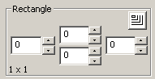
Figure 4.5-11 OpenScrape Rectangle Group Box

Starting at the top, there is a rectangle group box. This group box allows you to define the extents (left, right, top, bottom) of the region record’s bounding rectangle. The bounds are inclusive – in other words, a rectangle defined as left=0, right=5, top=0 and bottom=6 will be 6 pixels wide and 7 pixels high. The rectangle settings can be direct entered into the controls, you can use the spinners next to the controls, or you can use the rectangle drawing tool to quickly draw the rectangle on the poker table.

To use the rectangle drawing tool, click once on this control:
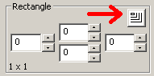
Figure 4.5-12 OpenScrape Rectangle drawing tool

...then move your mouse cursor to the Main OpenScrape window where the image of the poker table is displayed. The mouse cursor will change to look like crosshairs with an arrow pointing right and down. Left click and hold the mouse button anywhere on the poker table image to define the left-top corner of the rectangle. Drag to the right and down, and when you reach the right-bottom corner of the rectangle, release the left mouse button.

A zoomed view of the region is displayed in the box at the bottom right of the Table Map Editor window. The Table Map Editor window can be enlarged, if needed, to show the entire region. Use the Zoom Level control to adjust the zoom level in this display.

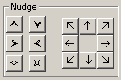
Figure 4.5-13 OpenScrape Nudge group box

To the right of the rectangle group box is the nudge group box. These controls allow you to adjust the size and position of the region record’s rectangle in a variety of ways. The group of six controls on the left, starting from top left and moving clockwise, allow you to make the rectangle taller, shorter, thinner, smaller, bigger and wider. The group of 8 controls on the right, starting from top left and moving clockwise, allow you to move the rectangle up-left, up, up-right, right, down-right, down, down-left, and left.

Note: Regions can also be moved by first selecting the region by left clicking within the region’s flashing red rectangle on the poker table image on the Main window, then by holding the Shift key and dragging and dropping the region to its new location.

Note: Keyboard shortcuts also exist to move and resize regions:
Arrow keys - Move the region 1 pixel
Numpad keys 1, 3, 7, and 9 – Move the region diagonally 1 pixel
Shift + Arrow keys - Move the region 5 pixels
Control + Arrow keys - Resize the region by 1 pixel
Control + Shift + Arrow keys – Resize the region by 5 pixels

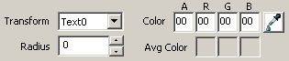
Figure 4.5-14 OpenScrape Region record parameters

The next set of controls allows you to set the remainder of the parameters on a region record. Here you can set the type of transform, the radius of the RGB color cube, and the center color of the RGB color cube. The use of RGB color cubes for transforms of type Color and Text is described in the technical reference below. Also in this group of controls is an eyedropper button that is used to populate the color parameters, as opposed to directly entering those values. To use the eyedropper, click once on the eyedropper button, then hover over the region’s image display at the bottom of the Table Map Editor window. When the color you want is present in the four color fields, click the left mouse button to lock them in.

As a helpful reference, the “Avg Color” fields are populated with the calculated average color of all pixels in the region. This is useful for finding RGB color cube centers and for text transform separations.

Figure 4.5-15 OpenScrape Transform result preview

This field provides an instant preview of the results of combining the current pixels in the region with the current transform for that region. If this is a Text transform, the actual transformed ASCII text is displayed. If this is a Color transform, True or False is displayed, depending if the region’s average color is inside or outside of the defined RGB color cube. If this is a Hash transform, the value of the matching Hash record is displayed. If this is an Image transform, the value of the matching Image record is displayed.

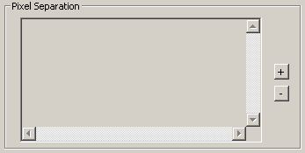
Figure 4.5-16 OpenScrape Pixel Separation display

If your region is defined to have a Text transform, then the Pixel Separation window will be populated with a preview of this separation. The key to good Text transformation is the separation of foreground pixel colors from background pixel colors. In this display, foreground pixels will be shown as an “X”, and background pixels as a blank space. The size of the font used in this display can be adjusted with the “+” and “-“ buttons to the right.

Note: Remember that the whole purpose of a region definition, with a given type of transformation, is to tell the screen scraper what the pixels mean that are displayed on the screen within that region. The return value of the transformation is provided to the OpenHoldem game state engine which then uses those values to establish the game state and to provide various information that your bot logic needs to make action decisions. A human can easily look at the balance for seat #2 and see that it is $950.12. For a computer it is harder – we need to specify the rectangle that bounds this balance region, define it as a text transform, choose a color that lets the screen scraper identify foreground from background pixels, and then collect each of the individual font characters (more on this below) so that the screen scraper engine can look up the actual ASCII text for these pixels.

The Edit menu of on the Main window contains a “Duplicate Region” entry, which is intended to allow the quick creation of related region records. First, select a region record from the tree display on the Table Map Editor window, then select Edit/Duplicate Region from the Main window. This action will display this window:

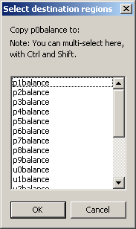
Figure 4.5-17 OpenScrape Duplicate Region window

In this case, the p0balance region was selected. You are given the option to duplicate the selected region record to other region records of the same type. In this case, all of the unpopulated pXbalance and uXbalance region records are candidates. You can select one or more than one destination record here (using the standard Windows Ctrl and Shift multi-select capability) to copy the selected region to. When you click the OK button, the new region records will be created for you, and you can then move them where needed and adjust them appropriately.

Technical Reference
In the Table Map (.tm) file, these records will be preceded with the characters "r$". Region records have the following format:

r$<name> <left> <top> <right> <bottom> <color> <radius> <transform>

<name> is the name of the record (see table below)
<left>, <top>, <right> and <bottom> are integer values within the casino table, where the upper left corner of the client area is considered to be 0, 0
<color> is a 1-8 character hexadecimal number in the form AABBGGRR (Microsoft Window's COLORREF format). The usage of the color value is dependent on the transform selected.
<radius> is an RGB color distance.
<transform> describes the engine algorithm that should be used to interpret the pixels in the region.

The available transforms are:
Type | Description
N | None - This is used for those regions that do not need a transform as their only purpose is to describe a rectangle for use by the scraper engine. An example is button location (i0button - i9button) which informs the Autoplayer engine of the allowed rectangle for mouse clicks.
C | Color - This is a calculation of the average RGB color for the entire region. Used in conjunction with the radius, the engine will determine if the contents of the region, as seen during game play, match the color/radius as specified in the Table Map. The color value in the region record defines the center of a cube, and the radius defines the dimensions of that cube. This cube is then mapped to an RGB color space, and if the average color of the region falls within this cube, then a match is reported. A negative radius can also be specified, in which case if the average color of the region falls outside of the cube, then a match is reported.
I | Image - This transform does two things. It first searches the Image records in the Table Map for a pixel-by-pixel match, and returns the value of that Image record if a match is found. If no pixel-by-pixel match is found, the transform then searches for the closest match, based on this perceptual difference algorithm: http://pdiff.sourceforge.net/ There is an internal hard-coded limit, which prevents Image records from matching the region if 65% or more of available pixels of that region do not match. If this limit did not exist, then clearly non-matching regions could return all sorts of junk.  This exact-match-to-pdiff failover is automatic, and requires no additional work from the Table Map creator other than to set the transform to "I" and to collect the images. This is a powerful transform, but be aware that this power comes at the cost of CPU cycles.
T | Text - This is an OCR (http://en.wikipedia.org/wiki/Optical_character_recognition) algorithm for the purpose of converting screen pixels to ASCII text. The color cube specifications (as in the C transform) are used to separate the foreground from the background pixels. A lookup is then performed against the Font records in the Table Map on a character by character basis to produce a resultant text string.
Hn | Hash n - This transform reduces the contents of the rectangle to a 32-bit value. OpenHoldem and OpenScrape use only a single, well respected hash algorithm that is open for public review. Because of the selection of this algorithm, we have not yet seen a hash collision (that did not have an unrelated root cause, like record duplication). That is not to say that a hash collision is not impossible, however the mapping of 52 card images (for example) into a 32-bit address space makes this highly unlikely. If a collision ever occurs, there is the option to use hash types other than Type 0. Types 0-3 all use different hash seeds with the same algorithm, and thus if a collision is seen, one could simply change the hash type for that region.  The Type 0 hash algorithm uses all pixels in a region to calculate a hash. To use specific pixels in the region, use Types 1-3. Types 1-3 default to using all pixels in a region as well, but if Hash Point records are present in the Table Map and of a matching type, the engine will use those specific points for calculation of the hash.  Once a region is hashed, the resultant 32-bit hash value is then looked up in the h$ records in the Table Map. If a match is found, the name of the h$ record is returned and acted on appropriately (i.e. common card 1 is Queen-Hearts, Fold button is present, Player 2 is seated, etc.)
Valid region records and their descriptions:
Record | Description
c0cardface0 - c0cardface4 | Common cards 0-4; represents the entire card, the best transformation is probably hash. Typically either c0cardfaceX is used, or c0cardfaceXrank / c0cardfaceXsuit, but not both.  Valid results are a case-insensitive, two character string. The first character is the rank and should be one of: “2”, “3”, “4”, “5”, “6”, “7”, “8”, “9”, “t”, “j”, “q”, “k”, or “a”. The second character is the suit and should be one of: “c”, “d”, “h” or “s”.
c0cardface0rank - c0cardface4rank | Rank of common cards 0-4; the best transformation is probably text. Typically either c0cardfaceX is used, or c0cardfaceXrank / c0cardfaceXsuit, but not both.  Valid results are case-insensitive, and are one of “2”, “3”, “4”, “5”, “6”, “7”, “8”, “9”, “10”, “t”, “j”, “q”, “k”, or “a”.
c0cardface0suit - c0cardface4suit | Suit of common cards 0-4; the best transformation is probably text. Typically either c0cardfaceX is used, or c0cardfaceXrank / c0cardfaceXsuit, but not both.  Valid results are case-insensitive, and are one of “c”, “d”, “h” or “s”.
c0handnumber, c0handnumber1 - c0handnumber9 | Ten regions to specify where the game state engine should find the current handnumber. The first region found with valid numeric information will be used and the remainder skipped. c0handnumber is searched first, then c0handnumber1 to c0handnumber9 in that order.
c0istournament | Used to identify if this table is a tournament game. Any transform can be used equally well with this region.  If the result from this region’s transform is anything besides blank (empty string) then this region is considered to represent a tournament game.
c0smallblind | Identifies the region on the poker table where the small blind can be found. Title text parsing is much easier to implement if that option is available, otherwise a text transformation can be used with this region to identify the small blind.
c0bigblind | Identifies the region on the poker table where the big blind can be found. Title text parsing is much easier to implement if that option is available, otherwise a text transformation can be used with this region to identify the big blind.
c0bigbet | Identifies the region on the poker table where the big bet can be found. Title text parsing is much easier to implement if that option is available, otherwise a text transformation can be used with this region to identify the big bet.
c0ante | Identifies the region on the poker table where the ante can be found. Title text parsing is much easier to implement if that option is available, otherwise a text transformation can be used with this region to identify the ante.
c0pot0 - c0pot4 | The value of the main pot should be identified by c0pot0 using a text transform. c0pot1 to c0pot4 can be used to identify side pots if required.
c0potNchipXY | See chip scraping instructions for p0chipXY - p9chipXY below. The difference is that the "N" refers to the different pots - N=0 is the main pot, N=1-4 are side pots.
c0limits, c0limits0 - c0limits9 | Identifies the region on the casino table where the limit information can be found; this region is used in conjunction with the Symbol records c0limits and c0limits0-c0limit9 text parse strings. This region should really only be used if title text parsing is not an option.
i0button - i9button | Specifies the rectangular area in which the Autoplayer can click the mouse for each button 0-9.
i0label - i9label | Specifies the action that should be associated with buttons 0-9. By default, and if not overridden here, button 0 will be interpreted as the fold button, 1 as the call button, 2 as the raise button and 3 as the allin button.  The return value from the transformation of this region (hash or text) will determine how the scraper engine interprets the button. All values are changed to lowercase and have spaces and '-' removed. Only the leftmost characters will be tested  "allin", "a11in", "allln", "a111n", "aiiin" : button is seen as the allin button  "raise", "ra1se", "ralse", "bet" : button is seen as the raise button  "call", "caii", "ca11" : button is seen as the call button  "check" : button is seen as the check button  "fold", "fo1d", "foid" : button is seen as the fold button  "autopost", "aut0p0st" : button is seen as the autopost button  "sitin", "s1t1n" : button is seen as the sitin button  "sitout", "s1tout", "sit0ut", "s1t0ut" : button is seen as the sitout button  "leave" : button is seen as the leave button  "prefold" : button is seen as the prefold button  Examples: "All-In" will be recognized as allin; "Auto-post blinds" will be recognized as autopost
i0labelY - i9labelY | Where Y = 0 - 9. As an adjunct to the iXlabel regions, the iXlabelY region definitions allow the specification of an alternative location with alternate properties, such as color, for any button. The specification of these regions is exactly as that of the iXlabel regions with an addition of a numeric (0 - 9) suffix. The iXlabel regions are searched first, then the iXlabelY regions. The first region that resolves to a text value will stop any subsequent evaluations.
i0state - i9state | Specifies whether the button0 - button9 is live and available to be clicked. The best transformation is hash or color.  If the leftmost characters of the result from this region’s transform are either “true”, "on", "yes", "checked" or "lit" then the button will be seen as available to be clicked. If any other result is returned, such as "false", then the button will be seen as not available to be clicked. Results are case-insensitive.
i3edit | Specifies the rectangular region that can be used for entering a SWAG bet.
i86button, i860button - i869button | Similar to the i0button - i9button regions, however these regions are intended to be used to combat spam/popups that could occlude the poker window. If the corresponding state region returns true, the Autoplayer will try to click in this region to dismiss the spam/popup.
i86state, i860state - i869state | The corresponding state regions for the i86button, i860button - i869button regions above. The best transformation is hash or color.  If the leftmost characters of the result from this region’s transform are either “true”, "on", "yes", "checked" or "lit" then the button will be seen as available to be clicked. If any other result is returned, such as "false", then the button will be seen as not available to be clicked. Results are case-insensitive.
p0active - p9active | Used to determine if a player is active (sitting in) or not (sitting out). Any transform can be used equally well with this region.  If the leftmost characters of the result from this region’s transform are either “true” or “active”, then the region is considered to be active. If any other result is returned, such as "false", "inactive", "out" or "away", then the chair is not considered to be active. Results are case-insensitive.
p0balance - p9balance | Used to identify a player's balance. It only makes sense to use a text transform for these regions.
p0bet - p9bet | Used to identify a player's bet. It only makes sense to use a text transform for these regions.
p0cardback - p9cardback | Used to identify when a seat 0-9 displays a card back. The best transformation is hash or color.  If the leftmost characters of the result from this region’s transform are either “true” or “cardback”, then the region is considered to be showing a cardback. If any other result is returned, such as "false", then the chair is not considered to have be showing a cardback. Results are case-insensitive.
p0cardface0 - p9cardface0 | The first card for seats 0-9; represents the entire card. The best transformation is probably hash. Typically either pXcardfaceY is used, or pXcardfaceYrank / pXcardfaceYsuit, but not both.  Valid results are a case-insensitive, two character string. The first character is the rank and should be one of: “2”, “3”, “4”, “5”, “6”, “7”, “8”, “9”, “t”, “j”, “q”, “k”, or “a”. The second character is the suit and should be one of: “c”, “d”, “h” or “s”.
p0cardface1 - p9cardface1 | The second card for seats 0-9; represents the entire card. The best transformation is probably hash. Typically either pXcardfaceY is used, or pXcardfaceYrank / pXcardfaceYsuit, but not both.  Valid results are a case-insensitive, two character string. The first character is the rank and should be one of: “2”, “3”, “4”, “5”, “6”, “7”, “8”, “9”, “t”, “j”, “q”, “k”, or “a”. The second character is the suit and should be one of: “c”, “d”, “h” or “s”.
p0cardface0rank - p9cardface0rank | The rank of the first card for seats 0-9. The best transformation is probably text. Typically either pXcardfaceY is used, or pXcardfaceYrank / pXcardfaceYsuit, but not both.  Valid results are case-insensitive, and are one of “2”, “3”, “4”, “5”, “6”, “7”, “8”, “9”, “10”, “t”, “j”, “q”, “k”, or “a”.
p0cardface0suit - p9cardface0suit | The suit of the first card for seats 0-9. The best transformation is probably text. Typically either pXcardfaceY is used, or pXcardfaceYrank / pXcardfaceYsuit, but not both.  Valid results are case-insensitive, and are one of “c”, “d”, “h” or “s”.
p0cardface1rank - p9cardface1rank | The rank of the second card for seats 0-9. The best transformation is probably text. Typically either pXcardfaceY is used, or pXcardfaceYrank / pXcardfaceYsuit, but not both.  Valid results are case-insensitive, and are one of “2”, “3”, “4”, “5”, “6”, “7”, “8”, “9”, “10”, “t”, “j”, “q”, “k”, or “a”.
p0cardface1suit - p9cardface1suit | The suit of the second card for seats 0-9. The best transformation is probably text. Typically either pXcardfaceY is used, or pXcardfaceYrank / pXcardfaceYsuit, but not both.  Valid results are case-insensitive, and are one of “c”, “d”, “h” or “s”.
p0dealer - p9dealer | Identifies if the dealer button is found for seat 0-9, or not. Color transforms are usually used for these regions, but hash, text or image transforms can be used too.  If the leftmost characters of the result from this region’s transform are either “true” or “dealer”, then the chair is considered to have the dealer button. If any other result is returned, such as "false", then the chair is not considered to have the dealer button. Results are case-insensitive.
p0name - p9name | Identifies the name of the player in seat 0-9. It only makes sense to use a text transform for these regions.
p0seated - p9seated | Identifies whether seat 0-9 is occupied (seated) or not. Color transforms are usually used for these regions, but hash, text or image transforms can be used too.  If the leftmost characters of the result from this region’s transform are either “true” or “seated”, then the chair is considered to be seated. If any other result is returned, such as "false" or "unseated", then the chair is not considered to be seated. Results are case-insensitive.
p0chipXY - p9chipXY | Note: Chip scraping should *only* be used if the actual numeric bet text cannot be found elsewhere on the poker table. Text transformation is magnitudes of effort easier to accomplish.  Step 1 : Ensure that the poker site uses static landings for all of the chip stacks.  Step 2 : Determine the size of an individual chip, and should include any portion of the chip that is painted anywhere within the window regardless of how faded or transparent.  Step 3 : Create regions for the initial base of each player's chip stacks with the size determined in step 2; p0chip00, p1chip00, ..., p9chip00.  Step 4 : Create vertical stride chip regions for each player's chip stack; p0chip01, p1chip01, ..., p9chip01. These regions should perfectly surround the 2nd chip that rests above the base pXchip00.  Step 5 : Create horizontal stride chip regions for each player's chip stack; p0chip10, p1chip10, ..., p9chip10. These regions should perfectly surround the base chip in the second stack.  Step 6 : Optional and rare: If the vertical stride between chips in a stack is not uniform, then you will need to define pXchip02-pXchip09 for each chip in the stack. For those sites with non-uniform vertical chip strides, this means that there is a limit of 10 chips per stack that will be recognized by the engine.  Step 7 : Optional and rare: If the horizontal stride between chip stacks is not uniform, then you will need to define pXchip10-pXchip90 for each stack. For those sites with non-uniform horizontal chip strides, this means that there is a limit of 10 stacks that will be recognized by the engine.  In a worst case situation, there may be 100 chip regions * 10 players = 1000 region definitions required to scrape chips! (So now go look at scraping the bet text instead)
u0active - u9active | These are alternatives to the p0active-p9active regions, and are used for the player's seat. They are typically used when the player's seat changes appearance when it is the player's action, to avoid misscrapes due to change in color/size, whatever. Any transform can be used equally well with this region.  If the leftmost characters of the result from this region’s transform are either “true” or “active”, then the region is considered to be active. If any other result is returned, such as "false", "inactive", "out" or "away", then the chair is not considered to be active. Results are case-insensitive.
ubalance, u0balance - u9balance | These are alternatives to the p0balance-p9balance regions, and are used for the player's seat. They are typically used when the player's seat changes appearance when it is the player's action, to avoid misscrapes due to change in color/size, whatever. It only makes sense to use a text transform for these regions.
u0bet – u9bet | * New Symbol in version 2.0  These are alternatives to the p0bet-p9bet regions, and are used for the player's seat. They are typically used when the player's seat changes appearance when it is the player's action, to avoid misscrapes due to change in color/size, whatever. It only makes sense to use a text transform for these regions.
u0cardface0 - u9cardface0 | These are alternatives to the p0cardface0-p9cardface0 regions, and are used for the player's seat. They are typically used when the player's seat changes appearance when it is the player's action, to avoid misscrapes due to change in color/size, whatever.  Valid results are a case-insensitive, two character string. The first character is the rank and should be one of: “2”, “3”, “4”, “5”, “6”, “7”, “8”, “9”, “t”, “j”, “q”, “k”, or “a”. The second character is the suit and should be one of: “c”, “d”, “h” or “s”.
u0cardface1 - u9cardface1 | These are alternatives to the p0cardface1-p9cardface1 regions, and are used for the player's seat. They are typically used when the player's seat changes appearance when it is the player's action, to avoid misscrapes due to change in color/size, whatever.  Valid results are a case-insensitive, two character string. The first character is the rank and should be one of: “2”, “3”, “4”, “5”, “6”, “7”, “8”, “9”, “t”, “j”, “q”, “k”, or “a”. The second character is the suit and should be one of: “c”, “d”, “h” or “s”.
u0dealer – u9dealer | * New Symbol in version 2.0  These are alternatives to the p0dealer-p9dealer regions, and are used for the player's seat. They are typically used when the player's seat changes appearance when it is the player's action, to avoid misscrapes due to change in color/size, whatever. Color transforms are usually used for these regions, but hash, text or image transforms can be used too.  If the leftmost characters of the result from this region’s transform are either “true” or “dealer”, then the chair is considered to have the dealer button. If any other result is returned, such as "false", then the chair is not considered to have the dealer button. Results are case-insensitive.
uname, u0name - u9name | These are alternatives to the p0name-p9name regions, and are used for the player's seat. They are typically used when the player's seat changes appearance when it is the player's action, to avoid misscrapes due to change in color/size, whatever. It only makes sense to use a text transform for these regions.
u0seated - u9seated | These regions are alternatives to the p0seated-p9seated regions, and are used for the player's seat. They are typically used when the player's seat changes appearance when it is the player's action, to avoid misscrapes due to change in color/size, whatever. Color transforms are usually used for these regions, but hash, text or image transforms can be used too.  If the leftmost characters of the result from this region’s transform are either “true” or “seated”, then the chair is considered to be seated. If any other result is returned, such as "false" or "unseated", then the chair is not considered to be seated. Results are case-insensitive.
tablepointNNN | These regions are used when the "Green Circle Button" is clicked on the OpenHoldem toolbar to "automagically" find a table to connect to. These regions must be one pixel wide by one pixel tall and must use a color transform. All tablepoint records must match the pixel colors on the casino window for it to be recognized on a connect. See {How the “Green Circle Button” finds tables} for more details.

Font Records

Description
Font records are used as lookup records for Regions that utilize Text transformations. When a Text transformation is required for a region, the foreground pixels in that region will be scanned left to right, and the widest font record that matches those pixels will be considered a match. The region will continue to be scanned left to right until all the pixels in the region are consumed. The return value of that region’s text transform is this entire sequence of ASCII characters.

Manipulating font records using OpenScrape
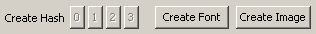
Figure 4.6-18 OpenScrape Create Font button

The “Create Font” button on the Table Map Editor window is used to create new font records. This button is only available if a Text transform is specified for the selected region record.

To create new font records:
- Select a Region record that has a text transform
- Ensure that the Region’s color parameters provide good separation of foreground and background pixels (preview in the Pixel Separation field)
- Click the “Create Font” button

Note: The number of the text transform in the region (Text0, Text1, Text2, or Text3) determines which Font record group (0 to 3) the new fonts will be added to.

Assuming that some of the pixels in the selected region represent unknown font characters, then the following window will appear when the “Create Font” button is clicked:

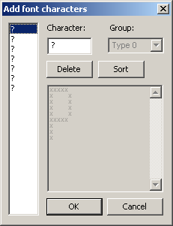
Figure 4.6-19 OpenScrape Add Font records window

On this window, a list of the individual font characters that OpenScrape thinks it has found is displayed in the list on the left side. As we have not told OpenScrape what character each of these pixel groups represent, they are displayed as question marks. (Note that the question mark can be considered a valid font character as well, so if you use this character in your Table Map, be aware of this fact).

For each unknown character in the list on the left, click to select it, then either:
- Enter which character is represents in the “Character” field (in this example, it is evident that the grouping of foreground pixels represents the capital letter P), or
- Click on the “Delete” button if this is not a character you want stored in the Table Map for some reason, such as it is a duplicate, or the automatic character separation didn’t work quite correctly

Clicking on the “Sort” button will arrange the characters alphabetically in the list, which might make them easier to process.

When you dismiss this window by clicking on the “OK” button, OpenScrape will add each of the characters in the list on the left, their ASCII representation, and their pixel layout to the list of Table Map records. This includes duplicates, and unknowns (question marks), so be sure to remove these prior to clicking “OK”, or your Table Map might get filled with superfluous Font records.

Fuzzy fonts
“Fuzzy fonts” are sometimes used by casinos when displaying text on their poker interfaces. You can identify if a casino uses fuzzy fonts by looking closely at the pixel patterns for individual characters as they are displayed at different times or in different locations on the screen. (Hint: use zoom) As an example, if when you look at the capital “A” character as it is displayed for seat 0’s name vs. seat 1’s name, you can see that those two letters use different pixels, of different colors, especially on the slanted arms of the “A”, you generally will need to use fuzzy font recognition.

The general procedure for defining fuzzy font records is as follows:
- Decide which fonts will be fuzzy, and create those in a different Font group from your other fonts (we will use group 1 “Text1” in this example). Fonts can be created with the font color defined as the foreground pixel color, or the background color as the foreground pixel color. In the case of the latter, the so-called inverse fonting may sometimes give better results. Experiment! If using the font color for the foreground pixel color, it is probably best to make the fonts as thick as possible using a large RGB color cube radius. If using the background color as the foreground pixel color, a radius of zero probably works best.
- Create a t1type Symbol record (for the Text1 group), and set the free-form text to "fuzzy" for default tolerance (25%), or to a specific tolerance value (0.50 for 50%, 0.33 for 33%, for example). Experiment to find the best tolerance – all casinos are different in how they display fuzzy fonts. If this symbol is set to anything besides "fuzzy" or a floating point value, then the engine will used non-fuzzy font recognition engine.
- You can also create multiple samples for various characters, and it will help. The numbers “6”, “8”, and “3”, for example, are similar enough that distinguishing fuzzy versions of these is difficult. Creating more font records (samples) for the various 6's, 8s and 3's will help with the recognition.

Technical Reference
In the Table Map (.tm) file, these records will be preceded with the characters "t$". Font records have the following format:

T<n>$<a> <x0> <x1> <x2> ... <x30>

<n> is the font group (0-3) that this font record belongs to
<a> is an actual printable (non-whitespace) case-sensitive ASCII character (note that the angle brackets <> are not used)
<x0> to <x30> are 32bit hexadecimal values that describe the foreground pixels for the character. The maximum individual character width is 31 pixels. These values describe the on-off state of the pixels for the character, with 1 meaning on (foreground) and 0 meaning off (background).

Hash Point Records

Description
The purpose of Hash Point records is to define the pixels within a region that are used in a hash calculation. The “Hash0” transform always uses all pixels in a region to calculate its hash, so these records are only relevant for regions that use “Hash1”, “Hash2”, or “Hash3” transforms.

There is a one to one correlation between the “Hash1”, “Hash2”, or “Hash3” transforms and the group 1, 2 and 3 Hash Point records. For example, a region that calls for a “Hash2” transform will use the pixels specified by the group 2 Hash Point records in the hash calculation.

The points defined for a Hash Point group must fall within the boundaries of the regions that you are calculating a hash for. Hash Points that fall outside of the region will be ignored, as they are invalid. For example, if you have card regions that are 10x20 pixels, then hash points (11,15) and (8,22) will be ignored, whereas hash points (5,5) and (9, 18) will be used in the hash calculation.

Manipulating hash point records using OpenScrape
- There are two ways to create new Hash Point records:

- Select the “Hash Points” category in the record tree display on the Table Map Editor window, and click the “New” button. A window will be displayed that allows you to enter the hash point group and the X and Y parameters:

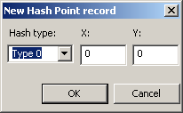
Figure 4.7-20 OpenScrape New Hash Point record – textual

- Somewhat less intuitively, but ultimately easier to use, is to select the “Hash Points” category in the record tree display on the Table Map Editor window, and click the “Edit” button. A window will be displayed that allows you to select the hash point group, a sample image, and then interactively define the Hash Points for that group:
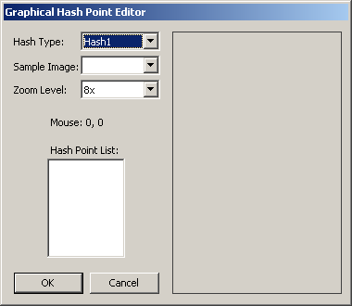
Figure 4.7-21 OpenScrape New Hash Point record – graphical

When you select a Hash Point group from the “Hash Type” control, the “Hash Point List” box will populate with all the Hash Points currently defined for that group. In this case, the box is empty, as we have not yet defined any Hash Point records for group 1.

After selecting an Image record in the “Sample Image” control (note you need to have Image records created first for this to work), the right side of the window will display that image and overlay the Hash Points for the selected group, like so:

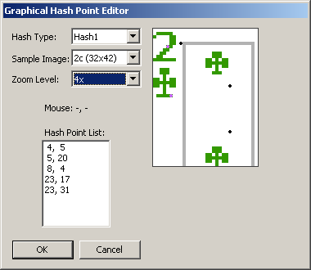
Figure 4.7-22 OpenScrape New Hash Point record – graphical with sample image

The zoom level of the sample image can be adjusted with the “Zoom Level” control. Adding Hash Points can be done interactively by left-clicking on the sample image where the point is needed. Right clicking on an existing point in the sample image will remove it from the group.

Clicking the “OK” button will then make the changes (adds and deletes) to the Table Map Hash Pointe record list.
- To edit an existing Hash Point record, select the record in the record tree display on the Table Map Editor window, and click the “Edit” button. A window will be displayed that allows you to edit the hash point group and the X and Y parameters.
- To delete an existing symbol record, select the record in the record tree display on the Table Map Editor window, and click the “Delete” button. A window will be displayed asking for verification of this action.
- An entire group of Hash Points can also be edited and/or deleted by selecting the “Hash Points” category in the record tree display on the Table Map Editor window, and clicking the “Edit” button. This will bring up the Graphical Hash Point Editor window, as described above.

Note: The Insert and Delete keys can also be used as a shortcut for adding and deleting individual Hash Point records.

Technical Reference
In the Table Map (.tm) file, these records will be preceded with the characters "p$". Hash point records have the following format:

p<n>$ <x> <y>

<n> is the group (1-3) that this hash point record belongs to
<x> and <y> are the coordinates of the point, relative to the region's rectangle, the top left corner of which is 0,0.

Hash Records

Description
The purpose of Hash Records is to allow for the rapid lookup of pixel patterns, without having to scan through each pixel in a region to find a match. For example, if we have a card region specified to use a “Hash0” transform, the screen scraper engine will first reduce the pixels in that region to a 32-bit hash value. (A link to Bob Jenkins’ hash algorithm that is used in this project can be found in the references section) Once the screen scraper engine has calculated the 32-bit hash value, it looks to see if there exists a matching 32-bit value in the associated group of Hash Records, in this example, group 0. If a matching 32-bit hash value is found, the screen scraper engine returns the <name> of the Hash Record to the game state engine.

Manipulating hash records using OpenScrape
Hash Records are created from specific Image records, so in order to create a Hash record, you must first have collected the associated Image record (see section {4.9}).

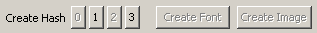
Figure 4.8-23 OpenScrape Create Hash Record buttons

The “Create Hash” buttons on the Table Map Editor window are used to create new Hash records. Button “0” creates Hash records in the Hash0 group, button “1” creates Hash records in the Hash1 group, and so on. These buttons are only available if an Image record has been selected in the tree display on the Table Map Editor window.

Note: Only one Hash record can exist in a Table Map in each hash group for any given Image record. Otherwise, there would be collisions, and the screen scraper engine would not know which Hash record was the correct match. In the “Create Hash Record buttons” screenshot above, Hash records for group 0 and 2 have already been created for the selected Image record, so those buttons are grayed out.

To create a new Hash records:
- Select an Image record
- Click the “Create Hash” button for the hash group that you want to create this Hash record in.

The following window will then appear to confirm the addition of the new Hash record:

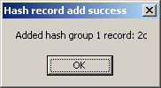
Figure 4.8-24 OpenScrape New Hash record confirmation

When you add a new Hash record with the “Create Hash” buttons, OpenScrape will calculate the hash value for you and add it to the record. (This is new behavior in 2.0; previous versions stored a zero hash value on new record creation) However, sometimes you may need to change that stored hash value, if for example, you replace the underlying Image record, or you change the number or location of the related Hash Points. If one or more hash values need to be updated, use the “Update Hashes” option on the Edit manu on the Main window, and the hash values on all Hash records will be re-calculated.

Technical Reference
In the Table Map (.tm) file, these records will be preceded with the characters "h$". Hash records have the following format:

h<n>$<name> <value>

<n> is the group (1-3) that this hash record belongs to
<name> is the string that is returned to the scraper engine upon a match (the “result”)
<value> is a 32bit hexadecimal value that contains the calculated hash

Image Records

Description
Image records serve multiple purposes. The first purpose is for regions that use the Image transform. When a region requires this type of lookup, the screen scraper engine will first look for an exact pixel-for-pixel image match in the Image records, and if no match is found, will then look for the closest match (with the 65% tolerance, as described in the Region Records {Technical Reference} section). The second purpose of the Image records is to serve as a reference from which Hash records are created (see the {Hash Records} section).
Note: Image transforms are very CPU intensive, as they require 2 passes through the Image records, the first to try to find an exact match, and the second to find a closest match. Each pass requires a comparison of every single pixel in the region. For large regions, this is a lot of comparisons. The time required to do Image transform lookups is directly proportional to the number of Image records present, and the size of the requesting Region record. It almost always makes more sense to use the Hash transform to do image matching, as the Hash lookup algorithm is orders of magnitude faster.

Manipulating image records using OpenScrape
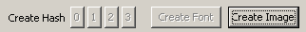
Figure 4.9-25 OpenScrape Create Image button

The “Create Image” button on the Table Map Editor window is used to create new Image records. This button is only available if a region record has previously been selected.

When the “Create Font” button is clicked, the following window will appear:

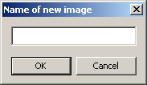
Figure 4.9-26 OpenScrape New Image Record window

The only required piece of information on this window is the name of the Image record, however, the name you choose is crucially important, as this name is what is returned to the game state engine directly for an Image transform, and is what is populated on the Hash record when you create a hash from this image.

The name is dependent on what the image is used for, but for example, if this is an image of the ace of clubs, you would want to name it “Ac”. If this is an image of a dealer button, you would want to name it “dealer”. (See the Region Records section, {Technical Reference}, for valid return values for each region)

Technical Reference
In the Table Map (.tm) file, these records will be preceded with the characters "i$". Image records have the following format:

i$<name> width height
scanline0
scanline1
...
scanlineN

<name> is the description of the image, and is the value returned to the screen scraper engine or is the name given to an associated Hash record
<width> and <height> are integer values that give the size of the image
<scanline0> - <scanlineN> contain the raw 32bit hexadecimal values for each pixel. Each pixel is in the form BBGGRRAA. There is no whitespace between pixel values. Each scanline is terminated with a standard Microsoft Windows line ending (carriage return/line feed). The number of scanline records is equal to the height of the image. The text length of a scanline record is width*8.

Creating the logic for your bot

Familiarizing yourself with OpenHoldem
So, here we are, 44 pages into the manual and we have not created a single snippet of bot logic yet. However, by this point you should have selected a target casino, and have acquired or created a Table Map for that casino so that the game state engine in OpenHoldem can understand what is happening on the poker table at any given time.

Before we get into the actual creation of bot logic, let’s explore the OpenHoldem interface.

Menu Options

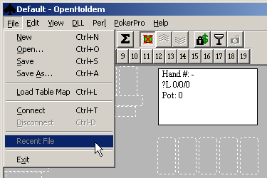
Figure 5.1-27 OpenHoldem File menu
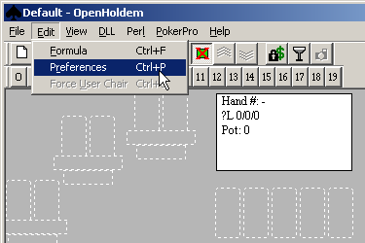
Figure 5.1-28 OpenHoldem Edit menu

The File menu contains the standard Windows options to open and save bot logic files. These logic files have the extension “.ohf”, for “OpenHoldem Formula”. There are also three OpenHoldem-specific options on this menu:
- Load Table Map: This option will force OpenHoldem to use a specific Table Map file and will override the automagic “Green Circle Button” method of connecting to poker tables.
- Connect and Disconnect: These options mirror the “Green Circle Button” and “Red Circle Button” on the main toolbar.

The Edit menu contains three options specific to OpenHoldem:
- Formula: This option will open the formula editor window – more information in the section {The Formula Editor}
- Preferences: This option will open a window to set various preferences for OpenHoldem’s operation.
- Force User Chair: This option will open a window allowing you to specify which seat at the table that OpenHoldem considers the “User Chair”. OpenHoldem usually autodetects the “User Chair” when card faces are seen in conjunction with action buttons, and this option will override that autodetection. This is probably only useful for testing purposes.

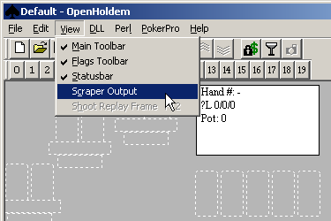
Figure 5.1-29 OpenHoldem View menu
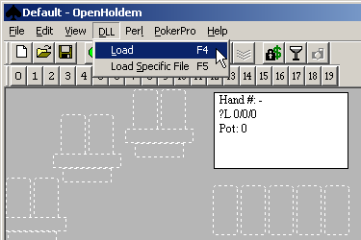
Figure 5.1-30 OpenHoldem DLL menu

The View menu has the standard Windows Toolbar/Status Bar options, plus two options specific to OpenHoldem:
- Scraper Output: This option opens a window that allows you to monitor the output from the screen scraper engine. This is useful for debugging purposes.
- Shoot Replay Frame: This option will save a “Replay Frame” in the “replay” folder in your OpenHoldem installation directory. See the {Replay Frames} section for more information.

The DLL menu is not a standard Windows menu item, but rather is used to load user-created DLL’s containing bot logic for use by the OpenHoldem decision and action engine. See the {User DLL} section for more information.
- Load: This option will load the DLL specified in Preferences, or in the Formula file.
- Load Specific File: This option will present a standard File Open window to allow you to select a specific DLL file that you want to load.

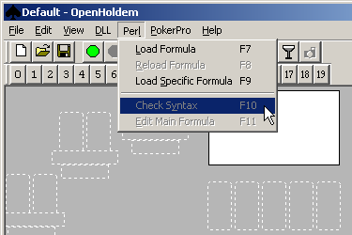
Figure 5.1-31 OpenHoldem Perl menu
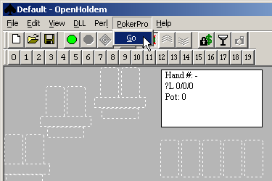
Figure 5.1-32 OpenHoldem PokerPro menu

The Perl menu is not a standard Windows menu item, but rather is used to load Perl files containing bot logic for use by the OpenHoldem decision and action engine. See the {Perl} section for more information.
- Load Formula: This option will load the Perl file specified in Preferences, or in the Formula file.
- Reload Formula: This option will re-load the Perl file specified in Preferences, or in the Formula file.
- Load Specific Formula: This option will present a standard File Open window to allow you to select a specific Perl file that you want to load.
- Check Syntax: This option will execute your Perl interpreters function to check the syntax of your Perl script.
- Edit Main Formula: This option will launch the editor specified in preferences and load it with your main Perl formula file.

The PokerPro menu is not a standard Windows menu item, but rather is used to connect OpenHoldem to a PokerPro server. PokerPro is an open server protocol designed by Ray Bornert. Full documentation on the PokerPro protocol can be found here: http://forum.winholdem.net/wbb/viewforum.php?f=22 More details can be found in the {PokerPro} section.
- Go: This option displays the PokerPro control window.

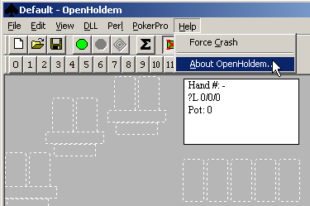
Figure 5.1-33 OpenHoldem Help menu

The Help menu has the standard Windows “About…” option, plus one option specific to OpenHoldem:
- Force Crash: This option will literally cause OpenHoldem to crash with an error. Specifically, the error is an assignment to a NULL pointer, like so:

int *invalid_memory_access = NULL;
*invalid_memory_access = 0;

This option is present primarily for one reason, to allow you to test how your automation system will handle an OpenHoldem crash, if it occurs. OpenHoldem is very stable, but as with all software, the occasional bug creeps in. Also, as OpenHoldem allows the use of user-defined code (via DLLs, Perl scripts, etc), misbehaved user defined code can also cause crashes. See the chapter on {Automation} for more information.

Toolbars
Figure 5.1-34 OpenHoldem Main toolbar

From left to right, the buttons on the Main toolbar are:
- New formula file
- Open formula file
- Save formula file
- Connect to table (Green circle) – More information in the section {How the “Green Circle Button” finds tables}
- Disconnect from table (Red circle)
- Engage The Autoplayer (Nested diamonds)
- Formula editor (Sigma button) – More information in the section {The Formula Editor}
- Show/Hide table display (Green felt with red “X”)
- Attach to top of poker window (3 “Up” chevrons)
- Attach to bottom of poker window (3 “Down” chevrons)
- Lock blinds (Padlock and dollar symbol) – More information in the section {Locking Blinds}
- View scraper output (Paint scraper – this is NOT a wine glass!)
- Shoot replay frame (Camera) – More information in the section {Replay Frames}

Figure 5.1-35 OpenHoldem Flags toolbar

The Flags toolbar is used to set internal OpenHoldem flag symbols to on or off. See the {OH-Script} section for discussion on the use of the flags symbols.

Status Bar
Figure 5.1-36 OpenHoldem Status Bar

From left to right, the fields on the Status Bar are:
- “Ready” – This is a standard Windows indicator to communicate application activity – for OpenHoldem it is always “Ready”.
- Your hole cards
- The common (board) cards
- Your poker hand
- The strength of your hole cards – the numerator of this field is set in preferences and can be one of 169, 1326 or 2652.
- Current values for prwin/prtie/prlos – More information in the section {The Iterator}
- Current value of f$P, one of the standard formula functions. This formula is intended to indicate number of opponents, however this number can be more or less than the number of opponents actually seen on the table at any given time. More information on f$P can be found in the {Primary Functions} section.
- Progress of the Monte Carlo iterator – the denominator of this field is drawn from your formula’s settings. See {The Formula Editor} section for more information on setting this number, and see the section {The Iterator} for more information on the Monte Carlo iterator.
The current action that the decision engine thinks the Autoplayer should take, based on the logic defined in your formula – see {Weighted prwin} section for more information on the Autoplayer.

Table Display
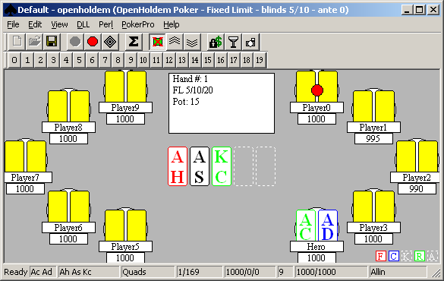
The OpenHoldem table display is intended to give you a quick visual reference as to what the screen scraper engine is actually seeing on the poker table at any given time. In this screen shot, OpenHoldem is connected to a ManualMode window. See the {ManualMode} section for more information on ManualMode.

The standard poker table information is presented in this display, including your hole cards, opponents’ cardbacks, common cards, players’ names and balances, the location of the dealer button, player bets and player seated/active status. If a player is seated, there will be a black circle displayed behind that players’ card frames. If a player is also active, that black circle will be filled in with white.

The FCKRA boxes on the bottom right indicate the status of the Fold, Call, Check, Raise and Allin buttons; colored means those buttons are seen as ready to be clicked, and white dotted outlines means they are not seen as ready to be clicked.

The center information box contains various other information, including the hand number, limit type and limits, ante and current pot value.

The Formula Editor
When the “Edit/Formula” menu option is selected, or the “Sigma” button on the main toolbar is clicked, the following window is opened:
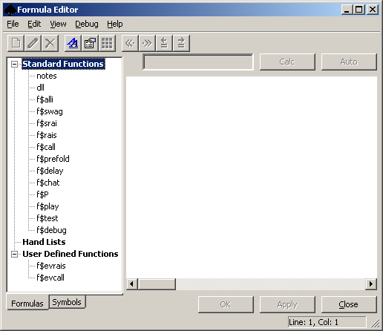
Figure 5.6-37 OpenHoldem Formula Editor

On the left side of this window is a tree (“Formulas”) that allows you to select the various functions that are present in your loaded formula file. Regardless of the language that you use for your bot logic, OH-script, C++ or Perl, the functions you see in the screenshot above will be present in every formula file, as these functions are central to how you instruct OpenHoldem to make poker decisions.

This tree also has a second tab (“Symbols”) that is built in documentation for all the OH-script language functions. See the {OH-Script} section for more information on this language.

The large control on the right side of the window displays the code for whatever function you have currently selected in the tree on the left.
Note: This window in the Formula Editor uses the open source “Scintilla Editor” component to display and allow editing of the selected funciton. More information on this component can be found here: http://www.scintilla.org

Above this Scintilla editor control are a “results” field, and a “Calc” and an “Auto” button. The “Calc” button will calculate the currently selected function and display the results in the “results” field. The length of time in seconds that it takes to calculate this function is added to the titlebar text of the Formula Editor window in square brackets. The “Auto” button is only available when the “f$debug” function is selected, and will cause the information displayed in the Scintilla editor control to be updated once every screen scrape cycle.

Below the Scintilla editor control are “OK”, “Apply” and “Close” buttons that mirror the functionality of the File menu options, and the toolbar buttons as described below.

Primary Functions
The following table describes the primary functions. These functions are “primary”, because they directly instruct the Autoplayer to take poker actions, such as going all-in, raising, checking, calling or folding. For more information on the Autoplayer’s processing logic, please see this section {Weighted prwin}.

Function | Description
f$alli | This function instructs the Autoplayer to move all-in, either with the slider, or by entering the bet into the SWAG box, depending on the parameters in the Table Map. If this function evaluates to a non-zero result, and an appropriate control is present on the table (slider, swag field), then the Autoplayer will move all in.
f$swag | This function instructs the Autoplayer to place a stated wager (SWAG) by entering the bet into the SWAG box. If this function evaluates to a non-zero result, and the SWAG box is present on the table, then the Autoplayer will enter the results of f$swag into the SWAG box and confirm the bet.
f$rais | This function instructs the Autoplayer to raise. If this function evaluates to a non-zero result, and the raise button is present on the table, then the Autoplayer will click the raise button.
f$call | This function instructs the Autoplayer to call. If this function evaluates to a non-zero result, and the call button is present on the table, then the Autoplayer will click the call button.

Secondary Functions
The following table describes the secondary functions. These are secondary, because they do not directly instruct the Autoplayer to take action, but rather are used indirectly to determine the action, some of which are not the traditional poker actions of all-in, raising, checking, calling or folding.

Function | Description
f$P | This function is intended to evaluate to the number of opponents that should be simulated when OpenHoldem calculates various symbols.  The symbols influenced by this function are those calculated by the Iterator (see {The Iterator} section}, prwin, prlos, and prtie, and also by the symbols prwinnow, prlosnow, and handrankp.  The f$P value is important to these symbols because it determines how many opposing hands are simulated. The f$P value will radically affect the values of these symbols. For example, the higher the f$P value the more opponent hands will be simulated and your win probability will be lower. Similarly, the lower the f$P value the less opponent hands will be simulated and your win probability will be higher. For instance, AA against 9 opponents (f$P==9) has about a 30% chance of winning, assuming every hand stays for the showdown (no-foldem). AA against 1 opponent (P=1) has about an 80% chance of winning.  The possible values for f$P are 0 to 22, inclusive. If f$P exceeds 22, it will be set to 22, as 22 is the maximum number of players our imaginary HoldEm table would be able to play (22 opponents * 2 cards = 44 cards, my two cards, the 5 common cards).
f$srai | This function is a support function for f$swag. The intent is that f$srai specifies the amount to raise above the current bet, and that f$swag then further adjusts that based on the style that the individual casino uses to post SWAG bets. Here is an example of a vanilla f$swag function that calls f$srai:  ##f$swag##  f$srai>0 ? ((((f$swag_adjust + f$srai)/sblind)+.5)^0)*sblind :  0  ##f$swag_adjust##  swagtextmethod == 3 ? (call + currentbet) :  swagtextmethod == 2 ? (call) :  0  Note that this f$swag also rounds your bet to the nearest sblind.
f$prefold | If this function evaluates to non-zero, and a pre-fold button is visible on the poker table window (as defined in the Table Map), then OpenHoldem will engage that pre-fold button as soon as it can (which may be before it is your turn to act).  A good example of a f$prefold function might be the following:  br==1 && nplayersdealt>4 && handrank2652>2652*0.66 && !currentbet && !f$swag && && !f$rais && !f$call
f$delay | The function controls how long to delay, once the specified number of stable frames have been seen (see {Preferences} section}, to take a poker action. The function evaluates to the delay time in milliseconds.  An example of this might be:  f$monsterhand ? randomround * 3000 : 0)  This function says that if f$monsterhand returns true, to randomly delay the Autoplayer’s action from zero to three seconds, otherwise it will not delay at all.
f$chat | This function directs the OpenHoldem Autoplayer when and what to enter into the casino client’s chat box. See the {Before you try to configure OpenHoldem to work with a Poker Tracker database, you must have a properly working Poker Tracker configuration set up first. This is not the most trivial of activities, and does have a learning curve. The best information on how to set up Poker Tracker can be found here: http://www.pokertracker.com } section for more information.
f$play | This function controls how the Autoplayer interacts with the sitin, sitout, and leave buttons as defined in the Table Map.  The possible values that this function can return are explicit and limited. Any other return values are ignored. The allow return values and their meaning are:  -2, Leave table  -1, No change (if you are sitting out, stay out, if sitting in stay that way)  0, Sit out  1, Sit in/Stay in
f$evrais | This function is a support function for f$rais. The intent is that f$evrais calculates the “Expected Value” of a raise action, and this value is then used in the f$rais decision function. This is generally considered a legacy function from WinHoldem, and is provided here for legacy compatibility reasons.
f$evcall | This function is a support function for f$call. The intent is that f$evcall calculates the “Expected Value” of a call action, and this value is then used in the f$call decision function. This is generally considered a legacy function from WinHoldem, and is provided here for legacy compatibility reasons.

Helper Functions
The following table describes the helper functions. These are not used by the Autoplayer.

Function | Description
notes | This is a free form function for you to use as you please. This is typically used for usage instructions and version notes.
dll | Contains a filename or path to a DLL to load by default. For example:  my_user_dll.dll
f$test | This function is intended to be used to test expressions. Whatever is typed in here gets calculated as a whole when the "Calc" button is clicked. f$test can be referenced from other formulas, although that is not recommended, as f$test is really intended as a development/debugging aid.
f$debug | The debug function operates differently than the other function. Its purpose is to allow for arbitrary expressions to be evaluated and the results of those expressions to be displayed. To add a new expression add a new line with an equal sign, followed by the expression.  For example:  = 2+2  = f$UserDefinedFormula  = nopponents  In order for the results to be displayed you must either press the 'Calc' or 'Auto' button. The 'Auto' button will recalculate the debug formula once each heartbeat.  For example:  4 = 2+2  1 = f$UserDefinedFormula  6 = nopponents  If an expression is invalid it will be reported where the result would normally be found.

Menu Options
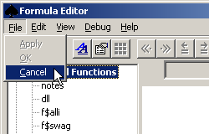
Figure 5.11-38 Formula Editor - File menu

The File menu has three options to control how changes made to your formula are applied back to the production formula:
- Apply: Copy changes made to the working formula to the production formula and keep the Formula Editor window open
- OK: Copy changes made to the working formula to the production formula and close the Formula Editor window
- Cancel: Discard changes made to the working formula and close the Formula Editor window

Note: When you open the Formula Editor, OpenHoldem makes a copy of the formula that you currently have loaded for use in the Formula Editor. Consider the formula that you loaded with File/Open, from the main OpenHoldem window, to be the “production” formula, and the copy that got made when you opened the Formula Editor to be the “working” formula. Keep in mind that the OpenHoldem Autoplayer ONLY operates on the production formula, and the Formula Editor ONLY operates on the working formula. The Apply/OK/Cancel options allow you to put changes back to the production formula that you made in the working formula. However, both the production and the working formulas draw from the same set of scraper engine output and calculated symbols.

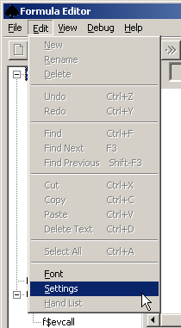
Figure 5.11-39 Formula Editor - Edit menu

The Edit menu has a number of options:
- New, Rename, Delete: These options are enabled/disabled depending on the function group or function that is selected. For example, User Defined Functions (UDFs) are only able to be created (with “New”) in the user Defined Functions group, and Standard functions cannot be deleted or renamed. If the Hand List group is selected, these options will all you to create, rename or delete Hand Lists as well. OpenHoldem supports 1000 different hand lists, numbered from list0 to list999.
- Undo, Redo, Find, Cut, Copy, Paste, Delete Text, Select All: These are all standard Windows menu items that operate in the standard way.
- Font: This menu option opens the standard Windows font selector dialog to allow you to select the font to display in the Scintilla editor window.
- Settings: This opens a window that allows you to set the Bankroll, Defcon, NIT, and Rake parameters of the formula file. These settings can be used in your formulas, and are referenced by some symbols.
- Hand List: When a Hand List is selected, this will open the Hand List Editor window so you can specify which starting hands belong in the selected Hand List. See the {Hand Lists} section for more information.

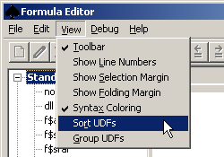
Figure 5.11-40 Formula Editor - View menu

The View menu has the standard Windows toolbar option, plus several OpenHoldem specific options:
- Show Line Numbers, Show Selection Margin, Show Folding Margin, and Syntax Coloring provide access to features of the Scintilla Control. See http://www.scintilla.org for more information.
- Sort UDFs and Group UDFs allow for grouping and sorting of User Defined Functions that you create. These options simply allow for ease of navigation, especially for formulas with large numbers of UDFs.

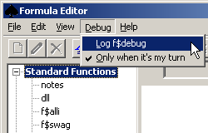
Figure 5.11-41 Formula Editor - Debug menu
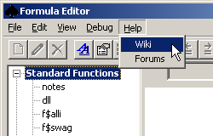
Figure 5.11-42 Formula Editor - Help menu

The Debug menu has options to control logging of the contents of the the f$debug function to a file. If the “Log f$debug” menu option is checked, and the "Auto" button is depressed, then OpenHoldem will write the entire contents of the f$debug function to a “f$debug*.log” file once per screen scrape cycle. The entire f$debug tab is written in comma-delimited format to a single line in the file. If the “Only when it’s my turn” option is checked, then the contents of f$debug are only written when the user chair has card faces and action buttons are present.

The Help menu provides links to the OpenHoldem Wiki and to the OpenHoldem discussion forums.

Toolbar
Figure 5.11-43 OpenHoldem Formula Editor toolbar

From left to right, the buttons on the Main toolbar are:
- New function/hand list (empty document)
- Rename function/hand list (pencil)
- Delete function/hand list (big X)
- Open the Windows font selection dialog (two blue letter As)
- Open the Formula Parameters window (hand pointing at a document)
- Open the Hand List Editor window (9 squares)
- Increase or decrease decimal precision (double arrow with a decimal point) – these two buttons are only valid when the f$debug function is selected, and control the number places that are displayed after the decimal point.
- Increase of decrease space for results (arrow with equal sign) – these two buttons are only valid when the f$debug function is selected, and control how much space is provided between the left hand side of the display and the equals sign, to allow more or less space to display results.

OH-Script

The Scripting Language
Introduction
OpenHoldem's scripting language is very similar to the C programming expression syntax. If you already know and understand C programming then you have an advantage in that the OH scripting language should be very familiar. This section is largely based off of Ray Bornert's original WinHoldem "C-tutorial" here: http://www.winholdem.net/help/help-c.html

Syntax
The general syntax for OpenHoldem formulas is same as that of the C programming language. However, the formulas are strict R-VALUES (right side of an assignment expression), meaning that there is no assignment operator. All values are stored as (double) floating point values on the expression stack. For bitwise operations the values are first converted to integer values and then the operator is applied.

Boolean Logic
A boolean expression is composed of logical operators (not, and, or, xor) and operands. All boolean operands have only two values - true and false. Each logical operand has a very well defined operation upon the operand(s) in the expression, with a very well defined result. When any numeric value is used in conjunction with a logical operator, any zero values are considered to be false (0) and any non-zero values are considered to be true (1). If the numeric value in question is not zero then it is considered to be true for boolean purposes.
Reams of material have been written on boolean logic. Example: http://en.wikipedia.org/wiki/Boolean_logic

Operators
These operators are listed in order of precedence
Category | Operator(s) | Associativity
Exponentiation | ** ln (not standard ANSI C) | Right to Left
Unary | ! ~ - ` | Right to Left
Multiplicative | * / % | Left to Right
Additive | + - | Left to Right
Bitwise Shift | << >> | Left to Right
Relational | < > <= >= | Left to Right
Equality | == != | Left to Right
Bitwise AND | & | Left to Right
Bitwise XOR | ^ | Left to Right
Bitwise OR | pipe (above forward slash on U.S. keyboard) | Left to Right
Logical AND | && | Left to Right
Logical XOR | ^^ (not standard ANSI C) | Left to Right
Logical OR | double pipe (above forward slash on U.S. keyboard) | Left to Right
Conditional | ?: | Right to Left
Group | () [] {} (not standard ANSI C) | Left to Right

Exponentiation
Power ** (not ANSI-C)
a ** b
Standard algebraic exponentiation on a and b.
a is raised to the power of b.

Natural Log ln (not ANSI-C)
ln a
Standard algebraic natural log of a
a == e ** (ln a)

Natural Log Base e (not ANSI-C)
e == ln(1)
e == 2.71828182845905

Unary
A unary operator takes a single operand.

Logical NOT !
False when the operand is true. True when the operand is false.
a | !a
false | true
true | false
0 | 1

Bitwise NOT ~
Logical NOT operation on a bit by bit basis.
expression | binary result
a | 11001001011101010110010101111010
~a | 00110110100010101001101010000101

Negation -
A good example is the minus sign when it is used to alter the sign of a value. Example: "a + b / -4" The minus sign in front of the 4 is a unary minus.

Bit Count ` (not ANSI-C)
Provides a count of the number of bits set in any integer value. Here are 3 examples of the number of bits that are set in some 32-bit integer numbers.
a | `a
0000000000000000000000000000000 | 0
0000000000000100000000000000000 | 1
0000010000000100000000000010000 | 3
1111111111111111111111111111111 | 32

Multiplicative
Multiply *
a * b
Standard algebraic multiplication on a and b.

Divide /
a / b
Standard algebraic division on a and b.

Modulo %
a % b
Standard algebraic modulo on a and b.

Additive
Add +
a + b
Standard algebraic addition on a and b.

Subtract -
a - b
Standard algebraic subtraction on a and b.

Bitwise Shift
Bitwise Shift Left <<
Slides the entire bit pattern to the left by N bits. Note that the leftmost bits are simply dropped and that the rightmost bits are filled with 0's. The shift magnitude is used as modulo 32, meaning that any shift N that is specified in excess of 32 bits has a N%32 operation performed prior to the shift.
expression | binary result
a | 11001001011101010110010101111010
a<<1 | 10010010111010101100101011110100
a<<7 | 10111010101100101011110100000000
a<<31 | 00000000000000000000000000000000
a<<32 | 11001001011101010110010101111010

Bitwise Shift Right >>
Slide the entire bit pattern to the right by N bits. Note that the rightmost bits are dropped and that the leftmost bits are filled with the leftmost bit of the operand. The shift magnitude is used as modulo 32, meaning that any shift N that is specified in excess of 32 bits has a N%32 operation performed prior to the shift.
expression | binary result
a | 11001001011101010110010101111010
a>>1 | 11100100101110101011001010111101
a>>7 | 11111111100100101110101011001010
a>>31 | 11111111111111111111111111111111
a>>32 | 11001001011101010110010101111010
a | 01001001011101010110010101111010
a>>1 | 00100100101110101011001010111101
a>>7 | 00000000100100101110101011001010
a>>31 | 00000000000000000000000000000000
a>>32 | 01001001011101010110010101111010

Relational
Less Than <
a | b | a < b
-1 | 0 | true
0 | 0 | false
+1 | 0 | false

Greater Than >
a | b | a > b
-1 | 0 | false
0 | 0 | false
+1 | 0 | true

Less Than Or Equal <=
a | b | a <= b
-1 | 0 | true
0 | 0 | true
+1 | 0 | false

Greater Than or Equal >=
a | b | a >= b
-1 | 0 | false
0 | 0 | true
+1 | 0 | true

Equality
Equal ==
a | b | a == b
-1 | 0 | false
0 | 0 | true
+1 | 0 | false

Not Equal !=
a | b | a != b
-1 | 0 | true
0 | 0 | false
+1 | 0 | true

Bitwise AND &
Logical AND operation on a bit by bit basis.

expression | binary
a | 11001001011101010110010101111010
b | 01001010010100101110001010101111
a&b | 01001000010100000110000000101010

Bitwise OR |
Logical OR operation on a bit by bit basis.

expression | binary
a | 11001001011101010110010101111010
b | 01001010010100101110001010101111
b | 11001011011101111110011111111111

Bitwise XOR ^
Logical XOR operation on a bit by bit basis.

expression | binary
a | 11001001011101010110010101111010
b | 01001010010100101110001010101111
a^b | 10000011001001111000011111010101

Logical AND &&
False when any operand is false. True when both operands are true.

a | b | a && b
false | false | false
false | true | false
true | false | false
true | true | true

Logical XOR ^^ (not ANSI-C)
False when operands are boolean equal. True when operands are not boolean equal. Note that "a^^b" is equivalent to "(a!=0)^(b!=0)".

a | b | a ^^ b
false | false | false
false | true | true
true | false | true
true | true | false

Logical OR ||
False when both operands are false. True when any operand is true.

a | b | a || b
false | false | false
false | true | true
true | false | true
true | true | true

Conditional ?:
Standard algorithmic if then else. "a ? b : c" means "If a then b else c"

a | b | c | a ? b : c
true | any | any | b
false | any | any | c

Grouping Operators ()[]{}
Note that [] and {} are not ANSI-C.

These grouping operators are used to either visibly separate sections of your code for readability and maintainability purposes, or to affect the precedence of logical operation. Note that unlike WinHoldem's grouping syntax, there is no limitation on how the various grouping operators can be nested.

Numeric Constants
Floating point constants

All numeric constants are treated internally as double floating point values in base 10.
Floating Point Numeric Constants
123.456
0.987
192837465
.5
17.
5.4321e-76

Integer constants
There are 4 integer options available as well that allow you to select the base of the constant. The 4 available bases are: 16, 8, 4, 2. Prefixing a numeric constant with a zero followed by a letter (see table below) will specify the numeric base of the constant.

Letter | Base | Name
x | 16 | Hex
o | 8 | Octal (non-standard ANSI C)
q | 4 | Quadal (non-standard ANSI C)
b | 2 | Binary (non-standard ANSI C)

Examples:
Decimal | Hex | Octal | Quadal | Binary
0 | 0x0 | 0o0 | 0q0 | 0b0
1 | 0x1 | 0o1 | 0q1 | 0b1
2 | 0x2 | 0o2 | 0q2 | 0b10
3 | 0x3 | 0o3 | 0q3 | 0b11
4 | 0x4 | 0o4 | 0q10 | 0b100
5 | 0x5 | 0o5 | 0q11 | 0b101
6 | 0x6 | 0o6 | 0q12 | 0b110
7 | 0x7 | 0o7 | 0q13 | 0b111
8 | 0x8 | 0o10 | 0q20 | 0b1000
9 | 0x9 | 0o11 | 0q21 | 0b1001
10 | 0xa | 0o12 | 0q22 | 0b1010
11 | 0xb | 0o13 | 0q23 | 0b1011
12 | 0xc | 0o14 | 0q30 | 0b1100
13 | 0xd | 0o15 | 0q31 | 0b1101
14 | 0xe | 0o16 | 0q32 | 0b1110
15 | 0xf | 0o17 | 0q33 | 0b1111
16 | 0x10 | 0o20 | 0q100 | 0b10000
31 | 0x1f | 0o37 | 0q133 | 0b11111
63 | 0x3f | 0o77 | 0q333 | 0b111111
127 | 0x7f | 0o177 | 0q1333 | 0b1111111
255 | 0xff | 0o377 | 0q3333 | 0b11111111

Calculated Symbols
This section is largely based on the information originally written by Ray Bornert and extended to include OpenHoldem-specific symbols. See here for the original WinHoldem symbols page: http://www.winholdem.net/help/help-formula.html#symbols

These symbols take output from the scraper engine, from Table Map parameters, and from your formula functions to derive various bits of data that are useful when instructing the OpenHoldem Autoplayer how to act.

General
Symbol | Meaning
ismanual | true if you're in manual mode, false otherwise
isppro | true if you're connected to a ppro server
site | 0=user/ppro 1=scraped
nchairs | the integer value for the Table Map symbol s$nchairs
isbring | true if OpenHoldem is attached to a Bring client window
session | the current logging instance (0-9)
handnumber | the site hand number if available
version | returns the version number of OpenHoldem that is currently running

Table Map
Symbol | Meaning
sitename$abc | true if user defined string “abc” appears within the Table Map symbol s$sitename
network$def | true if user defined string “def” appears within the Table Map symbol s$network
swagdelay | Autoplayer delay in milliseconds between swag keystrokes and button click
allidelay | Autoplayer delay in milliseconds between alli slider jam and button click
swagtextmethod | the site interpretation for swag edit text (Table Map symbol) 1=f$srai 2=f$srai+call 3=f$srai+call+currentbet

Formula file
Symbol | Meaning
rake | percentage amount added/subtracted to/from the pot
nit | number of iterations used to calculate the prwin/prtie/prlos and associated symbols. For an analysis of how many iterations to use, see this section: {Iterations and Standard Deviation}
bankroll | the user defined, real world bankroll

Limits
Symbol | Meaning
bblind | the big blind amount
sblind | the small blind amount
ante | the current pre-deal ante requirement
lim | the current table limit 0=NL 1=PL 2=FL
isnl | (lim==0)
ispl | (lim==1)
isfl | (lim==2)
sraiprev | the difference between the two largest unique wagers
sraimin | Scraped - (currentbet+call); PokerPro - the greater of bet and the current raise
sraimax | balance-call
istournament | true if a tournament table is detected

Hand Rank
Symbol | Meaning
handrank | one of the following based on the option specified in preferences
handrank169 | your pocket holdem hand rank 1-169
handrank2652 | your pocket holdem hand rank 12-2652
handrank1326 | your pocket holdem hand rank 6-1326 (handrank2652/2)
handrank1000 | your pocket holdem hand rank 4-1000 (1000*handrank2652/2652)
handrankp | 2652 / (1+nopponents)

Chairs
Symbol | Meaning
chair | your chair number 0-9 ... 0 is usually top right
userchair | user chair number (0-9)
dealerchair | dealer chair number (0-9)
raischair | raising chair number (0-9)
chair$abc | player “abc” chair number (0-9); -1 if not found
chairbit$abc | player “abc” chairbit (1 << chair$abc); 0 if not found

Rounds / Positions
Symbol | Meaning
betround | betting round (1-4) 1=preflop, 2=flop, 3=turn, 4=river
br | abbreviation for betround
betposition | your bet position (1=sblind,2=bblind,...,nplayersdealt=dealer); betposition will change as players fold in front of you.
dealposition | your deal position (1=sblind,2=bblind ... nplayersdealt=dealer); dealposition will not change as players fold
originaldealposition | a memory of deal position which retains its value through the hand, even if the user folds
callposition | your numbered offset from the raising player (who is 0)
seatposition | your seat position relative to the dealer
dealpositionrais | the deal position of the raising player (1-10)
betpositionrais | the bet position of the raising player (1-10)

Probabilities
Symbol | Meaning
prwin | the probability of winning this hand (0.000 - 1.000)
prlos | the probability of losing this hand (0.000 - 1.000)
prtie | the probability of pushing this hand (0.000 - 1.000)
prwinnow | probability that all opponents have a lower hand right now
prlosnow | probability that any opponents have a higher hand right now
random | random number between (0.000-1.000). Value is recalculated each time symbol appears in formula.
randomhand | random number between (0.000-1.000) for the hand. Value is calculated only once per hand.
randomround | random number between (0.000-1.000) for the current round. Value is calculated only once in current round.
randomround1 - randomround4 | random number between (0.000-1.000) for round 1 - 4. Value is calculated only once in that round.

Statistics
The symbols to calculate risk of ruin have never been implemented due to lack of documentation and lack of practical relevance. As of OpenHoldem 2.0.0 the risk-of-ruin-symbols are officially abolished and removed from the code-base.
The original documentation for these symbols can be found here:
WinHoldEm Help - Formula Editor
WinHoldem-Forum: Risk Of Ruin

Formulas
Symbol | Meaning
f$name | reference the specified standard or user defined function

f$P Formula
Symbol | Meaning
defcon | defense level is typically used in the f$P formula and determines the number of analyzer opponents (0.000=maxoffense 1.000=maxdefense) (the Formula Editor parameters dialog uses values 0-10)
isdefmode | true when defcon is at max
isaggmode | true when defcon is at min

Chip Amounts
Symbol | Meaning
balance | your balance
balance0 - balance9 | specific player/chair balance
stack0 - stack9 | sorted playersplaying balances from 0=biggest to 9=smallest
currentbet | your current amount of chips in play
currentbet0 - currentbet9 | specific player/chair currentbet
call | the amount you need to call
bet | the amount of a single initial bet or raise for current round
bet1 - bet4 | the amount of a single initial bet or raise for round 1 - round 4
pot | the total amount of chips in play including player bets
potcommon | the total amount of chips in the middle
potplayer | the total amount of chips in front of all players
callshort | total amount that will be added to the pot if all players call
raisshort | callshort + bet * nplayersplaying

Number of Bets
Symbol | Meaning
nbetstocall | total number of additional bets required to call.
nbetstorais | total number of additional bets required to raise.
ncurrentbets | total number of bets currently in front of you.
ncallbets | total number of bets you would have on the table if you call
nraisbets | total number of bets you would have on the table if you raise

List Tests
Symbol | Meaning
islist0 - islist999 | true if your hand is in the numbered (0-999) list
islistcall | true if your hand is in list 0
islistrais | true if your hand is in list 1
islistalli | true if your hand is in list 7
isemptylistcall | true if the call list is empty
isemptylistrais | true if the rais list is empty
isemptylistalli | true if the alli list is empty
nlistmax | highest list number in which your hand is listed
nlistmin | lowest list number in which your hand is listed

Poker Values
Symbol | Meaning
pokerval | absolute poker value for your 5 card hand
pokervalplayer | absolute poker value for your 2 card pocket hand only
pokervalcommon | absolute poker value for the common cards
pcbits | bit list of where your pocket cards are used in your 5 card hand
npcbits | number (0-2) of your pocket cards used in your 5 card hand

Poker Value Constants
Symbol | Meaning
hicard | 1<< 0 (2 ** 0)
onepair | 1<<24 (2 ** 24)
twopair | 1<<25 (2 ** 25)
threeofakind | 1<<26 (2 ** 26)
straight | 1<<27 (2 ** 27)
flush | 1<<28 (2 ** 28)
fullhouse | 1<<29 (2 ** 29)
fourofakind | 1<<30 (2 ** 30)
straightflush | 1<<31 (2 ** 31)
royalflush | 0x800edcba
fiveofakind | 0xff000000

Hand Tests
Symbol | Meaning
$CCc | references a hand symbol - see the {Hand Symbols} section below for details
$$AB# | references a card symbol - see the {Card Symbols} section below for details
ishandup | true if your hand has gone up a level (i.e. from 1 pair to 2 pair)
ishandupcommon | true if common hand has gone up a level (i.e. from 1 pair to 2 pair)
ishicard | true when you have hicard hand
isonepair | true when you have one pair
istwopair | true when you have two pair
isthreeofakind | true when you have three of a kind
isstraight | true when you have a straight
isflush | true when you have a flush
isfullhouse | true when you have a full house
isfourofakind | true when you have four of a kind
isstraightflush | true when you have a straight flush
isroyalflush | true when you have a royal flush
isfiveofakind | true when you have a five of a kind

Pocket Tests
Symbol | Meaning
ispair | true when your two dealt pocket cards are rank equal (0-1)
issuited | true when your two dealt pocket cards are suit equal (0-1)
isconnector | true when your two dealt pocket cards are rank adjacent (0-1)

Pocket / Common Tests
Symbol | Meaning
ishipair | true when you have hi pair (0-1)
islopair | true when you have lo pair (0-1)
ismidpair | true when you have mid pair (0-1)
ishistraight | true when you have the highest straight possible
ishiflush | true when you have the highest flush possible

Players, Friends, Opponents
Note that the "friends" symbols are not interpreted the same way as they are in WinHoldem. OpenHoldem does not include any automated collusion capabilities, and thus "friends" has been redefined in OpenHoldem to mean “you” only. Thus if you are seated, nfriendsseated will resolve to 1. If you are not seated, nfriendsseated will resolve to zero.
Symbol | Meaning
nopponents | f$P function value for the Iterator
nopponentsmax | maximum allowable value for nopponents (1-22 default=9)
nplayersseated | number of players seated (including you) (0-10)
nplayersactive | number of players active (including you) (0-10)
nplayersdealt | number of players dealt (including you) (0-10)
nplayersplaying | number of players playing (including you) (0-10)
nplayersblind | number of players blind (including you) (0-10)
nfriendsseated | 1 if you are seated, 0 otherwise (0-1)
nfriendsactive | 1 if you are active, 0 otherwise (0-1)
nfriendsdealt | 1 if you are dealt, 0 otherwise (0-1)
nfriendsplaying | 1 if you are playing, 0 otherwise (0-1)
nfriendsblind | 1 if you are in a blind, 0 otherwise (0-1)
nopponentsseated | number of opponents seated (not including you) (0-9)
nopponentsactive | number of opponents active (not including you) (0-9)
nopponentsdealt | number of opponents dealt (not including you) (0-9)
nopponentsplaying | number of opponents playing (not including you) (0-9)
nopponentsblind | number of opponents blind (not including you) (0-9)
nopponentschecking | number of opponents playing with a zero current bet equal to the previous bettor (0-9)
nopponentscalling | number of opponents playing with a non-zero current bet equal to the previous bettor (0-9)
nopponentsraising | number of opponents playing with a current bet greater than the previous bettor (0-9)
nopponentsbetting | number of opponents playing with a non zero current bet (0-9)
nopponentsfolded | number of opponents that have folded this hand (0-9)
nplayerscallshort | number of players that must call to stay in the hand
nchairsdealtright | number of chairs dealt before your chair
nchairsdealtleft | number of chairs dealt after your chair
playersseatedbits | bits 9-0: 1=seated 0=unseated
playersactivebits | bits 9-0: 1=active 0=inactive
playersdealtbits | bits 9-0: 1=dealt 0=notdealt
playersplayingbits | bits 9-0: 1=playing 0=notplaying
playersblindbits | bits 9-0: 1=blind 0=notblind
opponentsseatedbits | bits 9-0: 1=seated 0=unseated
opponentsactivebits | bits 9-0: 1=active 0=inactive
opponentsdealtbits | bits 9-0: 1=dealt 0=notdealt
opponentsplayingbits | bits 9-0: 1=playing 0=notplaying
opponentsblindbits | bits 9-0: 1=blind 0=notblind
friendsseatedbits | bits 9-0: 1=seated 0=unseated, you only
friendsactivebits | bits 9-0: 1=active 0=inactive, you only
friendsdealtbits | bits 9-0: 1=dealt 0=notdealt, you only
friendsplayingbits | bits 9-0: 1=playing 0=notplaying, you only
friendsblindbits | bits 9-0: 1=blind 0=notblind, you only

Flags
Symbol | Meaning
fmax | highest numbered flag button pressed
f0 - f19 | true if flag 0 - flag 19 button is pressed, false otherwise
fbits | flag button bits 19-0 - 1=pressed 0=notpressed

Common Cards
Symbol | Meaning
ncommoncardspresent  ncommoncardsknown | number of common cards present
nflopc | short for ncommoncardsknown

(Un)known Cards
Symbol | Meaning
nouts | the total number of unseen single cards that if dealt to the board might put your hand in the lead. to be counted as an out, the card must be able to bump your level and your new level must be higher than the resulting common level
ncardsknown | total number of cards you can see (yours and commons)
ncardsunknown | total number of cards you cannot see (deck and opponents)
ncardsbetter | total number of single unknown cards that can beat you, e.g. if the board is four suited in hearts, and you have two spades, then ncardsbetter will be at least 9, because of the possible flush

nhands
Symbol | Meaning
nhands | total possible number of two-card hands using the unseen cards (nhandshi+nhandslo+nhandsti)
nhandshi | number of hands that can beat you in a showdown right now
nhandslo | number of hands that you can beat in a showdown right now
nhandsti | number of hands that can tie you in a showdown right now

Flushes / Straights / Sets
Symbol | Meaning
nsuited | total number of same suited cards you have (1-7)
nsuitedcommon | total number of same suited cards in the middle (1-5)
tsuit | specific card suit for nsuited (1-4)
tsuitcommon | specific card suit for nsuitedcommon (1-4)
nranked | total number of same ranked cards you have (1-4)
nrankedcommon | total number of same ranked cards in the middle (1-4)
trank | specific card rank for nranked (2-14)
trankcommon | specific card rank for nrankedcommon (2-14)
nstraight | total number of connected cards you have (1-7)
nstraightcommon | total number of connected common cards (1-5)
nstraightfill | total number of cards needed to fill a straight (0-5)
nstraightfillcommon | total number of cards needed to fill a common straight (0-5)
nstraightflush | total number of suited connected cards you have (1-7)
nstraightflushcommon | total number of suited connected common cards (1-5)
nstraightflushfill | total number of cards needed to fill a straightflush (0-5)
nstraightflushfillcommon | total number of cards needed to fill a common straightflush (0-5)

Rank Bits (aces are hi and lo)
Symbol | Meaning
rankbits | bit list of card ranks (yours and commons)
rankbitscommon | bit list of card ranks (commons)
rankbitsplayer | bit list of card ranks (yours)
rankbitspoker | bit list of card ranks (pokerval)
srankbits | bit list of suited card ranks (yours and commons tsuit)
srankbitscommon | bit list of suited card ranks (commons tsuitcommon)
srankbitsplayer | bit list of suited card ranks (yours tsuit)
srankbitspoker | bit list of suited card ranks (pokerval tsuit)

Rank Hi (aces are hi)
Symbol | Meaning
rankhi | highest card rank (14-2) (yours and commons)
rankhicommon | highest card rank (14-2) (commons)
rankhiplayer | highest card rank (14-2) (yours)
rankhipoker | highest card rank (14-2) (pokerval)
srankhi | highest suited card rank (14-2) (yours and commons tsuit)
srankhicommon | highest suited card rank (14-2) (commons tsuitcommon)
srankhiplayer | highest suited card rank (14-2) (yours tsuit)
srankhipoker | highest suited card rank (14-2) (pokerval tsuit)

Rank Lo (aces are hi)
Symbol | Meaning
ranklo | lowest card rank (14-2) (yours and commons)
ranklocommon | lowest card rank (14-2) (commons)
rankloplayer | lowest card rank (14-2) (yours)
ranklopoker | lowest card rank (14-2) (pokerval)
sranklo | lowest suited card rank (14-2) (yours and commons tsuit)
sranklocommon | lowest suited card rank (14-2) (commons tsuitcommon)
srankloplayer | lowest suited card rank (14-2) (yours tsuit)
sranklopoker | lowest suited card rank (14-2) (pokerval tsuit)

Time
Symbol | Meaning
elapsed | time in seconds since sitting down
elapsedhand | time in seconds since end of previous hand
elapsedauto | time in seconds since autoplayer took action
elapsedtoday | time in seconds since midnight GMT
elapsed1970 | time in seconds since 1970-01-01 00:00:00 GMT (Thursday)
clocks | number of CPU clocks since the last screen scrape
nclockspersecond | number of CPU clocks per second
ncps | number of CPU clocks per second

Autoplayer
Symbol | Meaning
myturnbits | bits 43210 correspond to buttons KARCF (check alli rais call fold).  (bit 4 (check) was added in OpenHoldem 2.0)
ismyturn | (myturnbits & 7) (rais or call/chec or fold)
issittingin | true when you are not being dealt out
issittingout | true when you are being dealt out
isautopost | true when you are autoposting
isfinalanswer | true when autoplayer preparing to act; false any other time.

History
Symbol | Meaning
nplayersround1 - nplayersround4 | number of players that began betting round 1 - round 4
nplayersround | number of players that began the current betting round
prevaction | record of previously attempted autoplayer action. (-1=fold 0=chec 1=call 2=rais 3=swag 4=alli)
didchec | the number of times the autoplayer has checked during the current round
didcall | the number of times the autoplayer has called during the current round
didrais | the number of times the autoplayer has raised during the current round
didswag | the number of times the autoplayer has swag'd during the current round
nbetsround1 - nbetsround4 | the largest number of bets in front of any player during round 1- round 4
nbetsround | the largest number of bets in front of any player right now
didchecround1 - didchecround4 | true if userchair checked during round 1 - round 4
didcallround1 - didcallround4 | true if userchair called during round 1 - round 4
didraisround1 - didraisround4 | true if userchair raised during round 1 - round 4
didswaground1 - didswaground4 | true if userchair swag'd during round 1 - round 4

RON / RUN
These symbols report the total number of possible river endings for the opponent (ron$) and the user (run$). A value of zero means that type of poker hand is not possible. Any non-zero value means that type of poker hand will be seen that many times.
Symbol | Meaning
ron$royfl | river opponent number : possible royal flush
ron$strfl | river opponent number : possible straight flush
ron$4kind | river opponent number : possible four of a kind
ron$fullh | river opponent number : possible full house
ron$flush | river opponent number : possible flush
ron$strai | river opponent number : possible straight
ron$3kind | river opponent number : possible three of a kind
ron$2pair | river opponent number : possible two pair
ron$1pair | river opponent number : possible one pair
ron$hcard | river opponent number : possible high card
ron$total | river opponent number : sum of all possible river endings
ron$pokervalmax | the maximum possible pokerval for the opponent
ron$prnuts | opponent chances of hitting the nuts on or before the river
ron$prbest | opponent chances of hitting pokervalmax on or before the river
ron$clocks | total number of cpu clocks used to calculate the ron$ symbols
run$royfl | river user number : possible royal flush
run$strfl | river user number : possible straight flush
run$4kind | river user number : possible four of a kind
run$fullh | river user number : possible full house
run$flush | river user number : possible flush
run$strai | river user number : possible straight
run$3kind | river user number : possible three of a kind
run$2pair | river user number : possible two pair
run$1pair | river user number : possible one pair
run$hcard | river user number : possible high card
run$total | river user number : sum of all possible river endings
run$pokervalmax | the maximum possible pokerval for the user
run$prnuts | user chances of hitting the nuts on or before the river
run$prbest | user chances of hitting pokervalmax on or before the river
run$clocks | total number of cpu clocks used to calculate the run$ symbols

Versus
Symbol | Explanation
vs$nhands | Total possible number of opponent hands
vs$nhandshi | Number of opponent hands that have higher river chances
vs$nhandsti | Number of opponent hands that have equal river chances
vs$nhandslo | Number of opponent hands that have lower river chances
vs$prwin | Probability (0.000 - 1.000) of winning versus all possible opponent hands
vs$prtie | Probability (0.000 - 1.000) of chopping versus all possible opponent hands
vs$prlos | Probability (0.000 - 1.000) of losing versus all possible opponent hands
vs$prwinhi | Probability (0.000 - 1.000) of winning versus higher opponent hands
vs$prtiehi | Probability (0.000 - 1.000) of chopping versus higher opponent hands
vs$prloshi | Probability (0.000 - 1.000) of losing versus higher opponent hands
vs$prwinti | Probability (0.000 - 1.000) of winning versus equal opponent hands
vs$prtieti | Probability (0.000 - 1.000) of chopping versus equal opponent hands
vs$prlosti | Probability (0.000 - 1.000) of losing versus equal opponent hands
vs$prwinlo | Probability (0.000 - 1.000) of winning versus lower opponent hands
vs$prtielo | Probability (0.000 - 1.000) of chopping versus lower opponent hands
vs$prloslo | Probability (0.000 - 1.000) of losing versus lower opponent hands
vs$x$prwin | Probability (0.000 - 1.000) of winnning versus hand list x
vs$x$prlos | Probability (0.000 - 1.000) of losing versus hand list x
vs$x$prtie | Probability (0.000 - 1.000) of a tie versus hand list x

History
Symbol | Explanation
hi_<sym>x (x=1-4) | *the value of the symbol <sym> as of your last turn in betting round x. Example: hi_prwin1 would return prwin as of your last turn in br1.
Valid values for <sym> are:
PROBABILITIES: prwin, prlos, prtie
CHIP AMOUNTS: balance, balance0, balance1, balance2, balance3, balance4, balance5, balance6, balance7, balance8, balance9, stack0, stack1, stack2, stack3, stack4, stack5, stack6, stack7, stack8, stack9
POKER VALUES: pokerval, pokervalplayer, pokervalcommon, pcbits, npcbits
HAND TESTS: ishandup, ishandupcommon, ishicard, isonepair, istwopair, isthreeofakind, isstraight, isflush, isfullhouse, isfourofakind, isstraightflush, isroyalflush, isfiveofakind
POCKET/COMMON TESTS: ishipair, islopair, ismidpair, ishistraight, ishiflush
(UN)KNOWN CARDS: nouts, ncardsbetter
NHANDS: nhands, nhandshi, nhandslo, nhandsti, prwinnow, prlosnow
FLUSHES SETS STRAIGHTS: nsuited, nsuitedcommon, tsuit, tsuitcommon, nranked, nrankedcommon, trank, trankcommon, nstraight, nstraightcommon, nstraightfill, nstraightfillcommon, nstraightflush, nstraightflushcommon, nstraightflushfill, nstraightflushfillcommon
RANK BITS: rankbits, rankbitscommon, rankbitsplayer, rankbitspoker, srankbits, srankbitscommon, srankbitsplayer, srankbitspoker
RANK HI: rankhi, rankhicommon, rankhiplayer, rankhipoker, srankhi, srankhicommon, srankhiplayer, srankhipoker
RANK LO: ranklo, ranklocommon, rankloplayer, ranklopoker, sranklo, sranklocommon, srankloplayer, sranklopoker
run$ ron$: ron$royfl, ron$strfl, ron$4kind, ron$fullh, ron$strai, ron$3kind, ron$2pair, ron$1pair, ron$hcard, ron$total, ron$pokervalmax, ron$prnuts, ron$prbest, run$royfl, run$strfl, run$4kind, run$fullh, run$strai, run$3kind, run$2pair, run$1pair, run$hcard, run$total, run$pokervalmax, run$prnuts, run$prbest

Action
Symbol | Explanation
lastraisedx (x=1-4) | which chair was the last to raise in round x
raisbitsx (x=1-4) | which chairs raised in round x
callbitsx (x=1-4) | which chairs called in round x
foldbitsx (x=1-4) | which chairs folded in round x
oppdealt | trailing indicator for nopponentsdealt
ac_aggressor | which chair was aggressor (might be from previous round)
ac_agchair_after | does the aggressor chair act after me?
ac_preflop_pos | preflop position of the userchair (SB=1 BB=2 Early=3 Middle=4 Late=5 Dealer=6)
ac_prefloprais_pos | preflop position of the raiser (SB=1 BB=2 Early=3 Middle=4 Late=5 Dealer=6)
ac_postflop_pos | postflop position of the userchair (first=1 early=2 middle=3 late=4 last=5)
ac_pf_bets | 1 for no callers or blinds only  2 for Called Pot - 1 bet to call  3 for Raised Back - 1 more bet to call because someone behind you raised after you've already bet/called/raised  4 for Raised Pot - 2 bets to call  5 for Reraised Pot - 3+ bets to call  NOTE: Only valid when br==1
ac_first_into_pot | returns true if you are first into the pot (first to act or checked to you)
ac_betposx (x=0-9) | returns bet position of specified chair
ac_dealposx (x=0-9) | returns deal position of specified chair

MyHand
Basically, the mh_str symbols (e.g. mh_str_twopair) return a relative ranking of your hand (hole and common) strength from 1 to 5. A Wiki article on this topic can be found here: http://www.maxinmontreal.com/wiki/index.php5?title=OpenHoldem:EndUserDocumentation:Symbols:mh_str_explained
Symbol | Explanation
mh_3straightxy | (x=1 for wheel, 0 not, y=1 for broadway, 0 not) - returns true if the board has a wheel straight draw or broadway straight draw, given the wheel/broadway parameters  00 - true if the board has neither a wheel straight draw nor a broadway straight draw  10 - true if the board has a wheel straight draw  01 - true if the board has a broadway straight draw  11 - true if the board has either a wheel straight draw or a broadway straight draw
mh_bottomsd | true if I have a bottom straight draw (if you are contributing a single card to an open-ended straight draw and that card is the smallest, this symbol is true e.g. hole: T2 common: 345K)
mh_nsuitedbetter | number of missing suited cards that are higher than my best suited card
mh_kickerbetter | number of cards that can beat your kicker
mh_kickerrank | rank of your kicker (returns 0 if kicker is shared [board] and thus useless)
mh_nouts | number of outs (HTC's formula)
mh_str_strflush | 0-5 (5 best) of the relative strength of your straight flush
mh_str_quads | 0-5 (5 best) of the relative strength of your four of a kind
mh_str_fullhouse | 0-5 (5 best) of the relative strength of your full house
mh_str_flush | 0-5 (5 best) of the relative strength of your flush
mh_str_straight | 0-5 (5 best) of the relative strength of your straight
mh_str_trips | 0-5 (5 best) of the relative strength of your three of a kind
mh_str_twopair | 0-5 (5 best) of the relative strength of your two pair
mh_str_onepair | 0-5 (5 best) of the relative strength of your one pair

Table statistics
The setting for "y minutes" is set Preferences, and defaults to 15 minutes.
Symbol | Explanation
floppct | percentage of players seeing the flop for the last y minutes
turnpct | percentage of players seeing the turn for the last y minutes
riverpct | percentage of players seeing the river for the last y minutes
avgbetspf | average number of bets preflop for the last y minutes
tablepfr | pfr percentage preflop for the last y minutes
maxbalance | my highest balance during the session
handsplayed | number of hands played this session
balance_rankx (x=0-9) | ranked list of player balances (includes players not currently in hand, and includes currentbet for each player as well). rank0 has highest balance.

Logging
Symbol | Explanation
log$YourTextGoesHere | When executed, adds your specified text to the log.  For example if you have:  [ br == 2 && (nsuited == 3 || nstraight == 3) && log$ItLives ]  in your f$rais formula and you flop a backdoor flush draw, then OpenHoldem will raise and also add the text "ItLives" to the log file, just before the RAIS line. Everytime a log$ symbol is accessed it will be flagged for logging. You can use this to track which part of your formula is to blame for the action taken by OpenHoldem.  Note: You want to use the log$ symbol at the end of a logic block, to make sure it only gets flagged when all the previous statements are true.
Note: You have to turn on Log Symbols in the preferences. You can also dictate the maximum number of log symbols that will be logged per action. When enabled, up to 4 log symbols will be displayed in OpenHoldem's main window.

ICM calculator
An overview of basic ICM push/fold decisions and how they work with OpenHoldem can be found here: http://www.maxinmontreal.com/wiki/index.php5?title=ICM
Symbol | Explanation
icm | my tournament equity before any action is considered (just balances)
icm_fold | my tournament equity if I fold
icm_callwin | my tournament equity if I call and win
icm_calllose | my tournament equity if I call and lose
icm_calltie | my tournament equity if I call and tie
icm_alliwin0 - icm_alliwin9 | my tournament equity if I push all-in and win against 0 - 9 callers
icm_allilose1 - icm_allilose9 | my tournament equity if I push all-in and lose against 0 - 9 callers

Hand multiplexor
The purpose of the hand multiplexor is to transfer control to a specific named formula based on your actual 2 card hand. Note that the X's and x's are not case sensitive.
Symbol | Explanation
f$$X | Evaluate the UDF that corresponds to my first card
f$$XX | Evaluate the UDF that corresponds to my first card and second card
f$$XXx | Evaluate the UDF that corresponds to my first card, second card and suited/unsuited state
The X's in the three symbols will be substituted with your actual hand values at time of evaluation. The first "X" will contain the the rank of your highest hole card, the second "X" will contain the rank of your lowest hole card, and the third "x" will contain either a "s" or "o" depending if your hole cards have the same suit or not. The $$ will be replaced with a single dollar sign.
For example, if my hole cards are AhKh, then "f$$X" will result in "f$A" upon evaluation. Similarly, "f$$XX" would result in "f$AK" and "f$$XXx" would result in "f$AKs".
OpenHoldem will then evaluate the corresponding user defined function and return that value for the hand multiplexor symbol. If there is not a corresponding UDF defined for a given set of hole cards, then the return result is zero, not an error.
The values returned by the hand specific UDFs are entirely defined by you; one simple suggestion is to have them return 1 for call and 2 for raise; if you do this then your raise formula can do this:

|| [ f$$XXx >= 2 ] //hand specific formula calc

Memory Symbols
The purpose of these symbols is to provide storage for values in order to reuse them at some later time. In reality, this is a kludge to close a hole in the WinHoldem (and now OpenHoldem) script language. A much better choice for LHS (left hand side) expressions is Perl or via the user-DLL extension.
Please see the {Memory Symbols} section for more information.
Symbol | Meaning
me_st_ | Stores a value. Example: me_st_abc_123_45 - stores the value "123.45" in variable "abc".  use "_" for the decimal in values  a function name can also be passed in, instead of a number, for example:  'me_st_def_f$myfunc' would store the results of function f$myfunc in variable def
me_re_ | Retrieves a previously stored value. Example: me_re_abc - retrieves the value from variable "abc".

Hand Symbols
You can reference your dealt hand (hole cards) directly by using the $ symbols. The general form of the $ hand symbols are: $RRs. The $ character is required, followed by 1 or 2 standard card rank characters. The hand symbols are not case sensitive.
A,K,Q,J,T,9-2 or by X or x which is a wild card that will match any rank. This is followed by an optional suit indicator: s - suited, o - offsuit. If the suit indicator is omitted then suit does not matter.

Examples
Symbol | Meaning
$AA | true if you were dealt aces
$JT | true if you were dealt jack ten
$AKs | true if you were dealt ace king suited
$49o | true if you were dealt four nine offsuit
$QXs | true if you were dealt queen any suited
$J | true if you were dealt any jack
$XXs | true if you were dealt any suited hand
$XXo | true if you were dealt any offsuited hand
$q2 | true if you were dealt queen two

Card Symbols
The actual card value or rank/suit value for both your hand and the board can be referenced using card symbols. The general form of the $$ card symbols are: $$AB#. The card symbols are not case sensitive.
$$ is required.
A - is p for player, c for common
B - is c for card, r for rank, s for suit
# - is the card number (player 0-1, common 0-4)

Examples
Symbol | Meaning
$$pc0 | the card value for player card zero (1st dealt card).
$$pr1 | the rank value of player card one (2nd dealt card).
$$cr0 | the rank value of common card zero (1st common card dealt).
$$cs4 | the suit value of common card four (5th common card dealt - river).

Card Values
A single card value is stored in a single 8-bit byte. All bits (7-0) are used. The card rank is stored in the hi-order 4 bit nibble (bits 7-4). The card suit is stored in the lo-order 4 bit nibble (bits 3-0). The valid values for card rank are 1-14 as follows:
# | CardRank
14 | Ace
13 | King
12 | Queen
11 | Jack
10-2 | Ten-Two
1 | Ace (in lo straight)

# | CardSuit
4 | Spade
3 | Heart
2 | Diamond
1 | Club

Poker Value
OpenHoldem classifies and orders poker hands into a single 32bit value.
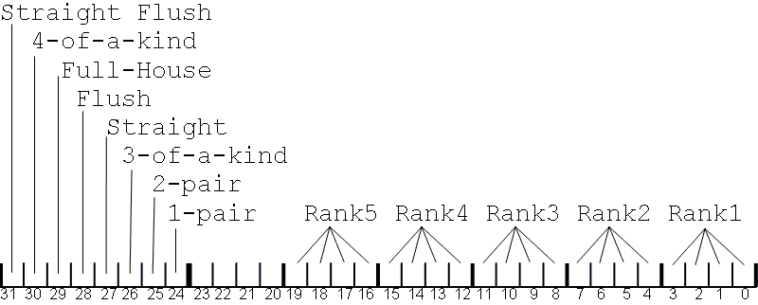

Bits 31-24 indicate the hand rank
Straight flush = bit 31 set
Four of a kind = bit 30 set
Full house = bit 29 set
Flush = bit 28 set
Straight = bit 27 set
Three of a kind = bit 26 set
Two pair = bit 25 set
One pair = bit 24 set
5-of-a-kind is indicated when bits 31-24 are set to 1
High-card (no pair) is indicated when bits 31-24 are set to 0

Bits 23-20 are not used

Bits 19-16 indicate the rank of the top card in the hand

Bits 15-12 indicate the rank of the second card in the hand

Bits 11-8 indicate the rank of the third card in the hand

Bits 7-4 indicate the rank of the fourth card in the hand

Bits 3-0 indicate the rank of the fifth card in the hand

Numeric values for the ranks (bits 19-1) are:
# | Rank
14 | Ace
13 | King
12 | Queen
11 | Jack
10-2 | Ten-Two
1 | Ace (in lo straight)

The pokerval symbol maps every 0 to 7 card poker hand onto the 32bit number space in correct order of game precedence, allowing two poker hands can be compared to see which is the better hand - higher values are better. The lowest possible value is 0 (no cards). The highest possible value is 5-aces which is encoded as 0xFF0EEEEE.

Player/Pocket Card List
The symbol pcbits is a bit list that indicates where your dealt pocket cards are used in your 5 card poker hand. Ony the lower order 5 bits are significant - one bit per card in your 5 card poker hand. Each bit corresponds to a pokerval rank field as follows:

bit# | pokerval
bit4 | rank5
bit3 | rank4
bit2 | rank3
bit1 | rank2
bit0 | rank1

If all bits in pcbits are zero then neither of your two cards are used in your 5 card hand.
The following formula fragment will be true if you have a sucker straight:

((nstraight==5) && (pcbits==1))

The following formula fragment will be true if you are filling an inside straight:

((nstraight==5) && (pcbits&14))

The formula symbol npcbits contains the number of your pocket cards being used in your 5 card poker hand. The possible values are: 0, 1 and 2.

Rank Bits
OpenHoldem uses the following method to classify a group of cards according to rank within a single value. Note that if an ace is present then both the 14 bit and the 1 bit will be set.

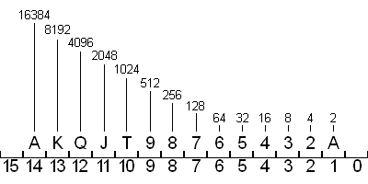

Bit 15 is not used
Bit 14 - A (16384)
Bit 13 - K (8192)
Bit 12 - Q (4096)
Bit 11 - J (2048)
Bit 10 - T (1024)
Bit 9 - 9 (512)
Bit 8 - 8 (256)
Bit 7 - 7 (128)
Bit 6 - 6 (64)
Bit 5 - 5 (32)
Bit 4 - 4 (16)
Bit 3 - 3 (8)
Bit 2 - 2 (4)
Bit 1 - 1 (2)
Bit 0 is not used

example: $JT = 3072
example: $65432 = 124
example: $KJ9753 = 10920
example: $AQT8642 = 21846

Parse-Time and Run-Time Errors
The OpenHoldem scripting language will detect various error conditions for you, and warn you of these conditions. Each time a formula is loaded, it is “parsed” for correctness – if there are any syntactical errors upon this parse, then a message box will be displayed that alerts you to the location of this error.

Additionally, several classes of run-time errors will be detected, including divide-by-zero and infinite recursion. Note that the OH-Script language does not support recursion in any form, due to the absence of the assignment operator.

Perl
The purpose of the Perl option is to provide a scripting language for beginners that is possibly easier to get productive with, if you either already familiar with Perl, or have a strong disposition for not using OH-Script.

Advantages of Perl
- Suitability for rapid prototyping
- Wide-spread usage
- Many libraries available and an active community at http://cpan.org
- Really good interfacing, e.g. to C.
- Syntax similar to C and some other script languages (bash, awk, tcl)

Disadvantages of Perl
- Performance: Perl compiles to intermediate code (similar to bytecode),
which gets executed by the interpreter. This is slower than compiled binary code, however some built-in functions (e.g. string- and list-operations) are said to be faster than C.
- Clarity. Perl is a language, which bought good ideas from nearly everywhere. You can write clear and understandable programs, if you want; but most Perl "gurus" are famous for the opposite. It is quite easy to write non-maintainable obfuscated Perl code.

Installation and configuration of Perl
- Download ActivePerl from http://www.activestate.com/Products/activeperl and install
- Perl needs the package "Win32::API" to interact with the callback DLL. Download this package using Perl’s package manager. Type at the command line (case sensitive; you should have administrator privileges to do this):
ppm install Win32::API
- OpenHoldem must be able to find "PerlEz.dll" which contains our embedded interpreter.
You must change the DLL search path from the DOS prompt:
set PATH = C:\Programs\Perl\Bin;%PATH%
- You need Visual C++ 2005 redist. package from Microsoft (SP1), especially msvcrt.dll, otherwise Perl can't load correctly (you will get a message: "PerlEz.dll not found or not accessible").

Perl usage
- All symbols beginning with "pl_" (e.g. "pl_call") in your formula will be treated as Perl symbols and requested from OpenHoldem’s built-in Perl interpreter. The same for gws-calls inside the dll. All symbols are expected to be either double constants, double variables or functions without parameters returning a double value.
- Perl for OpenHoldem has a built-in function "gws" (get_WinHoldem_Symbol), allowing you to request OpenHoldem symbols or DLL symbols in your Perl formulas. (Therefore you have full interoperability of OH script, DLL and Perl. You can further use all your existing code). This function "gws" resides in a package called "Perl_OH_Interaction.pm", which you have to include in your bot:
use Perl_OH_Interaction;
- The table name can be accessed using the function gwt. To get a player name for a given chair use gwp(N), where N is the chair number. Load a Perl file via the menu or using the preferences.

Perl introduction
- http://en.wikipedia.org/wiki/Perl

Perl recommended books
- Wainwright: Professional Perl Programing
- Schwartz: Learning Perl, Intermediate Perl, Mastering Perl
- Conway: Perl hacks, tips and tools for programing, debugging and surviving
- Till: Teach yourself Perl in 21 days

Perl editors
You may need an editor with syntax-highlighting for Perl.
- emacs (wonderful editor from the UNIX world; for windows and free)
ftp://ftp.gnu.org/gnu/emacs/windows/
Take the bin.tar.gz.
- Komodo-Edit (recommended by http://www.activestate.com)

Perl bot framework
The embedded archive below contains some files, ready to be filled with your bot logic, including:
- A classic formula, redirecting some symbols to Perl functions
- A nearly empty Perl bot, giving you a start
- The module Perl_OH_Interaction.pm, providing the "gws" function

Perl demo bot
You will find an extremely simple demo bot in the embedded archive below. To use it, you have to adapt the following lines according to your system settings:
use lib "C:\..."
use constant the_DebugFile => "..."
Perl starter files
The most recent version of this can always be found here: http://www.maxinmontreal.com/forums/viewtopic.php?p=20129

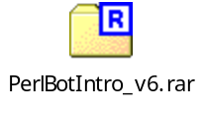

User DLL
OpenHoldem has the ability to interface with a user-compiled DLL. Microsoft Windows provides a feature whereby running code can load other code, presuming that code is provided in the form of DLL files. OpenHoldem utilizes this Windows DLL feature to allow you to extend the functions within OpenHoldem to practically anything that you want, provided you can write the code for it and compile it. Generally, people who create DLLs write them in the C or C++ languages, as those are the native historical target languages for using DLL functions, as defined by Microsoft. There are ways to have OpenHoldem use a C/C++ DLL shell which then calls code written in other languages, such as managed languages like .NET, but that topic is beyond the scope of this manual. If you are interested in doing this, there are plenty of programming forums on the Internet that can help with this activity.

OpenHoldem provides a number of preferences for how a user-DLL will be loaded. It can be done on start-up, when a formula is loaded, or manually. See the {Preferences} section for more information.

From this point on, the assumption is that, if you are creating a user-DLL, it will be written in the C or C++ languages. To do this, you need a C/C++ compiler – the express editions of Microsoft Visual Studio will suffice for this, as these user-DLLs typically do not need the MFC library, which is only present in the paid versions of Microsoft Visual Studio. A starting framework for a user-DLL can be found in the source code library on Google Code, but is also embedded just below this paragraph. See the {References} section for links.

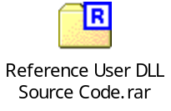

How OpenHoldem calls DLL functions
The OpenHoldem to DLL interface is small and clean. OpenHoldem will send or request information from the DLL when needed, and it is up to the DLL’s author to process these requests. The exported library function process_message is used for this interface and has the following prototype:

USERDLL_API double process_message (const char* pmessage, const void* param)

The various messages that can be passed in the “pmessage” parameter are as follows:

pmessage | meaning and parameters
state | Each scrape cycle, OpenHoldem will send the current game state to the DLL. As the author of the DLL, you will decide what to do with this game state information. The game state information is stored in a structure within OpenHoldem, and a pointer to this structure is passed to your User DLL in the “param” parameter. An example of how to cast this void pointer to the game state structure is provided in the Reference User DLL source code. The details of what is included in this game state structure are in the header file in the Reference User DLL source code.
query | Any symbol that begins with the characters “dll$” is interpreted by the OpenHoldem parser as requiring a call to the loaded User DLL in order to determine its value. The “query” message is the mechanism for requesting the value of this symbol. Any symbol name can be created for use by your User DLL, as long as it begins with “dll$”, and your DLL code knows how to handle it.  So, for example, if the OpenHoldem decision engine encounters a symbol called “dll$kill_phil” in the evaluation of the “f$alli” function, then a synchronous call will be made to the User DLL to provide the value of dll$kill_phil in order to complete the evaluation of f$alli. The evaluation of f$alli will block until your DLL handles this request and provides a result.  The name of the symbol (in this case, “dll$kill_phil”) is provided in the “param” parameter, and should be cast to a (const char*).  A simple example of how to process this message is provided in the Reference User DLL source code.
pfgws | Immediately after your User DLL is loaded, OpenHoldem will send a “pfgws” message once, which contains a pointer to a function within OpenHoldem that allows you to retrieve OpenHoldem symbols for use in your DLL code. “pfgws” is an acronym for “Pointer to Function for Get Winholdem Symbol”. This has not been renamed to something different for legacy compatibility reasons.  The pointer to the OpenHoldem “get symbol” function is provided in the “param” parameter, and should be cast to the p_getsym_t typedef and stored in a variable provided by your DLL. From then on, any time your DLL needs to know the value of one of the OpenHoldem calculated symbols, call this function.  The Reference User DLL source code provides a function that shows how to use the parameter provided in this message. The prototype for this function is:  double getsym( int chair, const char* name, bool& iserr )  This sample function takes the chair and the symbol name as input parameters and returns an error code in the “iserr” output parameter. An error will be returned if, for example, the “name” parameter contains an invalid OpenHoldem symbol name.
event | There are two event messages that are passed to your DLL. Both of these messages have NULL “param” parameters.  - “load” – this message is sent once immediately after your DLL is loaded. Typically this is used for some kind of initialization activity by your DLL.  - “unload” – this message is sent once just prior to OpenHoldem unloading your DLL from memory. This could be due to OpenHoldem shutdown, manual intervention from the DLL menu, or new formula loading. Typically this is used to clean up your DLL’s activities, such as connections to databases, closure of threads, etc.
phl1k | This message provides a pointer to OpenHoldem’s internal hand list array, for your DLL to read and modify as needed. The “param” parameter contains a pointer to this array and should be cast to the following type:  bool inlist[1000][13][13]  OpenHoldem can store 1000 different hand lists, and the first dimension of this array specifies the hand list number, the second and third dimensions specify the rank of the first and second card, where rank0>=rank1 is interpreted to mean suited cards, and rank0<rank1 is interpreted to mean unsuited cards. This is a very sparsely populated array, where the intersection of the three dimensions specifies if the particular card pair is present in the hand list or not. A non-zero value at this intersection indicates that the card pair is present; zero indicates that the card pari is not present.
prw1326 | This message provides a pointer to a prw1326 structure stored in OpenHoldem. This prw1326 structure is used to describe the manner in which OpenHoldem calculates its prwin, prtie and prlos symbols, based on the information which the DLL developer places in this structure. Unless the DLL code sets a specific enabling flag in this structure, the current prwin, prtie and prlos calculation is unchanged.  Please see the {prw1326} section for more information.
p_send_chat_message | This message provides a pointer to a SendChatMessage function in OpenHoldem that allows you to send any chat message you want at any time. The OH-Script only version of f$chat only allows certain pre-defined chat messages to be sent.  This message is sent once immediately after your DLL is loaded, with the pointer to the SendChatMessage function in the “Param” parameter. This parameter should be cast to the following prototype:  void SendChatMessage(char* new_message)  Usage of this function is specified in more detail in the {f$chat} section.

The order that these messages are passed after the DLL is loaded is as follows:
- event / load
- pfgws
- phl1k
- prw1326
- p_send_chat_message

Note: Basic code examples for handling most of these DLL messages are provided in the Reference User DLL source code.

A Simple Example
An easy way to get started is to override all OH-Script processing with DLL functions. There are a number of reasons to do this, including:
- Limitations of the OH-Script language (no assignments is the biggest limitation)
- Speed of compiled code versus interpreted code
- Low level integration with other technologies (your own tracking database, for example)

To override all OH-Script processing, simply instruct each primary function to only have a call to a “dll$” symbol. For example, in f$alli, use the following code:

dll$alli
In f$rais, use the following code:

dll$rais
And so on. In your User DLL, handle each of these “dll$” symbols as described above. Now all of the decision logic has been moved from OH-Script code to code that you provide in your DLL. It is important to remember that even if you want to code up most of your bot logic in C/C++, you still must use the OpenHoldem primary functions themselves to call this logic.

prw1326
The prw1326 structure and associated individual chair structure have the following specification:

//prwin 1326 chair structure
struct sprw1326_chair
{
int level; //indicates weighting level for 'always consider'
int limit; //max index into weight array - used for computational efficiency
int ignore; //if non-zero no weighting will be applied to this chair
int rankhi[1326]; //higher ranked card number in pocket cards
int ranklo[1326]; //lower ranked card number in pocket cards
int weight[1326]; //the significance value for this hand
double scratch; //for future reference
};

//prwin 1326 structure
struct sprw1326
{
int useme; //unless set to 1326 the normal OH prwin will be used
int preflop; //unless set to 1326 the normal OH prwin will be used pre-flop
int usecallback; //unless set to 1326 the callback function will not be invoked
double (*prw_callback)(void); //if enabled will be invoked before the prwin calculation pass
double scratch; //for future reference
int bblimp; //if non-zero no weighting will be applied if a chair has put nothing in the pot
sprw1326_chair vanilla_chair; //will be precalculated by OH at startup - convenience values
sprw1326_chair chair[10]; //structures for each chair
};

To use the structure from a User DLL, the following would also need to be added:

typedef sprw1326* pp13;
pp13 prw1326;

Also, in the process_message handling add:

if (strcmp(pmessage,"prw1326")==0)
{
prw1326 = (pp13)param;
return 0;
}
During OpenHoldem initialization the prw1326.vanilla_chair structure is set up so that .level is 1024, the .ranklo and .rankhi arrays contain the card order used for the normal OpenHoldem prwin calculation (but expanded from 169 to 1326 format), the weighting of the high third of these cards is set to 1024, the middle third is sloped down from 1024 to zero, and .limit is set so that the final third are never even considered as possible opponent cards. The .vanilla_chair is then copied to each of the ten .chair structures. This should mean that even if the capability is activated by setting .useme to 1326, the prwin calculation will not crash and will give an anodyne weighted result. The vanilla_chair is not referenced or used by OpenHoldem other than at start-up, and could be altered and used by the DLL developer to act as a default profile for new players.

A more complete explanation of how the prw1326 approach works can be found in the {Weighted prwin} section.

isfinalanswer
isfinalanswer is a calculated OpenHoldem symbol that is really only of use to User DLL developers. This symbols is true (non-zero) just prior to the Autoplayer acting, and false (zero) any other time. If Y scrapes in a row are identical (Y is set in Edit->Preferences->Autoplayer->Frame Delay) then when dll$iswait, dll$alli, dll$swag, dll$rais, dll$call are called, isfinalanswer is true. Unless dll$iswait returned zero, in that case isfinalanswer is false. More information on dll$iswait here: {dll$iswait}.

dll$iswait
Prior to the OpenHoldem Autoplayer taking action, it will query your User DLL, if one is loaded, for the value of dll$iswait. If this query returns non-zero, then OpenHoldem will not execute the Autoplayer’s action this scrape cycle, but rather will skip the action and continue to the next screen scrape cycle. While dll$iswait returns non-zero, isfinalanswer will always be zero.

In this post: http://www.maxinmontreal.com/forums/viewtopic.php?f=174&t=6885, Matrix says:

While dll$iwait is true don't have to respond to formula requests. You do have to somehow make sure that by the time dll$iswait is true that OpenHoldem has been returned the correct result.
When you go down this route you may encounter the problem of OpenHoldem stop evaluating the formulas, because there has been no change in state and dll$iswait is false. The best thing to do in this case is to disable all caching inside of OpenHoldem and always return a valid formula result and set dll$iswait to false on the very first valid frame with buttons you see from OpenHoldem.

cmd$recalc
A User DLL also has the ability to send the request "cmd$recalc", which will force OpenHoldem to recompute the versus tables and restart the Iterator thread.

Hand Lists

Hand List Editor

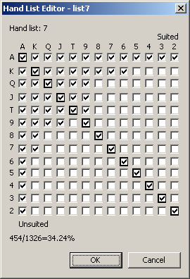
Figure 5.16-44 OpenHoldem Hand List Editor

The OpenHoldem Hand List editor is displayed when you click on the “9 yellow squares” toolbar button from the Formula Editor window. This provides a graphical interface for defining the Hand Lists as used within OpenHoldem for various symbols and functions. The output of this window is not all that difficult to understand, and if you choose your card pairs here, save your formula, then open the formula in a text editor, you can quite easily see the format used.

On this window, you specify which of your 169 starting hands (hole cards) are included in which Hand List. In the screen shot above, Hand List 7 was selected prior to clicking the “9 yellow squares” toolbar button. There is a diagonal group of starting hands running from top left to bottom right and identified with bolded checkboxes. These are the paired starting hands, i.e. AA, KK, JJ, 55. Above this diagonal line are checkboxes for the suited starting hands, i.e. AhKh, 3s2s, Jc7c. Below this diagonal line are checkboxes for the unsuited starting hands, i.e. AhJc, 3d2h.

When the “OK” button is clicked, the starting hand selections you have made are saved to the Hand List you selected.

Using Hand Lists
Hand lists are used by the following calculated symbols, and can be referenced in OH-Script code, or by Perl or DLL-based logic.

Symbol | Meaning
islist0 – islist999 | true if your hand is in the numbered (0-999) list
islistcall | true if your hand is in list 0
islistrais | true if your hand is in list 1
islistalli | true if your hand is in list 7
isemptylistcall | true if the call list is empty
isemptylistrais | true if the rais list is empty
isemptylistalli | true if the alli list is empty
nlistmax | highest list number in which your hand is listed
nlistmin | lowest list number in which your hand is listed

How the “Green Circle Button” finds tables
The “Green Circle Button” on the OpenHoldem toolbar is the usual way that one connects an OpenHoldem instance to a poker window. This is done automagically, however an explanation of what happens behind the scenes is useful if you have problems connecting to your target poker window. The following steps are taken to identify which windows on your screen are valid poker tables.

Step 1: A list of all visible top level windows that have a non-blank caption is collected

Step 2: Each window in this list is compared against each Table Map that you have placed in your “scraper” directory. For each step that follows, if a non-match is detected, OpenHoldem will then immediately move on to the next window/Table Map.

Step 3: The size of the client portion of the window is compared to the clientsize records in the Table Map. The window is considered a match if the Table Map indicates the correct size as given by the record clientsize, or if the size is within the size limits given by clientsizemin and clientsizemax.
Step 4: The window’s title text is compared to the keyword text filters provided by titletext records in the Table Map. The window is considered a match if the free-form text in any of the titletext records is found in the window’s title. Additionally, if any !titletext records are present in the Table Map, then a window is considered a non-match if the free-form text in any of the !titletext records is found in the window’s title.
Step 5: Any tablepoint records that exist in the Table Map are then the compared to the window’s pixels. If the color of any pixel does not match its tablepoint record then the window is considered a non-match.
In summary, OpenHoldem will connect to a window if it matches the client size, title text and pixel colors as specified in a Table Map.

Preferences
The preferences for OpenHoldem’s operation can be accessed via the Edit/Preferences menu item from the main window. A description of each preference follows.

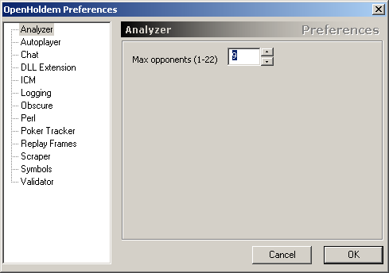
Figure 5.18-45 OpenHoldem Preferences – Analyzer

Analyzer preferences control how the OpenHoldem Iterator functions. At the moment there is only one preference available here. See the {The Iterator} section for more information.

- Max opponents: The OpenHoldem Iterator uses the value of the f$P function as the number of opponents in its Monte Carlo simulation. The maximum value that f$P can return is set here, any value of f$P greater than this will result in the number specified in this preference being used instead.

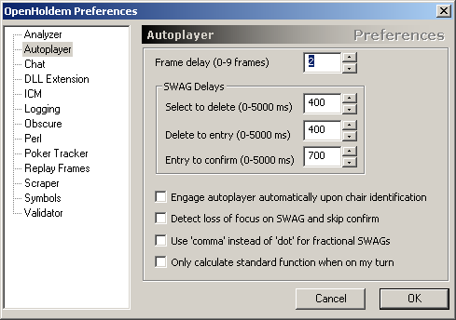
Figure 5.18-46 OpenHoldem Preferences – Autoplayer

Autoplayer preferences control how the OpenHoldem Autoplayer functions. See the {The Autoplayer} section for more information.

- Frame delay: This parameter specifies how many simultaneous identical screen scrapes must occur prior to the Autoplayer taking action. Generally, you want to have a stable poker screen before your take action, and this setting will allow various animations and so forth to finish, ensuring that your poker logic has correct game state information prior to making a decision.
- SWAG Delay, select to delete: For SWAG actions, this setting determines how long (in milliseconds) that OpenHoldem will pause after performing the SWAG Select action as specified in the Table Map, and prior to performing the SWAG Delete action as specified in the Table Map. These preferences are not set in the Table Map itself, as these are highly dependent on your CPU and network capacity and utilization, and thus are largely specific to your particular computing environment.
- SWAG Delay, delete to entry: For SWAG actions, this setting determines how long (in milliseconds) that OpenHoldem will pause after performing the SWAG Delete action as specified in the Table Map and prior to performing the SWAG Entry action. These preferences are not set in the Table Map itself, as these are highly dependent on your CPU and network capacity and utilization, and thus are largely specific to your particular computing environment.
- SWAG Delay, entry to confirm: For SWAG actions, this setting determines how long (in milliseconds) that OpenHoldem will pause after performing the SWAG Entry action, and prior to performing the SWAG Confirm action as specified in the Table Map. These preferences are not set in the Table Map itself, as these are highly dependent on your CPU and network capacity and utilization, and thus are largely specific to your particular computing environment.
- Engage Autoplayer automatically…: This setting instructs OpenHoldem to automatically start the Autoplayer when it has identified the user’s chair.
- Detect loss of focus on SWAG..: The SWAG action is the longest running of the poker actions, due to the need to select the text, delete it, enter the bet and confirm it. Occasionally, focus will be lost from the table that the SWAG action is being executed on, either due to multi-tabling (maybe the casino is set up to pop the table that requires your attention to the front?), or perhaps due to you or your Automation solution clicking elsewhere when the Autoplayer was working. When this loss of focus occurs, and if this setting is checked, then OpenHoldem will cancel the current SWAG attempt and retry on the next scrape cycle.
- Use ‘comma’ instead of ‘dot’…: Some casinos require the use of the “comma” as a decimal separator rather than the “dot”. This setting will instruct OpenHoldem to use a comma if needed. Eventually this setting should be moved to the Table Map file itself, as it is casino-specific. See the {Appendix B – Future TODOs} section.
- Only calculate standard function on my turn: Normally, OpenHoldem will calculate the primary functions on every scrape cycle. This setting will instruct OpenHoldem to only calculate these primary functions when it is your turn (card faces and action buttons are present). It will also prevent the calculation of most of the CPU expensive symbols including prwin/prlos/prtie, however the handrank symbols will be calculated as these are commonly used in the f$prefold calculations. f$prefold and f$play are still evaluated regardless if it is your turn or not.

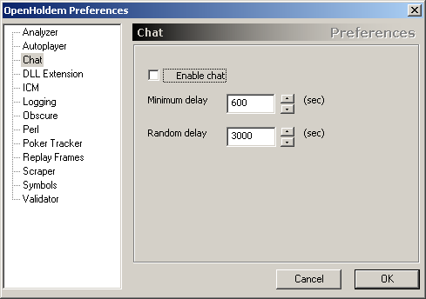
Figure 5.18-47 OpenHoldem Preferences – Chat

Chat preferences control how the OpenHoldem’s Chat feature in the Autoplayer functions. See the {f$chat} section for more information.

- Enable Chat: This parameter will completely disable the Chat feature if unchecked
- Minimum delay: This is the minimum amount of time that Chat will wait (in seconds) between the posting of messages to the chat box on the Casino client. This is a safety feature and is present to prevent accidental spamming of the chat box. Feel free to set this to “1” if you are overly confident in your configuration skills.
- Random delay: In addition to the “Minimum delay”, the amount of time specified in this parameter (in seconds) will be used to randomly delay the entry of a chat message into the chat box. The setting here is the maximum amount of random delay.

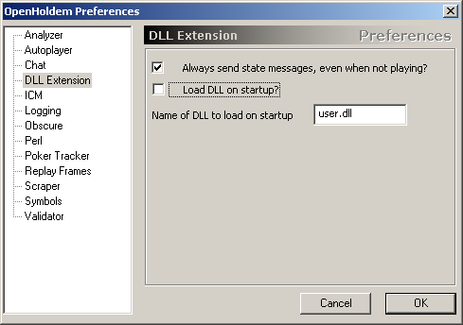
Figure 5.18-48 OpenHoldem Preferences - DLL Extension

DLL Extension preferences control how the OpenHoldem works with a User DLL. See the {User DLL} section for more information.

- Always send state messages…: By default, OpenHoldem will send “state” messages to a loaded User DLL on every scrape cycle, regardless of whether or not your player is currently in the hand. If this box is unchecked, these “state” messages will not be sent when you are “not playing”. This can be useful to avoid unnecessary consumption of CPU in the DLL when not needed.
- Load DLL on startup?: If this setting is checked, OpenHoldem will try to automatically load a User DLL when the program starts up. The order in which files are tried is as follows:
  - The DLL as specified in the loaded Formula file
  - The DLL as specified in this preferences window (below)
- Name of DLL to load on startup: This specifies a DLL file to load on startup. This file is only attempted if the “Load DLL on startup” setting is checked.

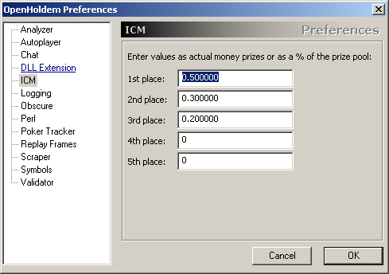
Figure 5.18-49 OpenHoldem Preferences – ICM

ICM preferences control how the OpenHoldem Independent Chip Model calculator operates. There are a plethora of resources online for understanding the Independent Chip Model. Start here: http://www.google.com/#hl=en&q=independent+chip+model

- 1st through 5th place: These settings specify the values of 1st through 5th place of your tournament, and are directly used in the ICM Engine’s calculations. Specify percentages or absolute prize values here. Percentages should add up to 100% if you want to ensure trusted results. Enter zero if a prize is not paid out for the structure of the game you are playing.

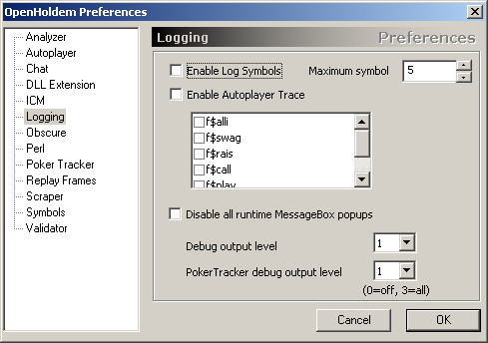
Figure 5.18-50 OpenHoldem Preferences – Logging

Logging preferences control what information OpenHoldem will periodically write to various log files.

- Enable Log Symbols: If this setting is checked, any log$ symbols that are encountered in your OH-Script will be added to OpenHoldem’s log file. Everytime a log$ symbol is accessed it will be flagged for logging. You can use this to track which part of your formula is responsible for the action taken by OpenHoldem. You want to use the log$ symbol at the end of a logic block, to make sure it only gets flagged when all the previous statements are true.
- Maximum symbols: This is used in conjunction with the “Enable Log Symbols” preference, and specifies the maximum number of log$ symbols that will be logged per action. When “Enable Log Symbols” enabled, up to four log$ symbols will be displayed in OpenHoldem's main window in the center information box.
- Enable Autoplayer Trace: This setting will enable tracing to the log file of the Autoplayer’s evaluation process. The primary functions that are traced are selected in the listbox control directly below. See the {Autoplayer Trace} sub-section in the {Validator} section for more information.
- Disable all runtime MessageBox…: This preference will prevent OpenHoldem from displaying warning and error message boxes during runtime (when OpenHoldem is connected to a table). This is extraordinarily dangerous and should only be used when you have a 100% stable bot that you want to move to a fully automated execution model. It is strongly advised that you do not check this option until you have a very stable and thoroughly tested botting environment.
- Debug output level: This will control the verbosity of the output written to the log files. Zero will disable all logging, and 3 is the highest level of logging. At the time of this writing, detailed level-3 logging is available for critical parts of OpenHoldem, including the heartbeat thread, the Screen Scraper engine, and the Autoplayer engine.
- Poker Tracker debug output level: This will control the verbosity of the output written to the Poker Tracker log files. Zero will disable all logging, and 3 is the highest level of logging.

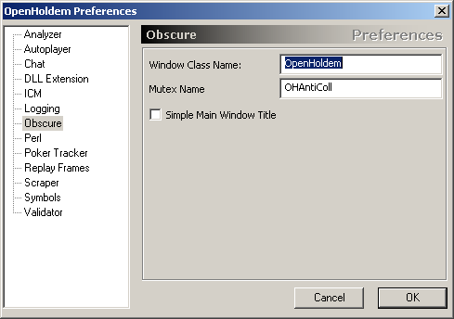
Figure 5.19-51 OpenHoldem Preferences – Obscure

Obscure preferences control various detectable components of OpenHoldem, and are primarily useful in setting up a highly stealthed environment. See the {Stealth} chapter for more information.

- Window Class Name: Every window running under Microsoft Windows has a specific “class name” associated with it. This is easily identifiable by the casinos’ poker software and it is suggested that this be changed to something else.
- Mutex Name: OpenHoldem uses system-wide mutexes to ensure that multiple running instances of OpenHoldem do not interfere with each other when performing Autoplayer actions. The name of this system-wide mutex is easily identifiable by the casinos’ poker software and it is suggested that this be changed to something else.
- Simple Main Window Title: By default, OpenHoldem will include all sorts of useful information in its window title bar. This useful information is also easily identifiable by the casinos’ poker software. Check this preference to use a simple window title instead.

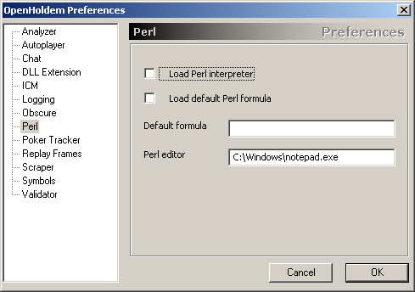
Figure 5.19-52 OpenHoldem Preferences – Perl

Perl preferences control how OpenHoldem interacts with the installed Perl interpreter and your Perl formulas. See the {Stealth} section for more information on installing and configuring Perl.

- Load Perl interpreter: When checked, this preference will cause the Perl interpreter to be loaded into memory.
- Load default Perl formula: When checked, this preference will cause the default Perl formula (as specified in “Default formula” directly below) to be loaded on startup.
- Default formula: This is the path to the Perl formula that will be loaded if the “Load default Perl formula” preference is checked.
- Perl editor: This is the path to the editor that will be launched when a Perl formula is selected for editing from the Perl menu on the main window.

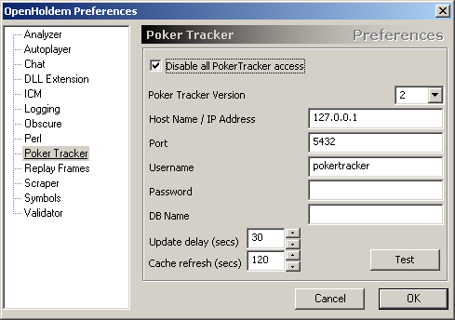
Figure 5.19-53 OpenHoldem Preferences - Poker Tracker

Poker Tracker preferences control how OpenHoldem interacts with a Poker Tracker database. See the {PokerTracker} section for more information on using Poker Tracker with OpenHoldem.

- Disable all Poker Tracker access: Checking this preference will completely disable all Poker Tracker functionality in OpenHoldem. If you make no use of any Poker Tracker symbols, then it is safe to check this box.
- Poker Tracker version: OpenHoldem supports interacting with both Poker Tracker v2 and Poker Tracker v3 databases. This setting will instruct OpenHoldem as to which flavor of Poker Tracker you are using.
- Host Name / IP Address, Port, Username, Password, DB Name: These are the parameters that you entered when you setup your Poker Tracker PostgreSQL database. Enter them here so OpenHoldem knows how to connect to your database. If you do not understand what these settings mean, please go here for more information: http://www.pokertracker.com
- Update delay: OpenHoldem maintains an internal cache of Poker Tracker statistics that it periodically queries from the Poker Tracker database. This setting determines the frequency that OpenHoldem will use (in seconds) to consider re-querying those statistics. This setting is akin to the “Scrape Delay” setting in the Scraper preferences for the screen scraper engine. This parameter does not need to be a particularly small value, as the information in Poker Tracker does not change that often itself. Note: Just because this delay has expired, and the Poker Tracker query engine “wakes up”, does not guarantee that every statistic will be updated. Rather, this works in conjunction with the “Cache refresh” parameter below to decide if a statistic needs updating or not.
- Cache refresh: After the Poker Tracker query engine has been “woken up”, because the delay specified in the “Update delay” parameter has expired, the engine will scan through each of its statistics for every chair and determine if that statistic needs updating or not. If the duration between now and the last time that a given statistic was retrieved from Poker Tracker is greater than this parameter (in seconds), then the engine considers the statistic to be stale and will query Poker Tracker for a new value.
- Test: This button will test the connection to the Poker Tracker database as specified by the above parameters and will report success or failure codes. Help with connecting to PostgreSQL databases can be found here: http://www.pokertracker.com, or here: http://www.postgresql.org

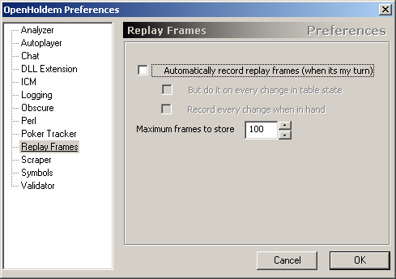
Figure 5.19-54 OpenHoldem Preferences - Replay Frames

Replay Frames preferences control how OpenHoldem collects Replay Frames for offline development and debugging use. See the {Replay Frames} section for more information on using Replay Frames.

- Automatically record replay frames: If this setting is checked, OpenHoldem will automatically record Replay Frames. The alternative is manual Replay Frame collection by using the “camera” button on the main toolbar.
- But do it on every change in table state: If the “Automatically record replay frames” preference is checked, this option will be available to instruct OpenHoldem to collect Replay Frames on every change in table state. Typically, OpenHoldem only collects Replay Frames when it is your turn to act.
- Record every change when in hand: If the “Automatically record replay frames” preference is checked, this option will be available to instruct OpenHoldem to collect Replay Frames on every screen scrape cycle when you are in the hand. Typically, OpenHoldem only collects Replay Frames when it is your turn to act.
- Maximum frames to store: OpenHoldem will collect a maximum number of Replay Frames as specified by this parameter, then it will reuse filenames starting at the beginning.

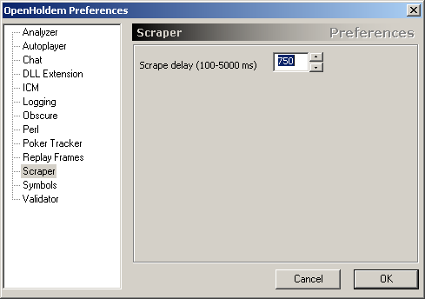
Figure 5.19-55 OpenHoldem Preferences – Scraper

Scraper preferences control how the OpenHoldem Screen Scraper engine functions. At the moment there is only one preference available here. See the {Creating a Table Map} section for more information.

- Scrape Delay: This parameter specifies the amount of time (in milliseconds) that the OpenHoldem Screen Scraper engine will pause in between subsequent screen scrape passes. This amount of time does not specify the time from the beginning of scrape 1 to the beginning of scrape 2, but rather the amount of delay between the end of scrape 1 and the beginning of scrape 2. The primary consideration for this parameter is that of CPU consumption, and the default of 750ms seems to work well for most people.

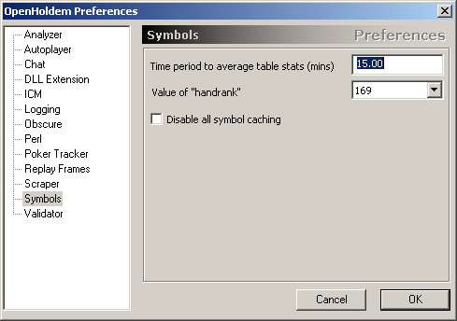
Figure 5.19-56 OpenHoldem Preferences – Symbols

Symbols preferences control various aspects of OpenHoldem’s calculated symbols. See the {Calculated SymbolsCreating a Table Map} section for more information.

- Time Period to Average Table Stats: As discussed in the {Calculated Symbols} section, the Table Stats symbols (floppct, turnpct, riverpct, avgbetspf and tablepfr) are calculated on a rolling time average. The time frame (in minutes) specified by this parameter determines how far back in time these averages are calculated. For example, if this is set to 15 minutes, then the averages will be for the last 15 minutes of activity at the table.
- Value of “handrank”: handrank is a calculated symbol, and is set to one of 169, 1000, 1326, 2652 or p. Depending on the option selected here, handrank will be set equal to the calculated handrank169, handrank1000, handrank1326, handrank2652 or handrankp symbols. This setting also determines the hand rank value that is displayed on the main window’s status bar (see {Status Bar} for more information). See section {Starting Hand } for more information on hand ranks.
- Disable all symbol caching: The normal operation for the OpenHoldem parsing and decision engine is to cache the results of each symbol that it calculates in a given scrape cycle. The reason for this, is that if a UDF is referenced 100 times in a given function calculation, it makes sense to save the results of the first calculation, and then reuse the results in the other 99 references. This is just an efficient use of CPU resources. By checking this preference, you instruct OpenHoldem to bypass this caching and guarantee that each symbol is re-calculated each time it is needed. Whether this option is checked or unchecked, dll$ symbols are never cached, as if a caching of User DLL symbols is needed, that can easily be accommodated in the DLL itself by the DLL developer.

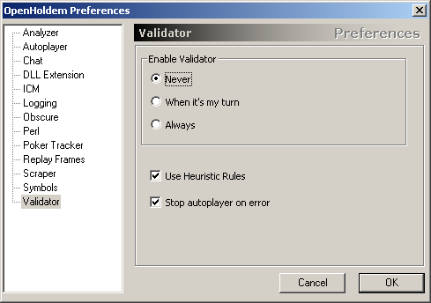
Figure 5.19-57 OpenHoldem Preferences – Validator

Validator preferences control various aspects of OpenHoldem’s Validator engine. See the {Validator} section for more information. This is a new feature in OpenHoldem version 2.0. The purpose of the Validator is to help people to develop more reliable bots and Table Maps. It will execute several hundred consistency-checks at the symbol level to detect invalid game-states, mis-scrapes or incomplete information. The Validator will write possible problems to the log-file and also show a message box, as long as messages are not disabled. The rules used by the Validator are always being refined and developed. The discussion forum is the best place to keep on top of this: http://www.maxinmontreal.com/forums/viewtopic.php?f=189

- Enable Validator: This preference determines when the Validator is engaged to do its work, either Never (completely off), when it is my turn, or always.
- Use Heuristic Rules: Some rules are heuristic, i.e. they are "common sense", but not always true. Example: A game does usually not last longer than 2 minutes, so the autoplayer has to act at least once per 120 seconds. If it does not do so, there seems to be a problem. Maybe the Table Map does not detect the players’ cards or the buttons. This setting can result in false positives and is recommended for testing only, but not for real-money-play.
- Stop Autoplayer on error: If the Validator discovers an inconsistency, and this preference is checked, the Autoplayer will be instructed to stop Autoplaying.

Locking Blinds
There is a button on OpenHoldem’s main toolbar, that looks like a padlock and dollar symbol, which opens up the following window to allow you to “lock blinds”.

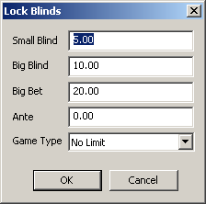
Figure 5.20-58 OpenHoldem Lock Blinds window

OpenHoldem has many methods for determining the blinds at any given time, including:
- Scraping of Title Bar text (as specified in the Table Map)
- Scraping of Regions from the Table Map
- Intuiting the blinds from patterns in betting round 1

In some cases, you may want to bypass all of these blind detection methods and force OpenHoldem to use a certain blind setup. A good example of this is if you are playing at a Ring Table, where the blinds never change. This would not be so applicable to SNGs or MTTs, as the blinds regularly change in those games. This window will allow you to specify blinds to be used as long as the “padlock and dollar symbol” button on the main toolbar is depressed.

The Iterator
OpenHoldem includes a Monte Carlo Holdem simulator for use in calculating various statistics for use by your bot logic, the primary of which are the prwin/prtie/prlos trio. There are many resources on the Internet for learning about Monte Carlo poker simulations, a good place to start is here: http://pokerforprogrammers.blogspot.com, but there are plenty of other resources here too: http://www.google.com/#hl=en&q=monte+carlo+poker+simulation

There are a number of parameters that feed into the OpenHoldem iterator:
- f$P: The result of the f$P function directly determines the number of opponents that are simulated in the Iterator. The greater the number of opponents, the lower your chances of winning. The lower the number of opponents, the higher your chances of winning.
- NIT: The “Number of Iterations” parameter determines the number of cycles the Iterator processes each time the prwin trio of symbols are needed. Simplistically, the greater the number of iterations, the more precise will be the values in the prwin trio. A discussion on the appropriate number of iterations to choose for your needs can be found here: {Iterations and Standard Deviation}
- Table level hand weightings: This is discussed in detail here: {Weighted prwin}
- Opponent level hand weightings: This is discussed in detail here: {Enhanced prwin}

Note: The Iterator simulates a “nofoldem” game in all cases. This means that all players at the start of the hand (derived from f$P) will see the hand through to the end, and that your hand is compared to all other players’ hands to see if you won, lost or tied. In reality, this will rarely be the case, as inevitably, one or more players will fold before showdown.

Iterations and Standard Deviation
This material was originally produced by BuckyBall and can be found here: http://forum.winholdem.net/wbb/viewtopic.php?t=3742

Standard deviation of prwin/prtie/prlos by Number of Iterations (NIT)
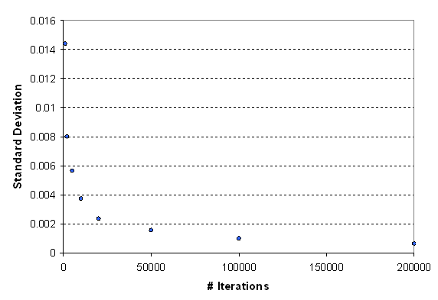
Figure 5.21-59 Standard Deviation by Iterations

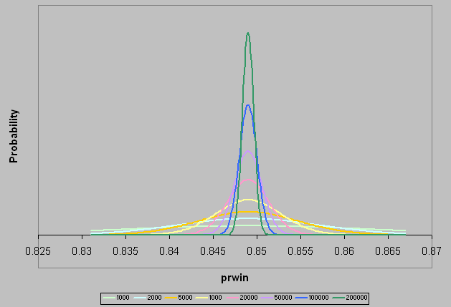
Figure 5.21-60 Probability by prwin

Here is how to use the data in the above graphs:

Decide what error you find acceptable 99% of the time. For example, if you are happy with getting prwin's of 0.846 - 0.852 99% of the time for AA headsup preflop, your error would be (0.849) +- 0.003.
That error is "3 standard deviations". To get 1 standard deviation, divide by 3 (to give std. dev. = 0.001).
Find that standard deviation in the top chart and read off the number of iterations required. In our case, it would be 100,000 required iterations.

The prwin values you obtain will be within 1 standard deviation 67% of the time, within 2 standard deviations 95% of the time, and within 3 standard deviations 99% of the time.

Weighted prwin
A weighted prwin is one which is calculated by making informed selections of the cards that opponents are likely to hold, and using these cards in the calculation of your win probability. Factors which can be used to make inferences about cards include willingness to pay to see flop, betting behavior when faced by common cards, and historical information about opponent behavior. Essentially it aims to put your opponents on cards as accurately as possible.

OpenHoldem’s “Weighted prwin” is based on a fairly simple model using pre-flop behavior. For DLL developers, there is also the option to use {Enhanced prwin}.

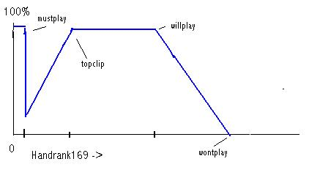
Figure 5.11-61 Weighted prwin model

To enable Weighted prwin, various user-defined functions in a formula file must be defined to return the following values, expressed as handrank169 values (see {Calculated Symbols}):

function | explanation
f$mustplay | Opponents holding cards better than this are assumed always to play them. This allows for the situation where opponents slow play the strongest hands in the hope of milking more from the pot with them.
f$topclip | Indicates that hands better than this are less likely to be played, since the betting level is too low.
f$willplay | Hands better than this will be played.
f$wontplay | Hands worse than this are highly unlikely to be played.

The success in using a model of this sort depends on the data available to allow the formula developer to devise appropriate expressions for the f$functions outlined above. Currently in OpenHoldem the most accessible is floppct - the percentage of opponents seeing the flop averaged over a user definable period. This is a reasonably accurate expression of the strength of cards which opponents are prepared to play. An example of its use could be:

f$willplay
handsplayed<10?72:(180*floppct)>(nopponents*2+1)?180*floppct:nopponents*2+1

f$wontplay
f$willplay*1.4

Note: If f$willplay evaluates to zero, prwin weighting will be turned off. f$wontplay should not be less than f$willplay.

Although this is primitive it gives the single greatest advantage of using a weighted prwin rather than an unweighted one; it eliminates the cards from the calculation which opponents are unlikely to invest any money in. Since it depends on statistical information a constant value is given until floppct has had time to establish itself. The '180' is because 90 is the midpoint of handrank169 at which the number of hands above and below are the same (the stronger hands tend to have fewer possible examples).

Ideally the calculation should be based on betting averages at different levels, since it is what opponents are prepared to pay that determines the probable strength of their hand, and should be recorded on an opponent (and even position) basis. The problem with more refined data accumulation is that it takes an increasing number of hands to gain significance, and is sensitive to changes in playing conditions, such as the number of players, which can alter opponent behavior. Nevertheless statistics of this sort have been used successfully in other bots based on a weighted prwin, and may be available from OpenHoldem in the future.

The OpenHoldem weighted prwin uses a handrank169 table (see {Starting Hand }) which is based on published data about hands players actually take to flop, and varies from conventional ones giving win probabilities, particularly in the way it favors suited hands! In the absence of statistical support it is not recommended that you implement f$topclip or f$mustplay unless you have a good picture of the standard of play at a table.

If f$willplay is absent, or returns a zero value, the prwin weighting is turned off. It will also be turned off if your f$P function specifies more than 13 opponents. If your opponents at flop include a big blind who has not been raised, no weighting will be applied to his hand, since no assumptions can be made about it.

You may need to change your f$P function if using weighted prwin. The “P factor” established in your f$P function is in fact a kludge to compensate for the fact that opponents who fold have weaker hands. prwin weighting allows for this, and therefore a prwin bot is best coded using the actual number of opponents playing. A suggestion for an f$P function, if you use prwin pre-flop, could be:

(nopponentsplaying==0) ? 0 : //zero if no opponents
(br>1)? nopponentsplaying : //just use actual opponents post-flop
(handsplayed<10)? nopponentsplaying : //fallback until floppct becomes reliable
(nopponentscalling+nopponentsraising+nopponentschecking*floppct+0.49)<1 ? 1 : //this should never happen, but .....
nopponentscalling+nopponentsraising+nopponentschecking*floppct+0.49 //make an estimate for opponents who have still to act

This attempts to estimate the number of opponents you are likely to face when you act pre-flop, and is most significant when you are in early position. Whilst the principle is valid, that actual function should be thoroughly tested in practice.

Enhanced prwin

Overview
OpenHoldem’s Iterator can be switched from its normal table-level weighting calculation to one which considers hands likely to be held by individual opponent chairs. This can only be activated at the DLL level using the {prw1326} structure whose address is passed to the DLL at load time. The mechanism that OpenHoldem uses to select opponent cards for each pass of the Iterator is, for each active opponent, to choose a random number between zero and .limit and use this as an index into the chair [1326] arrays. .ranklo and .rankhi are checked to ensure that neither of the cards is already in use, if .weight is less than .level another random number is used so that the hand will only be selectable .weight/.level of the time, and if the hand is available after these tests it is assigned for the opponent for that pass of the Iterator.

This approach allows the DLL coder to implement something very like the {Weighted prwin}, but at opponent chair level; to trim the probabilities of certain opponent hands as the hand develops; or to switch to an approach where only limited Hand Lists are considered for an opponent (possibly without any relative weighting). Please bear in mind that with Enhanced prwin, OpenHoldem is completely dependent on you to set up the prw1326 structure, and any errors you make will affect the reliability of the result; or cause OpenHoldem to hang or crash. It is not a feature for the novice coder to experiment with.

How to use it from a DLL
To use Enhanced prwin from a DLL, you need to declare the structures and pick up the pointer to them as described here: {prw1326}. To switch OpenHoldem to a calculation using data in the structure which you have generated you need to set:

prw1326->useme = 1326;

If this is all you do OpenHoldem will switch at flop and after to an enhanced calculation using the vanilla hand profiles it set up for each chair at initialization. This will probably give slightly worse results than a well-configured {Weighted prwin}, since the profiles are static!

Now assume that at the flop you become convinced that chair 2 has a pair of aces. No other ace is known, so he can have six possible hands. You want to set the structure so that OpenHoldem only calculates prwin using those hands for that opponent. First we need to note how OpenHoldem (or more specifically the PokerEval library) represents cards. Card rank 2 to Ace is represented by 0 to 12. You then add a number representing the suit. For hearts add 0, for diamonds add 13, for clubs add 26, and for spades add 39. Ac is thus 12+26=38. The six pairs he can have are AhAd, AhAc, AhAs, AdAc, AdAs and AcAs. You set the first six positions in the [1326] arrays:

prw1326->chair[2].rankhi[0]=12; //Ah
prw1326->chair[2].ranklo[0]=25; //Ad
...
prw1326->chair[2].rankhi[5]=25; //Ad
prw1326->chair[2].ranklo[5]=51; //As

Since you only want six card pairs to be considered you set:
prw1326->chair[2].limit=6;

Finally you set the weighting for each hand. As each hand is considered equally probable:

for(i=0;i<6;i++)prw1326->chair[2].weight[i]=prw1326->chair[2].level;

Once the hand was over you would not want to leave chair 2 as having a pair of aces.

prw1326->chair[2]=prw1326->vanilla_chair;

would reset it.

This was an example of using prw1326 to set an opponent on a hand list. We chose a very small list for ease of illustration, but it is worth noting that this can be dangerous. If another opponent had a hand list which included a pair of aces, and an ace appeared on common, then there would be a risk that OpenHoldem could not find enough cards to satisfy an iteration and would hang. Since the iteration process is so CPU intensive we did not include code to catch this situation.

Now let us suppose that chair 3 is a tight player. You think he will only place money on the upper half of the cards, and will only reliably pay for the top 25%. In this case you would want to take the vanilla profile and change the weightings on it.

for(i=0;i<332;i++) prw1326->chair[3].weight[i]=prw1326->chair[3].level;
for(i=332;i<663;i++) prw1326->chair[3].weight[i]=prw1326->chair[3].level*(663-i)/332;
prw1326->chair[3].limit=663;

Because we have set .limit for the chair we do not need to bother about the weightings for the bottom half of the hand list, because they will never be considered.

The procedure above would set a general profile for chair 3 based on pre-flop behavior. You might have a situation in which his betting behavior indicated that he might well have a jack in his hand. One response would be to traverse the hand list and reduce the weighting for any hand which did not contain a jack. A quicker technique is to increase the .level value (which automatically reduced the probability for all hands) and then increase the weighting only for hands containing a jack. It can be very useful to build up indexes in your DLL which show the hands which contain aces, kings etc, and also for those which contain suited cards. This can speed up this sort of operation considerably.

prw1326->preflop
If you use prwin at all pre-flop, there are real advantages to using the normal {Weighted prwin} before the flop. Enhanced prwin works by considering specific hand profiles for opponents, and in general, pre-flop you are not sure who your opponents later on will be. It also does not use the P factor to calculate against a number of opponents; it works strictly on active opponents. Using table tightness and position in an f$P formula to estimate likely number of opponents means that {Weighted prwin} is more useful pre-flop. Nevertheless, if you set…

prw1326->preflop=1326;

…then enhanced prwin will also be used pre-flop.

prw1326->bblimp
If this is set non-zero then Enhanced prwin will not attempt any weighting for a chair who has not voluntarily put any money into the pot pre-flop (i.e. an unraised BB). Please note that this is not set by default, but is a flag which should be set for the prwin calculation to be wholly realistic.

prw1326->chair[x].ignore
If this is set non-zero then Enhanced prwin will not attempt any weighting for chair x. The Iterator will make no assumptions about the chair hand list. The chair itself will still be included in the prwin calculation if it is still playing, but it is just treated as if it was an unraised BB, so that it could have any available hand.

Callback
There is a mechanism for synchronizing your setting of the prw1326 structure with the prwin cycle. You can specify a callback function which will be invoked immediately before the prwin iteration loop is started. You can use this to copy a local structure image over prw1326. Any code here should be short, simple and clean. Avoid get_symbol calls, logging or complex external functions. If you think the callback function is a good place to make a couple of hundred Poker Tracker queries then the OpenHoldem developers reserve the right to be offensively unsympathetic to you. If you have callback function in your code of type:

double mycallback(void)
{
//do something here
return 0;
}

then you can set

prw1326->prw_callback=mycallback;
prw1326->usecallback=1326;

The return value is not used currently by OpenHoldem.

Notes
The simple minded technique for getting a random number between 0 and X is rand()%X. Unfortunately the rand() function returns an integer between 0 and 32767, and if X is not a sub-multiple of 32768 then the result is biased (only slightly if X is not too large). You can code to eliminate this, but in an iterated piece of code this introduces an extra CPU load. Currently in prw1326 we do this elimination on the random numbers used to select the hand from the hand list, but not on the .weight / .level assessment since the default .level of 1024 does not introduce any bias. The effect of an unfortunate choice of .level (such as one > 16384) would be to cause hands with a low .weight to be over-represented in the calculations.

If you want to set an opponent on a limited hand list there are two ways you can do it with prw1326; you can take a 1326 list and set the weight of the unwanted hands to zero, or you can create a sequence of just those hands you are interested in and set .limit so that only they are considered. Both will produce the same result, but the latter is more CPU-efficient, particularly for a short list, since the Iterator does not have to waste time rejecting many hands with a zero .weight.

When you unload a DLL from the OpenHoldem menu, the .useme and .usecallback flags will be cleared but nothing else in the prw1326 structure will be changed. Another loaded dll will then find the structure as the previous one left it, so you cannot assume the initial OpenHoldem initialization unless you do careful housekeeping to restore it on DLL exit.

Starting Hand Ranking
OpenHoldem uses a starting hand rank table that is based on the 2652 possible starting two card hands. The original discussion around these hand rankings was developed by Ray Bornert and can be found here:
http://forum.winholdem.net/wbb/viewtopic.php?t=94
http://forum.winholdem.net/wbb/viewtopic.php?t=316

This table is as follows:

Number of opponents on the X axis, hand rank (1 is best) on the Y axis

--- --9------- --8------- --7------- --6------- --5------- --4------- --3------- --2------- --1------- ---
1 *AAo*- 12 *AAo*- 12 *AAo*- 12 *AAo*- 12 *AAo*- 12 *AAo*- 12 *AAo*- 12 *AAo*- 12 *AAo*- 12 1
2 *KKo*- 24 *KKo*- 24 *KKo*- 24 *KKo*- 24 *KKo*- 24 *KKo*- 24 *KKo*- 24 *KKo*- 24 *KKo*- 24 2
3 *QQo*- 36 *QQo*- 36 *QQo*- 36 *QQo*- 36 *QQo*- 36 *QQo*- 36 *QQo*- 36 *QQo*- 36 *QQo*- 36 3
4 *AKs*- 44 *AKs*- 44 *JJo*- 48 *JJo*- 48 *JJo*- 48 *JJo*- 48 *JJo*- 48 *JJo*- 48 *JJo*- 48 4
5 *JJo*- 56 *JJo*- 56 *AKs*- 56 *AKs*- 56 *AKs*- 56 *TTo*- 60 *TTo*- 60 *TTo*- 60 *TTo*- 60 5
6 *AQs*- 64 *AQs*- 64 *AQs*- 64 *AQs*- 64 *TTo*- 68 *AKs*- 68 *99o*- 72 *99o*- 72 *99o*- 72 6
7 *KQs*- 72 *KQs*- 72 *KQs*- 72 *TTo*- 76 *AQs*- 76 *AQs*- 76 *AKs*- 80 *AKs*- 80 *88o*- 84 7
8 *AJs*- 80 *AJs*- 80 *TTo*- 84 *KQs*- 84 *KQs*- 84 *99o*- 88 *AQs*- 88 *88o*- 92 *AKs*- 92 8
9 *TTo*- 92 *TTo*- 92 *AJs*- 92 *AJs*- 92 *AKo*- 108 *KQs*- 96 *AKo*- 112 *AQs*- 100 *77o*- 104 9
10 *KJs*- 100 *AKo*- 116 *AKo*- 116 *AKo*- 116 *AJs*- 116 *AKo*- 120 *AJs*- 120 *AKo*- 124 *AQs*- 112 10
11 *AKo*- 124 *KJs*- 124 *KJs*- 124 *KJs*- 124 *99o*- 128 *AJs*- 128 *KQs*- 128 *AJs*- 132 *AKo*- 136 11
12 *ATs*- 132 *ATs*- 132 *ATs*- 132 *ATs*- 132 *KJs*- 136 *KJs*- 136 *88o*- 140 *77o*- 144 *AJs*- 144 12
13 *QJs*- 140 *QJs*- 140 *QJs*- 140 *QJs*- 140 *ATs*- 144 *ATs*- 144 *ATs*- 148 *KQs*- 152 *AQo*- 168 13
14 *KTs*- 148 *KTs*- 148 *KTs*- 148 *99o*- 152 *QJs*- 152 *AQo*- 168 *AQo*- 172 *ATs*- 160 *ATs*- 176 14
15 *QTs*- 156 *QTs*- 156 *99o*- 160 *KTs*- 160 *AQo*- 176 *88o*- 180 *KJs*- 180 *AQo*- 184 *66o*- 188 15
16 *JTs*- 164 *99o*- 168 *QTs*- 168 *AQo*- 184 *KTs*- 184 *QJs*- 188 *QJs*- 188 *KJs*- 192 *AJo*- 212 16
17 *99o*- 176 *JTs*- 176 *AQo*- 192 *QTs*- 192 *KQo*- 208 *KTs*- 196 *KTs*- 196 *AJo*- 216 *KQs*- 220 17
18 *AQo - 200 *AQo*- 200 *JTs*- 200 *JTs*- 200 *QTs*- 216 *KQo*- 220 *KQo*- 220 *KTs*- 224 *ATo*- 244 18
19 *A9s - 208 *KQo - 224 *KQo*- 224 *KQo*- 224 *88o*- 228 *QTs*- 228 *AJo*- 244 *KQo*- 248 *A9s*- 252 19
20 *KQo - 232 *A9s - 232 *A9s*- 232 *88o*- 236 *JTs*- 236 *AJo*- 252 *77o*- 256 *A9s*- 256 *KJs*- 260 20
21 *88o - 244 *88o - 244 *88o*- 244 *A9s*- 244 *AJo*- 260 *JTs*- 260 *QTs*- 264 *QJs*- 264 *A8s*- 268 21
22 *K9s - 252 *K9s - 252 *AJo - 268 *AJo*- 268 *A9s*- 268 *A9s*- 268 *A9s*- 272 *ATo*- 288 *KTs*- 276 22
23 *T9s - 260 *T9s - 260 *K9s - 276 *K9s*- 276 *KJo*- 292 *KJo*- 292 *ATo*- 296 *66o*- 300 *KQo*- 300 23
24 A8s - 268 *AJo - 284 *A8s - 284 *KJo - 300 *K9s*- 300 *77o*- 304 *JTs*- 304 *A8s*- 308 *55o*- 312 24
25 J9s - 276 *A8s - 292 *T9s - 292 *A8s - 308 *A8s*- 308 *ATo*- 328 *KJo*- 328 *KJo*- 332 *A7s*- 320 25
26 Q9s - 284 J9s - 300 *KJo - 316 *Q9s - 316 *QJo*- 332 *K9s*- 336 *A8s*- 336 *QTs*- 340 *A9o*- 344 26
27 77o - 296 Q9s - 308 *Q9s - 324 *QJo - 340 *ATo - 356 *A8s*- 344 *K9s*- 344 *K9s*- 348 *KJo*- 368 27
28 AJo - 320 KJo - 332 J9s - 332 *T9s - 348 *77o - 368 *QJo*- 368 *QJo*- 368 *JTs*- 356 *QJs*- 376 28
29 A5s - 328 77o - 344 QJo - 356 *J9s - 356 *Q9s - 376 *Q9s*- 376 *66o*- 380 *A7s*- 364 *K9s*- 384 29
30 A7s - 336 A5s - 352 77o - 368 ATo - 380 *T9s - 384 *KTo*- 400 *KTo*- 404 *KTo*- 388 *KTo*- 408 30
31 A4s - 344 A7s - 360 A7s - 376 77o - 392 *J9s - 392 *A7s*- 408 *A7s*- 412 *QJo*- 412 *A8o*- 432 31
32 KJo - 368 QJo - 384 A5s - 384 A7s - 400 *KTo - 416 *J9s*- 416 *Q9s*- 420 *A9o*- 436 *A6s*- 440 32
33 A3s - 376 A4s - 392 ATo - 408 KTo - 424 *A7s - 424 *T9s - 424 *QTo*- 444 *55o*- 448 *QTs*- 448 33
34 66o - 388 A3s - 400 A4s - 416 A5s - 432 *A5s - 432 *QTo - 448 *J9s*- 452 *A5s*- 456 *A5s*- 456 34
35 A6s - 396 A6s - 408 KTo - 440 A4s - 440 QTo - 456 *A5s - 456 *A5s*- 460 *A6s*- 464 *A4s*- 464 35
36 QJo - 420 ATo - 432 A6s - 448 QTo - 464 JTo - 480 *66o - 468 *T9s*- 468 *Q9s*- 472 *A7o*- 488 36
37 K8s - 428 K8s - 440 K8s - 456 K8s - 472 K8s - 488 *JTo - 492 *A9o*- 492 *QTo*- 496 *QJo*- 512 37
38 A2s - 436 66o - 452 A3s - 464 A6s - 480 A4s - 496 *A6s - 500 *A6s*- 500 *A8o*- 520 *K8s*- 520 38
39 T8s - 444 A2s - 460 JTo - 488 JTo - 504 A6s - 504 *K8s - 508 *JTo*- 524 *K8s*- 528 *A3s*- 528 39
40 98s - 452 T8s - 468 QTo - 512 A3s - 512 66o - 516 *A4s - 516 *K8s*- 532 *A4s*- 536 *K9o*- 552 40
41 J8s - 460 KTo - 492 66o - 524 66o - 524 A3s - 524 A9o - 540 *A4s*- 540 *J9s*- 544 *44o*- 564 41
42 ATo - 484 98s - 500 T8s - 532 T8s - 532 Q8s - 532 A3s - 548 *55o - 552 *K9o*- 568 *Q9s*- 572 42
43 Q8s - 492 Q8s - 508 A2s - 540 Q8s - 540 T8s - 540 Q8s - 556 *A3s - 560 *A3s*- 576 *JTs*- 580 43
44 55o - 504 J8s - 516 Q8s - 548 A2s - 548 K7s - 548 K7s - 564 *K7s - 568 *JTo*- 600 *QTo*- 604 44
45 K7s - 512 JTo - 540 98s - 556 J8s - 556 J8s - 556 J8s - 572 *Q8s - 576 *K7s*- 608 *A6o*- 628 45
46 JTo - 536 QTo - 564 J8s - 564 K7s - 564 98s - 564 T8s - 580 *A8o - 600 *A7o*- 632 *K7s*- 636 46
47 KTo - 560 K7s - 572 K7s - 572 98s - 572 A2s - 572 A2s - 588 *K9o - 624 *T9s*- 640 *A5o*- 660 47
48 44o - 572 55o - 584 K6s - 580 K6s - 580 A9o - 596 98s - 596 *J8s - 632 *Q8s*- 648 *A2s*- 668 48
49 33o - 584 87s - 592 55o - 592 55o - 592 K6s - 604 K9o - 620 *A2s - 640 *A2s*- 656 *K6s*- 676 49
50 22o - 596 K6s - 600 87s - 600 A9o - 616 K9o - 628 55o - 632 *T8s - 648 *K6s*- 664 *A4o*- 700 50
51 QTo - 620 44o - 612 K5s - 608 87s - 624 55o - 640 K6s - 640 *K6s - 656 *44o*- 676 *K8o*- 724 51
52 87s - 628 97s - 620 97s - 616 K5s - 632 K5s - 648 A8o - 664 98s - 664 *Q9o*- 700 *Q8s*- 732 52
53 K6s - 636 33o - 632 44o - 628 97s - 640 87s - 656 Q9o - 688 Q9o - 688 *A5o*- 724 *J9s*- 740 53
54 97s - 644 22o - 644 K4s - 636 Q7s - 648 Q7s - 664 K5s - 696 A7o - 712 *A6o*- 748 *A3o*- 764 54
55 K5s - 652 K5s - 652 T7s - 644 K4s - 656 A8o - 688 T9o - 720 K5s - 720 *J8s*- 756 *K5s*- 772 55
56 76s - 660 T7s - 660 Q7s - 652 T7s - 664 Q9o - 712 Q7s - 728 J9o - 744 *K5s*- 764 *Q9o*- 796 56
57 T7s - 668 K4s - 668 J7s - 660 K9o - 688 T7s - 720 J9o - 752 T9o - 768 *K8o - 788 *JTo*- 820 57
58 K4s - 676 76s - 676 K3s - 668 J7s - 696 97s - 728 K4s - 760 Q7s - 776 *T8s - 796 *K7o*- 844 58
59 K3s - 684 Q7s - 684 A9o - 692 K3s - 704 K4s - 736 T7s - 768 A5o - 800 *A4o - 820 *A2o*- 868 59
60 Q7s - 692 K3s - 692 76s - 700 T9o - 728 T9o - 760 J7s - 776 44o - 812 *J9o - 844 *K4s*- 876 60
61 K2s - 700 J7s - 700 33o - 712 44o - 740 J7s - 768 87s - 784 K4s - 820 *Q7s - 852 *33o*- 888 61
62 J7s - 708 K2s - 708 K2s - 720 Q6s - 748 J9o - 792 A7o - 808 A6o - 844 *K4s - 860 *Q7s*- 896 62
63 86s - 716 86s - 716 Q6s - 728 Q9o - 772 K3s - 800 97s - 816 K8o - 868 *98s - 868 *K6o*- 920 63
64 65s - 724 65s - 724 22o - 740 J9o - 796 Q6s - 808 Q6s - 824 J7s - 876 A3o - 892 *T9s*- 928 64
65 54s - 732 Q6s - 732 K9o - 764 K2s - 804 44o - 820 K3s - 832 Q6s - 884 K7o - 916 *J8s*- 936 65
66 Q6s - 740 54s - 740 86s - 772 76s - 812 K2s - 828 44o - 844 T7s - 892 T9o - 940 *K3s*- 944 66
67 75s - 748 A9o - 764 T9o - 796 A8o - 836 76s - 836 A5o - 868 97s - 900 Q6s - 948 *Q8o*- 968 67
68 Q5s - 756 Q5s - 772 65s - 804 86s - 844 Q5s - 844 K8o - 892 87s - 908 K3s - 956 *Q6s*- 976 68
69 96s - 764 T9o - 796 Q5s - 812 Q5s - 852 A7o - 868 K2s - 900 K3s - 916 J7s - 964 *J9o*-1000 69
70 Q4s - 772 96s - 804 J9o - 836 33o - 864 86s - 876 Q5s - 908 A4o - 940 Q8o - 988 *K5o*-1024 70
71 Q3s - 780 75s - 812 Q9o - 860 65s - 872 A5o - 900 A6o - 932 Q5s - 948 A2o -1012 *K2s*-1032 71
72 64s - 788 Q4s - 820 96s - 868 Q4s - 880 Q4s - 908 76s - 940 K2s - 956 33o -1024 *Q5s*-1040 72
73 T9o - 812 K9o - 844 54s - 876 96s - 888 96s - 916 A4o - 964 Q8o - 980 K6o -1048 *T8s*-1048 73
74 Q2s - 820 J9o - 868 Q4s - 884 22o - 900 T6s - 924 86s - 972 K7o -1004 Q5s -1056 *J7s*-1056 74
75 A9o - 844 Q3s - 876 A8o - 908 T6s - 908 33o - 936 Q4s - 980 A3o -1028 K2s -1064 *K4o*-1080 75
76 T6s - 852 64s - 884 75s - 916 Q3s - 916 K8o - 960 Q8o -1004 J8o -1052 T7s -1072 *Q7o*-1104 76
77 53s - 860 T6s - 892 T6s - 924 A7o - 940 J6s - 968 J6s -1012 Q4s -1060 J8o -1096 *T9o*-1128 77
78 J6s - 868 Q9o - 916 Q3s - 932 J6s - 948 65s - 976 T8o -1036 T8o -1084 97s -1104 *Q4s*-1136 78
79 85s - 876 Q2s - 924 J6s - 940 75s - 956 Q3s - 984 T6s -1044 J6s -1092 87s -1112 *J8o*-1160 79
80 J9o - 900 J6s - 932 Q2s - 948 54s - 964 A6o -1008 96s -1052 76s -1100 Q4s -1120 *K3o*-1184 80
81 K9o - 924 85s - 940 64s - 956 Q2s - 972 A4o -1032 J8o -1076 A2o -1124 K5o -1144 *22o*-1196 81
82 43s - 932 53s - 948 85s - 964 A5o - 996 T8o -1056 A3o -1100 98o -1148 T8o -1168 *Q6o*-1220 82
83 J5s - 940 A8o - 972 J5s - 972 J5s -1004 J5s -1064 K7o -1124 33o -1160 J6s -1176 *Q3s*-1228 83
84 Q9o - 964 J5s - 980 53s - 980 K8o -1028 Q8o -1088 Q3s -1132 K6o -1184 Q3s -1184 *98s*-1236 84
85 74s - 972 J4s - 988 A7o -1004 85s -1036 Q2s -1096 98o -1156 T6s -1192 Q7o -1208 *T7s*-1244 85
86 J4s - 980 74s - 996 J4s -1012 64s -1044 75s -1104 33o -1168 86s -1200 98o -1232 *J6s*-1252 86
87 J3s - 988 43s -1004 A5o -1036 A4o -1068 J8o -1128 J5s -1176 96s -1208 K4o -1256 *K2o*-1276 87
88 J2s - 996 J3s -1012 J3s -1044 T8o -1092 98o -1152 65s -1184 Q3s -1216 T6s -1264 *Q2s*-1284 88
89 95s -1004 95s -1020 95s -1052 J4s -1100 54s -1160 Q2s -1192 J5s -1224 J5s -1272 *Q5o*-1308 89
90 63s -1012 J2s -1028 74s -1060 A6o -1124 22o -1172 A2o -1216 Q2s -1232 Q2s -1280 *J5s*-1316 90
91 A8o -1036 63s -1036 T8o -1084 98o -1148 A3o -1196 75s -1224 K5o -1256 96s -1288 T8o -1340 91
92 T5s -1044 T5s -1044 J2s -1092 Q8o -1172 K7o -1220 J4s -1232 J4s -1264 Q6o -1312 J7o -1364 92
93 52s -1052 A5o -1068 43s -1100 J8o -1196 J4s -1228 K6o -1256 65s -1272 76s -1320 Q4o -1388 93
94 42s -1060 A7o -1092 A4o -1124 J3s -1204 85s -1236 85s -1264 Q7o -1296 86s -1328 97s -1396 94
95 T4s -1068 T8o -1116 K8o -1148 53s -1212 J3s -1244 54s -1272 75s -1304 J7o -1352 J4s -1404 95
96 T3s -1076 T4s -1124 T5s -1156 A3o -1236 64s -1252 J3s -1280 J7o -1328 22o -1364 T6s -1412 96
97 84s -1084 98o -1148 98o -1180 95s -1244 95s -1260 22o -1292 J3s -1336 K3o -1388 J3s -1420 97
98 98o -1108 T3s -1156 J8o -1204 J2s -1252 A2o -1284 T5s -1300 85s -1344 J4s -1396 Q3o -1444 98
99 T2s -1116 84s -1164 T4s -1212 T5s -1260 T5s -1292 95s -1308 K4o -1368 T7o -1420 98o -1468 99
100 A5o -1140 52s -1172 63s -1220 74s -1268 J2s -1300 J2s -1316 T7o -1392 Q5o -1444 T7o -1492 100
101 T8o -1164 A4o -1196 A6o -1244 K7o -1292 K6o -1324 64s -1324 T5s -1400 J3s -1452 J6o -1516 101
102 A7o -1188 T2s -1204 A3o -1268 T4s -1300 T4s -1332 K5o -1348 95s -1408 K2o -1476 87s -1524 102
103 73s -1196 42s -1212 Q8o -1292 43s -1308 53s -1340 Q7o -1372 97o -1432 T5s -1484 J2s -1532 103
104 32s -1204 K8o -1236 T3s -1300 A2o -1332 74s -1348 87o -1396 87o -1456 97o -1508 96s -1540 104
105 A4o -1228 A3o -1260 84s -1308 T3s -1340 87o -1372 T4s -1404 22o -1468 87o -1532 Q2o -1564 105
106 94s -1236 J8o -1284 T2s -1316 84s -1348 T3s -1380 T7o -1428 Q6o -1492 65s -1540 J5o -1588 106
107 93s -1244 A6o -1308 52s -1324 63s -1356 97o -1404 J7o -1452 J2s -1500 J2s -1548 T5s -1596 107
108 62s -1252 73s -1316 A2o -1348 T2s -1364 43s -1412 97o -1476 54s -1508 95s -1556 T4s -1604 108
109 A3o -1276 Q8o -1340 K7o -1372 87o -1388 T7o -1436 74s -1484 T4s -1516 75s -1564 97o -1628 109
110 K8o -1300 94s -1348 42s -1380 K6o -1412 T2s -1444 K4o -1508 K3o -1540 Q4o -1588 J4o -1652 110
111 J8o -1324 32s -1356 87o -1404 52s -1420 84s -1452 T3s -1516 64s -1548 T4s -1596 T6o -1676 111
112 92s -1332 93s -1364 94s -1412 94s -1428 K5o -1476 53s -1524 Q5o -1572 85s -1604 86s -1684 112
113 A6o -1356 A2o -1388 73s -1420 97o -1452 Q7o -1500 Q6o -1548 T3s -1580 J6o -1628 95s -1692 113
114 87o -1380 87o -1412 93s -1428 93s -1460 63s -1508 84s -1556 K2o -1604 T3s -1636 T3s -1700 114
115 Q8o -1404 92s -1420 92s -1436 73s -1468 J7o -1532 T2s -1564 74s -1612 Q3o -1660 J3o -1724 115
116 83s -1412 62s -1428 32s -1444 42s -1476 94s -1540 K3o -1588 84s -1620 54s -1668 76s -1732 116
117 A2o -1436 K7o -1452 97o -1468 T7o -1500 K4o -1564 94s -1596 T2s -1628 T6o -1692 87o -1756 117
118 82s -1444 83s -1460 K6o -1492 K5o -1524 93s -1572 43s -1604 76o -1652 J5o -1716 T2s -1764 118
119 97o -1468 97o -1484 62s -1500 92s -1532 52s -1580 63s -1612 Q4o -1676 T2s -1724 96o -1788 119
120 72s -1476 82s -1492 83s -1508 Q7o -1556 73s -1588 76o -1636 94s -1684 96o -1748 J2o -1812 120
121 K7o -1500 76o -1516 T7o -1532 J7o -1580 Q6o -1612 Q5o -1660 53s -1692 64s -1756 85s -1820 121
122 76o -1524 72s -1524 82s -1540 32s -1588 76o -1636 93s -1668 J6o -1716 86o -1780 T5o -1844 122
123 T7o -1548 K6o -1548 76o -1564 76o -1612 92s -1644 K2o -1692 T6o -1740 76o -1804 94s -1852 123
124 65o -1572 T7o -1572 K5o -1588 83s -1620 K3o -1668 86o -1716 86o -1764 Q2o -1828 T4o -1876 124
125 K6o -1596 65o -1596 J7o -1612 62s -1628 42s -1676 92s -1724 96o -1788 94s -1836 75s -1884 125
126 86o -1620 K5o -1620 72s -1620 K4o -1652 86o -1700 73s -1732 93s -1796 74s -1844 93s -1892 126
127 54o -1644 86o -1644 Q7o -1644 82s -1660 83s -1708 96o -1756 Q3o -1820 84s -1852 86o -1916 127
128 K5o -1668 J7o -1668 K4o -1668 86o -1684 K2o -1732 52s -1764 63s -1828 J4o -1876 65s -1924 128
129 J7o -1692 54o -1692 86o -1692 Q6o -1708 Q5o -1756 Q4o -1788 43s -1836 93s -1884 95o -1948 129
130 Q7o -1716 Q7o -1716 65o -1716 K3o -1732 82s -1764 J6o -1812 J5o -1860 53s -1892 T3o -1972 130
131 75o -1740 K4o -1740 K3o -1740 72s -1740 62s -1772 T6o -1836 92s -1868 J3o -1916 84s -1980 131
132 K4o -1764 K3o -1764 Q6o -1764 K2o -1764 32s -1780 83s -1844 73s -1876 92s -1924 92s -1988 132
133 K3o -1788 75o -1788 K2o -1788 65o -1788 96o -1804 42s -1852 Q2o -1900 T5o -1948 76o -2012 133
134 96o -1812 K2o -1812 54o -1812 96o -1812 65o -1828 65o -1876 65o -1924 63s -1956 T2o -2036 134
135 64o -1836 Q6o -1836 96o -1836 Q5o -1836 T6o -1852 82s -1884 83s -1932 65o -1980 74s -2044 135
136 K2o -1860 96o -1860 75o -1860 54o -1860 Q4o -1876 Q3o -1908 J4o -1956 73s -1988 85o -2068 136
137 53o -1884 64o -1884 Q5o -1884 T6o -1884 J6o -1900 J5o -1932 52s -1964 43s -1996 54s -2076 137
138 Q6o -1908 Q5o -1908 T6o -1908 75o -1908 72s -1908 62s -1940 75o -1988 95o -2020 64s -2084 138
139 85o -1932 T6o -1932 Q4o -1932 Q4o -1932 75o -1932 75o -1964 82s -1996 75o -2044 83s -2092 139
140 T6o -1956 53o -1956 64o -1956 J6o -1956 Q3o -1956 32s -1972 85o -2020 83s -2052 94o -2116 140
141 Q5o -1980 Q4o -1980 J6o -1980 Q3o -1980 54o -1980 Q2o -1996 42s -2028 J2o -2076 75o -2140 141
142 43o -2004 85o -2004 Q3o -2004 Q2o -2004 J5o -2004 72s -2004 J3o -2052 85o -2100 82s -2148 142
143 Q4o -2028 J6o -2028 85o -2028 85o -2028 Q2o -2028 J4o -2028 T5o -2076 T4o -2124 93o -2172 143
144 Q3o -2052 Q3o -2052 53o -2052 64o -2052 85o -2052 54o -2052 62s -2084 82s -2132 73s -2180 144
145 74o -2076 Q2o -2076 Q2o -2076 J5o -2076 J4o -2076 85o -2076 95o -2108 52s -2140 65o -2204 145
146 Q2o -2100 43o -2100 J5o -2100 53o -2100 64o -2100 95o -2100 54o -2132 T3o -2164 53s -2212 146
147 J6o -2124 74o -2124 74o -2124 J4o -2124 95o -2124 T5o -2124 72s -2140 54o -2188 63s -2220 147
148 63o -2148 J5o -2148 43o -2148 95o -2148 J3o -2148 J3o -2148 T4o -2164 62s -2196 84o -2244 148
149 J5o -2172 J4o -2172 J4o -2172 J3o -2172 T5o -2172 64o -2172 J2o -2188 42s -2204 92o -2268 149
150 95o -2196 95o -2196 95o -2196 74o -2196 53o -2196 J2o -2196 32s -2196 64o -2228 43s -2276 150
151 52o -2220 63o -2220 J3o -2220 T5o -2220 J2o -2220 T4o -2220 64o -2220 72s -2236 74o -2300 151
152 J4o -2244 J3o -2244 J2o -2244 43o -2244 74o -2244 74o -2244 T3o -2244 T2o -2260 72s -2308 152
153 42o -2268 J2o -2268 63o -2268 J2o -2268 T4o -2268 53o -2268 74o -2268 74o -2284 54o -2332 153
154 J3o -2292 52o -2292 T5o -2292 T4o -2292 43o -2292 T3o -2292 84o -2292 94o -2308 64o -2356 154
155 J2o -2316 T5o -2316 52o -2316 63o -2316 T3o -2316 84o -2316 T2o -2316 84o -2332 52s -2364 155
156 84o -2340 84o -2340 T4o -2340 T3o -2340 84o -2340 T2o -2340 53o -2340 32s -2340 62s -2372 156
157 T5o -2364 42o -2364 84o -2364 84o -2364 63o -2364 94o -2364 94o -2364 93o -2364 83o -2396 157
158 32o -2388 T4o -2388 T3o -2388 52o -2388 T2o -2388 43o -2388 93o -2388 53o -2388 82o -2420 158
159 T4o -2412 T3o -2412 42o -2412 T2o -2412 94o -2412 63o -2412 63o -2412 92o -2412 42s -2428 159
160 T3o -2436 32o -2436 T2o -2436 94o -2436 52o -2436 93o -2436 43o -2436 63o -2436 73o -2452 160
161 73o -2460 T2o -2460 73o -2460 42o -2460 93o -2460 73o -2460 92o -2460 43o -2460 53o -2476 161
162 T2o -2484 73o -2484 94o -2484 73o -2484 73o -2484 92o -2484 73o -2484 73o -2484 63o -2500 162
163 62o -2508 94o -2508 32o -2508 93o -2508 42o -2508 52o -2508 83o -2508 83o -2508 32s -2508 163
164 94o -2532 62o -2532 93o -2532 92o -2532 92o -2532 83o -2532 52o -2532 82o -2532 43o -2532 164
165 93o -2556 93o -2556 62o -2556 32o -2556 83o -2556 42o -2556 82o -2556 52o -2556 72o -2556 165
166 92o -2580 92o -2580 92o -2580 83o -2580 62o -2580 82o -2580 42o -2580 62o -2580 52o -2580 166
167 83o -2604 83o -2604 83o -2604 62o -2604 32o -2604 62o -2604 62o -2604 42o -2604 62o -2604 167
168 82o -2628 82o -2628 82o -2628 82o -2628 82o -2628 32o -2628 72o -2628 72o -2628 42o -2628 168
169 72o -2652 72o -2652 72o -2652 72o -2652 72o -2652 72o -2652 32o -2652 32o -2652 32o -2652 169
--- --9------- --8------- --7------- --6------- --5------- --4------- --3------- --2------- --1------- ---

Yes, that is a small font. It is also embedded here as a text file for reference:
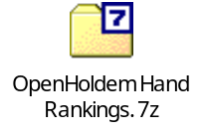

The rank order of hands changes depending on the number of opponents (f$p function).

From this hand rank table, OpenHoldem will derive the symbols handrank, handrank169, handrank1326, handrank2652, handrank1000, and handrankp.

There are two initial methods you can use to leverage these hand rankings in your formula. First, if you want a static rule that will not be affected by folding opponents then you would use this code snippet:

|| [ br==1 && handrank2652 <= 2652*dealposition/nplayersdealt**2 ]

Second, if you want a dynamic rule that will be affected by folding opponents then you would use this rule:

|| [ br==1 && handrank2652 <= 2652*betposition/nplayersplaying**2 ]

The table above also flags “good” hands with leading and trailing asterisks. The function used to determine the left asterisk is:

handrank2652 <= 2652/nplayersdealt

And the function used for the right asterisk is:

handrank2652 <= 2652 * (1.0 - e**(ln(0.500)/nopponents))

The right asterisk is the point where the probability that all opponent hands are worse becomes 50% or more.

For further reference, the following embedded file contains starting hand probabilities for 100,000 and 10 million hand samples.

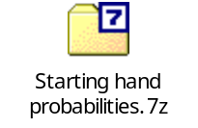

The Scrape Cycle (or “Heartbeat”)
Once OpenHoldem has been connected to a table, it will enter into a continuous loop that performs a variety of actions. The cycle of these actions is described here.

action | explanation
scrape window | Ask the screen scraper engine to scrape and interpret the current pixels on the poker window based on the parameters in the loaded Table Map {Creating a Table Map}
scraper override | If a Scraper Override DLL is loaded, then pass the current screen scrape to that DLL for possible overrides {Scraper Override DLL}
calculate symbols | Calculate all OpenHoldem symbols {Calculated Symbols}
create replay frame | If a replay frame {Replay Frames} is requested in preferences {Preferences}, create it now
validate game state | If the Validator {Validator} is enabled in preferences {Preferences}, then validate the current game state
send state to user dll | If a User DLL {User DLL} is loaded, then send the current game state to it
autoplay | If the Autoplayer {The Autoplayer} is engaged, then ask the Autoplayer to do its bit
wait | Sleep for the Scrape Delay period of time as specified in preferences {Preferences}

The Autoplayer
OpenHoldem’s Autoplayer engine uses the following logic to decide what action to take on the poker window:

- If the f$alli function evaluates to non-zero, and an all-in control is present (slider/SWAG box) then move all-in
- Else if the f$swag function evaluates to non-zero, and the SWAG box is present, then enter the f$swag result into the SWAG box and confirm the bet
- Else if the f$rais function evaluates to non-zero, and the Raise button is present, then click the Raise button
- Else if the f$call function evaluates to non-zero, and the Call button is present, then click the Call button
- Else if the Check button is present, then click the Check button
- Else click the Fold button

To determine when and which action to take the Autoplayer performs the following actions:

action | explanation
handle f$play | Evaluate the f$play function and take action depending on its return value
handle spam | Evaluate any i86 regions, and dismiss any popups/spam
handle f$prefold | If f$prefold evaluates to non-zero, then engage the prefold button as defined in the Table Map
handle f$chat | If f$chat evaluates to non-zero and safety constraints have been met, then enter a chat message into the chat box as defined in the Table Map
isfinalanswer | Determine the value of the isfinalanswer symbol – if the Iterator has finished, at least one action button is visible, we are “playing”, the number of sequential stable frames have been seen and the time value in f$delay has passed, then isfinalanswer is true
evaluate primary functions | f$alli, f$swag, f$rais and f$call are evaluated
take action based on the above logic | Use the if-then-else logic as described above to take the appropriate Autoplayer action

Replay Frames
OpenHoldem has the ability to create “Replay Frames”, either automatically as set in {Preferences}, or when the “camera” icon on the main toolbar {Toolbars} is clicked. A “Replay Frame” (or “frame” for short), is a combination of a Windows bitmap-formatted image file (.bmp) and an associated HTML file. These two files, in combination, provide an easy way to reproduce and diagnose a particular game situation. This is extremely helpful in the building and testing of your Table Maps and bot logic in an offline fashion. Simply connect OpenHoldem to a live poker table, and collect interesting frames for later use. Then at a later time, use {OHReplay} to display these frames. Further connect OpenScrape or OpenHoldem to these OHReplay-displayed frames and work at your leisure.

The HTML provides crucial context for the frame, the most important of which is the title text. This text is used exhaustively in most Table Maps to understand the game state.

Often, when you post a problem or discussion on the forums, you will be asked to provide a frame and Table Map to help the developers diagnose your problem. Feel free to open the bitmap image in your favorite image editor (MS Paint?) and black out the sensitive portions if needed. Be aware that blacking out some parts of the image may prevent the developers or community from helping you, so be careful with that.

Note: Both parts of the frame (.bmp and .html) and the associated Table Map are required to be provided when this is asked from you to help solve your problem!

Frames are created in a “replay” directory directly under the directory from which you launched OpenHoldem. The .bmp files are large, so ensure that you have enough space to hold the maximum number of frames you specified in {Preferences}. Once the maximum number is reached, OpenHoldem will start reusing frame numbers from the beginning.

PokerPro
PokerPro is a poker server developed by Ray Bornert. OpenHoldem has the ability to connect to this server, the primary benefit of which is the development of bot logic without risking real money. The configuration of the PokerPro server and a description of its network protocols is beyond the scope of this documentation, but extensive support on the topic can be found here: http://forum.winholdem.net/wbb/viewforum.php?f=22

When the main menu item PokerPro/Go is selected, the following window will appear:

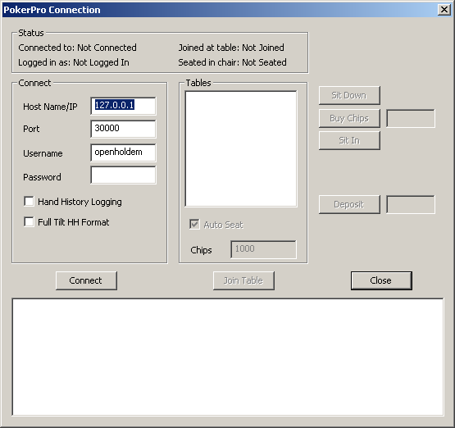
Figure 5.28-62 OpenHoldem PokerPro control

The top of this window provides a group box that informs you of the connection status to the PokerPro server.

On the left third of the window, in the “Connect” group box is where the connection details of the PokerPro server are specified. Additionally, you can choose to log hand histories either in the default PokerPro format or in the Full Tilt format here.

Once the server details are entered in the “Connect” group box, the “Connect” button can be used to connect to the server.

Upon connecting to the PokerPro server with the “Connect” button, the “Tables” group box in the middle third of the window will be populated with tables that are available on the connected PokerPro server. If you would like PokerPro to automatically seat you at a table when you join it, check the “Auto Seat” box and enter the amount of starting chips you would like to have.

After a table is selected from the “Tables” group box, you can join the selected table by clicking the “Join Table” button.

Once a table has been joined, the “Sit Down”, “Buy Chips”, “Sit In” and “Deposit” controls on the right third of the window will be enabled.

The bottom portion of this window contains a large scroll box that displays messages from the PokerPro server.

This window can be closed, and OpenHoldem will maintain its connection to the PokerPro server. To close the connection, reopen this window and choose the “Leave Table” or “Disconnect” buttons as needed.

PokerTracker
Before you try to configure OpenHoldem to work with a Poker Tracker database, you must have a properly working Poker Tracker configuration set up first. This is not the most trivial of activities, and does have a learning curve. The best information on how to set up Poker Tracker can be found here: http://www.pokertracker.com

Assuming you have a working Poker Tracker installation, let’s move on to getting OpenHoldem to work with your Poker Tracker database. OpenHoldem only works with PostgreSQL Poker Tracker databases, so if you do not have Poker Tracker configured in that way (and you know if you do), go back here and get that set up first. http://www.pokertracker.com

OK, so now you have Poker Tracker installed using PostgreSQL as the underlying database. Do you have Poker Tracker setup to automatically import hand histories into your database? If not, OpenHoldem will not be able to provide you any useful information, as there will be no information in your database to pull from. Learn how to automatically import hand histories here: http://www.pokertracker.com

After all of that is configured, you can use the settings in {Preferences} to instruct OpenHoldem how to connect to your Poker Tracker database.

When connected, OpenHoldem will query the database using the sitename and playername as key parameters for the query.

Sitename
Everything in Poker Tracker is first organized by what it calls a “site id”. When querying the database, the first thing OpenHoldem will try to do is associate your sitename or network, as specified in the Table Map, to a Poker Tracker “site id”. This is done by doing a case-insensitive substring lookup against the following lists. This means that if your sitename string is “stars10sng” it will still be able to associate that to the proper “site id”, as “stars” is within that sitename.

Version 2 list: "Stars", "Party", "Ultimate", "Absolute", "Microgaming", "Ongame", "Cryptologic", "Pacific", "FullTilt", "B2B", "Tribeca", "Worldpex", "iPoker", "Tain", "Bodog", "Everest", "Boss", "Betfair"

Version 3 list: "Stars", “Party", “FullTilt”, “iPoker", "Everest”, "Ongame"

If one of the above character strings cannot be found in either the sitename or network strings, as specified in your Table Map file, using a case-insensitive substring search, then OpenHoldem will not be able to lookup statistics for the players playing at your table.

As a note, the sitename string is searched first, and if a match cannot be found there, then the network string is searched.

Playername
The second critical piece of information that OpenHoldem needs to query the database is the name of the player. OpenHoldem gets this from the pXname/uXname regions on the Table Map. Note that this scraped name does not need to exactly match the name as stored in the database. This is useful, as there is currently no method for scraping spaces in players’ names. OpenHoldem will in all cases, return the statistics for an exact name match if it exists, and if it does not exist, will find the closest match using a Levenshtein distance algorithm (http://en.wikipedia.org/wiki/Levenshtein_distance). Note that Levenshtein distances that exceed one-half the length of the name as stored in Poker Tracker are discarded as invalid.

Poker Tracker symbols
Assuming all the prerequisites as described above are met, the following symbols will be available to your bot for use in its logic processing. The appropriate use of these symbols in opponent modeling is beyond the scope of this document, but plenty of references can be found on the Internet with a Google search.

Ring symbols

Symbol | Explanation
pt_iconx (x=0-9) | Poker Tracker auto-rate icon code for chair x
pt_iconlastrx (x=1-4) | Poker Tracker auto-rate icon code for the last raiser in round x
pt_pfrx (x=0-9) | Poker Tracker pre-flop raise percentage for chair x
pt_aggtotx (x=0-9) | Poker Tracker total aggression for chair x
pt_aggtotnopfx (x=0-9) | Poker Tracker total aggression excluding preflop for chair x
pt_aggpx (x=0-9) | Poker Tracker preflop aggression for chair x
pt_aggfx (x=0-9) | Poker Tracker flop aggression for chair x
pt_aggtx (x=0-9) | Poker Tracker turn aggression for chair x
pt_aggrx (x=0-9) | Poker Tracker river aggression for chair x
pt_floppctx (x=0-9) | Poker Tracker saw flop pct for chair x
pt_turnpctx (x=0-9) | Poker Tracker saw turn pct for chair x
pt_riverpctx (x=0-9) | Poker Tracker saw river pct for chair x
pt_vpipx (x=0-9) | Poker Tracker VP$IP for chair x
pt_handsx (x=0-9) | Poker Tracker number of hands that are in the database for chair x
pt_pf_rfix (x=0-9) | Poker Tracker "pre-flop raise first in" pct for chair x
pt_pf_crx (x=0-9) | Poker Tracker "pre-flop called raise" pct for chair x
pt_pfatsx (x=0-9) | Poker Tracker attempt to steal blinds for chair x
pt_wsdpx (x=0-9) | Poker Tracker went to showdown percentage for chair x
pt_wssdx (x=0-9) | Poker Tracker won $ at showdown for chair x
pt_fsbtsx (x=0-9) | Poker Tracker folded small blind to steal for chair x
pt_fbbtsx (x=0-9) | Poker Tracker folded big blind to steal for chair x

Ring symbols for the "raischair"

Symbol | Explanation
pt_ricon | Poker Tracker auto-rate icon code for raise chair
pt_rpfr | Poker Tracker pre-flop raise percentage for raise chair
pt_raggtot | Poker Tracker total aggression for raise chair
pt_raggtotnopf | Poker Tracker total aggression excluding preflop for raise chair
pt_raggp | Poker Tracker preflop aggression for raise chair
pt_raggf | Poker Tracker flop aggression for raise chair
pt_raggt | Poker Tracker turn aggression for raise chair
pt_raggrv | Poker Tracker river aggression for raise chair
pt_rfloppct | Poker Tracker saw flop pct for raise chair
pt_rturnpct | Poker Tracker saw turn pct for raise chair
pt_rriverpct | Poker Tracker saw river pct for raise chair
pt_rvpip | Poker Tracker VP$IP for raise chair
pt_rhands | Poker Tracker number of hands that are in the database for raise chair
pt_rpf_rfi | Poker Tracker "pre-flop raise first in" pct for raise chair
pt_rpf_cr | Poker Tracker "pre-flop called raise" pct for raise chair
pt_rpfats | Poker Tracker attempt to steal blinds for raise chair
pt_rwsdp | Poker Tracker went to showdown percentage for raise chair
pt_rwssd | Poker Tracker won $ at showdown for raise chair
pt_rfsbts | Poker Tracker folded small blind to steal for raise chair
pt_rfbbts | Poker Tracker folded big blind to steal for raise chair

Tournament symbols

Symbol | Explanation
ptt_iconx (x=0-9) | Poker Tracker auto-rate icon code for chair x
ptt_iconlastrx (x=1-4) | Poker Tracker auto-rate icon code for the last raiser in round x
ptt_pfrx (x=0-9) | Poker Tracker pre-flop raise percentage for chair x
ptt_aggtotx (x=0-9) | Poker Tracker total aggression for chair x
ptt_aggtotnopfx (x=0-9) | Poker Tracker total aggression excluding preflop for chair x
ptt_aggpx (x=0-9) | Poker Tracker preflop aggression for chair x
ptt_aggfx (x=0-9) | Poker Tracker flop aggression for chair x
ptt_aggtx (x=0-9) | Poker Tracker turn aggression for chair x
ptt_aggrx (x=0-9) | Poker Tracker river aggression for chair x
ptt_floppctx (x=0-9) | Poker Tracker saw flop pct for chair x
ptt_turnpctx (x=0-9) | Poker Tracker saw turn pct for chair x
ptt_riverpctx (x=0-9) | Poker Tracker saw river pct for chair x
ptt_vpipx (x=0-9) | Poker Tracker VP$IP for chair x
ptt_handsx (x=0-9) | Poker Tracker number of hands that are in the database for chair x
ptt_pf_rfix (x=0-9) | Poker Tracker "pre-flop raise first in" pct for chair x
ptt_pf_crx (x=0-9) | Poker Tracker "pre-flop called raise" pct for chair x
ptt_pfatsx (x=0-9) | Poker Tracker attempt to steal blinds for chair x
ptt_wsdpx (x=0-9) | Poker Tracker went to showdown percentage for chair x
ptt_wssdx (x=0-9) | Poker Tracker won $ at showdown for chair x
ptt_fsbtsx (x=0-9) | Poker Tracker folded small blind to steal for chair x
ptt_fbbtsx (x=0-9) | Poker Tracker folded big blind to steal for chair x

Tournament symbols for the "raischair"

Symbol | Explanation
ptt_ricon | Poker Tracker auto-rate icon code for raise chair
ptt_rpfr | Poker Tracker pre-flop raise percentage for raise chair
ptt_raggtot | Poker Tracker total aggression for raise chair
ptt_raggtotnopf | Poker Tracker total aggression excluding preflop for raise chair
ptt_raggp | Poker Tracker preflop aggression for raise chair
ptt_raggf | Poker Tracker flop aggression for raise chair
ptt_raggt | Poker Tracker turn aggression for raise chair
ptt_raggr | Poker Tracker river aggression for raise chair
ptt_rfloppct | Poker Tracker saw flop pct for raise chair
ptt_rturnpct | Poker Tracker saw turn pct for raise chair
ptt_rriverpct | Poker Tracker saw river pct for raise chair
ptt_rvpip | Poker Tracker VP$IP for raise chair
ptt_rhands | Poker Tracker number of hands that are in the database for raise chair
ptt_rpf_rfi | Poker Tracker "pre-flop raise first in" pct for raise chair
ptt_rpf_cr | Poker Tracker "pre-flop called raise" pct for raise chair
ptt_rpfats | Poker Tracker attempt to steal blinds for raise chair
ptt_rwsdp | Poker Tracker went to showdown percentage for raise chair
ptt_rwssd | Poker Tracker won $ at showdown for raise chair
ptt_rfsbts | Poker Tracker folded small blind to steal for raise chair
ptt_rfbbts | Poker Tracker folded big blind to steal for raise chair

Memory Symbols

Introduction
One of the most powerful features of OpenHoldem is its ability to remember. Very few other bots have this ability.

Planning
Working with memory symbols requires a bit of planning and specifically one should keep the following in mind:
- OpenHoldem does not know your memory symbol before you create it. This sounds simple but one should not forget it because it could create problems with your fist hand.
- Once a memory symbol is created, and a value is stored, OpenHoldem will remember that value until it is altered or replaced by another or until OpenHoldem is closed. This is great if you want OpenHoldem to remember what happened 10 hands ago but could bite you if you forget to reset them.
- It is of utmost importance to decide when and what should be remembered.

Formulation
The formulation of the memory symbol is as follows:

me_st_abc_123_45 - 'me_st_' stores a value "123.45" in variable "abc" (use "_" for the decimal in values)

A function name can also be passed in, instead of a number, for example: 'me_st_def_f$myfunc' would store the results of function f$myfunc in variable “def”.

me_re_abc - 'me_re_' retrieves the value from variable "abc"

Putting it together
To make things clear we will be putting two memory symbols into your bot.
A) We will create a “Stack to Pot Ratio” memory symbol (the function of this symbol is to store the ratio of our balance to the pot at the start of the betting on the flop to be retrieve later in order to make commitment decisions), and
B) We will create a “Slow Play” memory symbol, (the function of this symbol is to store our decision during a betting round that we will check-raise the next betting round regardless of what the next card is)
STEP 1: Create the symbols:
In f$alli we put:

(br==1 && !(didchecround1 || didcallround1 || didraisround1 || didswaground1) ? me_st_stpr_0 : 0) + (br==1 && !(didchecround1 || didcallround1 || didraisround1 || didswaground1) ? me_st_slowplay_0 : 0) +

English translation: it is preflop and we have not yet acted then we will create the memory symbols “stpr” (stack to pot ratio) and “slowplay” and we will reset the values to zero.
Comment: we do this in f$alli because it is the first formula that is evaluated by OpenHoldem. If we had put it in a formula that is not evaluated then no value will be stored.

STEP 2 (a):
In f$alli we put
(br==2 && !(didchecround2 || didcallround2 || didraisround2 || didswaground2) ? me_st_stpr_f$stpr : 0) + (br==2 && !(didchecround2 || didcallround2 || didraisround2 || didswaground2) ? me_st_slowplay_f$slowplay : 0)

English translation: it is on the flop and we have not yet acted then we will store the values of the functions f$stpr and f$slowplay at that moment.
Comment: Again this is the first thing we want OpenHoldem to do. It is very important to decide exactly when to pass the value into the memory symbols. Please note that the last line does not have “+”

STEP 2(b)
We create the functions whose value we want to store:

f$stpr

balance/potcommon

Comment: we don’t use “pot” because that would include any bets during round2 before us.

f$slowplay

br==2 && nhandshi==0 ? 1 : 0

Comment: this formula will return 1 when we have the nuts and this will be stored into the “slowplay” memory symbol

STEP 3
Retrieve and use the memory.
In f$srai we put

br==3 && me_re_slowplay && me_re_stpr<10 ? balance : 0

English translation: It is the turn and we, on the flop, decided to slow play and the ratio between the pot (at the start of br==2) and our balance at that time was 1:10 and therefore we will shove.

Conclusion
The memory symbols are very powerful but need a bit of planning. It is important to decide when to define, store and retrieve the values in these symbols.

f$chat
OpenHoldem’s chat feature is provided for two reasons: deception and fun. The key to chat is to use it wisely and to not overdo it.
OH-Script
Create a new formula f$chat with OpenHoldem, which returns 0, if you wish no chat and one of the constants described below to send a simple chat message. These constants are not available as OpenHoldem symbols, you have to use the numerical values (gg=1, nh=2, ...).
OH-Script with DLL
Simply define f$chat as dll$chat and handle this symbol in “query_symbol“ in your DLL. Return the same constants as used above to specify the message to send, especially “no_simple_Chat” to send no message.
DLL only
Using Chat in your DLL gives you two additional opportunities:
- Any chat message you want
- At any time
At startup your DLL will receive an additional message "p_send_chat_message", providing a pointer to access the chat function. The function has the following prototype:

void SendChatMessage(char* new_message)
Available chat messages
A complete list of available symbols for formula coders is defined in “PokerChat.hpp”

enum
{
no_simple_Chat = 0,
simple_Chat_gg,
simple_Chat_nh,
simple_Chat_vnh,
simple_Chat_n1,
simple_Chat_wow,
simple_Chat_lol,
simple_chat_rofl,
simple_Chat_haha,
simple_Chat_tu,
simple_Chat_thx,
simple_Chat_omg,
simple_Chat_sick,
simple_Chat_fu,
simple_Chat_fish,
simple_Chat_hi,
simple_Chat_hello,
simple_Chat_bye,
};
Safety measure:
To prevent a crazy bot flooding the chat, there are two settings in {Preferences}:
- Minimum delay (seconds)
- Additional random delay (seconds)

Adjust these to any value you are comfortable with, if you trust your bot.
Limitations:
- One message at a time. There is no waiting list, or queue, to handle multiple messages (as we are lazy and assume, there's no need for too much chat at a poker table).
- There is no way to specify any concrete delay. The messages will be sent only when {The Autoplayer} is active and there will be an additional delay per character, the intent being to simulate human-like input.
- Only predefined chat messages if you are not using a DLL.
- No support for non-alpha-numeric-characters, due to technical reasons.
- On some sites that temporarily block the chat (e.g. Cakepoker), multiple chat messages can queue up in the poker client. The obvious counter measure would be to always delete the chat box, but that could raise a red flag on other sites.
Chat and Table Maps
In order to use the chat function, OpenHoldem has to know where the chat box of your casino software is. Therefore the corresponding TableMap has to specify a region that defines the location of the chat box. The name of this region is “chatbox“, and describes a rectangle with no transform.
Without the chat box region, all attempts to chat will be ignored without any warnings, avoiding anything that could disturb the screen scraping process.

Validator

Overview
The Validator is a new tool introduced with OH 2.0.0, that is aimed to help people to develop more reliable bots and Table Maps. It will execute several hundred consistency-checks at the symbol level to detect invalid game-states, mis-scrapes or incomplete information. The Validator will write possible problems to the log-file and also show a message box, as long as messages are not disabled in {Preferences}.

This feature is being actively developed, please see the forum for more information: http://www.maxinmontreal.com/forums/viewtopic.php?f=189

Preferences
The Validator offers several options, available at "Edit -> Preferences -> Validator".

- Never: The Validator will be turned off completely. Not recommended for real-money-play.
- When it is my turn: The Validator will check the rules, when it is your turn, i.e when buttons are visible. This setting offers a good tradeoff between reliability and performance. Recommended for real-money-botting.
- Always: The validator will check all rules once per heartbeat-cycle. This setting will detect errors, even if it is not your turn, but it causes also a higher CPU-usage. Recommended for verification of new or modified TableMaps and for testing of bots.
- Use heuristic rules: Some rules are heuristic, i.e. they are "common sense", but not always true. Example: A game does usually not last longer than 2 minutes, so the Autoplayer has to act at least once per 120 seconds. If it does not do so, there seems to be a problem. Maybe the Table Map does not detect the players cards or the buttons. This setting can result in false positives and is recommended for testing only, but not for real-money-play.
- Stop Autoplayer on error: This setting will quit playing immediately, if an error occurs. Recommended for testing, if you want to investigate the error immediately, and maybe for very conservative real-money-botting.

Technical documentation
The Validator basically consists of a set of several hundred rules to be checked. Each rule is written in pseudo-code, that can be translated into C-macros easily (there is a little Perl-script for that purpose, "rules2cpp.pl"). Each rule consists of:

- a unique ID for the test case
- a flag to distinguish heuristic and non-heuristic rules
- some verbal reasoning.
- a precondition, that checks, if a rule can be applied to the current game state
- a postcondition, that has to be met, if a rule can be applied
- a list of symbols, that got used and are possibly affected in case of an error

In practice it looks like this:

BEGIN_TESTCASE
TESTCASE_ID ("0501")
HEURISTIC_RULE (false)
REASONING ("If it's my turn, then there has to be always a check or a call button.")
PRECONDITION ("ismyturn")
POSTCONDITION ((("myturnbits" & BUTTON_CHECK) != 0) || (("myturnbits" & BUTTON_CALL) != 0))
SYMBOLS_POSSIBLY_AFFECTED ("ismyturn, myturnbits")
END_TESTCASE

Log Files
OpenHoldem will generate a number of log files as it operates. The verbosity of the standard log and the Poker Tracker log can be set in {Preferences}.

Standard Log
This contains key actions that OpenHoldem sees, such as connection to a new table, table reset, and hand resets, player actions, as well as detailed before and after Autoplayer action information. The before-after Autoplayer action information is saved as a single line with the following format:

# hand commoncard rank poker win los tie P nit bestaction - play* call bet pot balance - FCRA FCRA swag

From left to right, the fields in this line are:
- # - Number of chairs at the table (as defined in the Table Map)
- hand - your hole cards
- commoncard – the board cards
- rank - your hand rank (as specified in {Preferences})
- poker - your poker hand
- win / los / tie - the prwin/prlos/prtie Iterator results
- P - the results from your f$P formula
- nit - your NIT setting from the Table Map
- bestaction - the action that the Autoplayer should take, based on the primary function results
- play - the actual action taken by the Autoplayer (may not be the same as best action, if the best action button is not present, for example)
- call / bet / pot / balance - the value of call, bet, pot and balance symbols
- first FCRA - the status of the fold, call, check, raise and allin buttons as seen by the scraper engine
- second FCRA - the status of the f$call, f$rais and f$alli functions
- swag - the value of the f$swag function

PokerTracker Log
The Poker Tracker log is created if you are connected to a Poker Tracker database, and depending on the level of verbosity, will provide exact query SQL that is sent to the database when statistics are needed.

f$debug log
This log is created when set from the menu options in the Formula Editor window.

Autoplayer Trace
This is an example of the log entries that are added to the standard log if the Autoplayer Trace option is enabled in {Preferences}.

*************************************************************
HAND RESET (num:0 dealer:2 cards:KsKc): Poker Academy Pro
*************************************************************
ROUND 1
>>> New hand 0
>>> My turn, br=1
>>> Chair 2 (6lleilli) posted the sb: $0.00
>>> Chair 3 (GusXensen) posted the sb: $0.00
>>> Chair 4 (JackPott) posted the sb: $0.00
>>> Chair 5 (Kale) posted the sb: $0.00
>>> Chair 1 (DanielXn) posted the sb: $0.00
log$ (Total: 19 | Showing: 19)
f$swag=40.00 [Line: 1, Col: 49]
f$srai=40.00 [Line: 4, Col: 9]
f$preflop_srai=40.00 [Line: 12, Col: 87]
f$preflop_position=4.00 [Line: 5, Col: 50]
nplayersdealt=6.00
dealposition=6.00
ncallbets=1.00
nopponentsbetting=3.00
islist16=1.00
bblind=10.00
br=1.00
f$raise_min_amount=10.00 [Line: 1, Col: 12]
currentbet=0.00
call=10.00
f$swag_adjust=0.00 [Line: 3, Col: 1]
swagtextmethod=1.00
f$call=1.00 [Line: 7, Col: 4]
f$srai=40.00 [Cached]
call=10.00
6 KsKc .......... 2 1pair 578 417 5 3 1000 $40.00 - SWAG 10.00 10.00 25.00 0.00 - FCRA .C.. 40.00
How to read the log
f$swag returned 40 processing line 1, character 49. It called the following functions: f$srai, f$raise_min_amount, f$swag_adjust, and used no other symbols.
f$preflop_position (returning on line 5 processing character 50) was called from f$preflop_srai which was called from f$srai. It called no other functions and used 2 symbols; nplayersdealt, dealposition whose values were 6 and 6.

ROUND 2
log$ (Total: 34 | Showing: 34)
Monster_Hand
checkLast_Monster_Raise
f$swag=115.33 [Line: 1, Col: 49]
f$srai=115.33 [Line: 10, Col: 9]
f$postflop_srai=115.33 [Line: 6, Col: 31]
f$postflop_scenario=2.00 [Line: 7, Col: 77]
f$round_first_action=1.00 [Line: 2, Col: 38]
didswag=0.00
didrais=0.00
didcall=0.00
didchec=0.00
betposition=3.00
ncallbets=0.00
nplayersround=3.00
f$flop_checklast_srai=115.33 [Line: 2, Col: 67]
f$handstrength=1.00 [Line: 8, Col: 105]
f$c_hs_MONSTER=1.00 [Line: 1, Col: 1]
br=2.00
vs$80$prlos=0.06
log$Monster_Hand=1.00
f$c_hs_MONSTER=1.00 [Cached]
f$cbet_amount=115.33 [Line: 1, Col: 23]
random=0.60
pot=160.00
log$checkLast_Monster_Raise=1.00
br=2.00
br=2.00
f$raise_min_amount=0.00 [Line: 1, Col: 12]
currentbet=0.00
call=0.00
f$swag_adjust=0.00 [Line: 3, Col: 1]
swagtextmethod=1.00
f$call=1.00 [Line: 5, Col: 7]
call=0.00
6 KsKc JsKd4c.... 2 3kind 915 85 0 2 1000 $115.33 - SWAG 0.00 10.00 160.00 0.00 - FCRA .C.. 115.33

log$ (Total: 30 | Showing: 30)
Monster_Hand
reraise_Monster_BIGRaise
f$swag=2340.00 [Line: 1, Col: 49]
f$srai=2340.00 [Line: 10, Col: 9]
f$postflop_srai=2340.00 [Line: 12, Col: 31]
f$postflop_scenario=5.00 [Line: 9, Col: 30]
f$round_first_action=0.00 [Line: 2, Col: 2]
didswag=1.00
didswag=1.00
nbetstocall=78.00
f$flop_reraised_srai=2340.00 [Line: 2, Col: 68]
f$handstrength=1.00 [Line: 8, Col: 105]
f$c_hs_MONSTER=1.00 [Line: 1, Col: 1]
br=2.00
vs$80$prlos=0.06
log$Monster_Hand=1.00
f$c_hs_MONSTER=1.00 [Cached]
f$raise_big_amount=2340.00 [Line: 1, Col: 5]
pot=1170.00
log$reraise_Monster_BIGRaise=1.00
br=2.00
br=2.00
f$raise_min_amount=895.00 [Line: 1, Col: 12]
currentbet=115.00
call=780.00
f$swag_adjust=0.00 [Line: 3, Col: 1]
swagtextmethod=1.00
f$call=1.00 [Line: 7, Col: 4]
f$srai=2340.00 [Cached]
call=780.00
6 KsKc JsKd4c.... 2 3kind 969 31 0 1 1000 $2340.00 - SWAG 780.00 10.00 1170.00 0.00 - FCRA .C.. 2340.00

Command Line Options
Version 2.0.0 of OpenHoldem introduced the ability to instruct OpenHoldem to use .ini files for storage of preferences, rather than using the registry. This is beneficial for two reasons:
- Stealth: .ini files are easier to hide than the registry
- Portability: .ini files can easily be deployed and moved from machine to machine

To specify the use of .ini files for preferences, rather than the registry, there are three options:
- “/ini” specifies the use of openholdem.ini, created in the OpenHoldem startup directory
- “/ini:[filepath]” specfies the use of [filename] as the ini file, must be a full path
- “/ini:~\[filename]” specifies the use of [filename] in the OpenHoldem startup directory as the ini file

Advanced Topics
Version 2.0.0 of OpenHoldem introduced the ability to instruct OpenHoldem to connect to a poker table by sending a connect message specifying a HWND. This is useful for automation reasons.

ManualMode & OHReplay

ManualMode

Description
ManualMode is a tool for simulating a poker game state offine. It allows you to set any game state you can think of, including your cards, players’ cards/backs, names, balances, blinds, game types, button, bets, buttons, etc.

A Table Map is included with the ManualMode tool to allow OpenHoldem to connect to the ManualMode main window and scrape the game state 100% correctly into the OpenHoldem engine. This will allow for offline construction of bot logic and the easy setup of various game state situations, some of which are very rare online (think Straight Flushes).

Familiarizing yourself with ManualMode

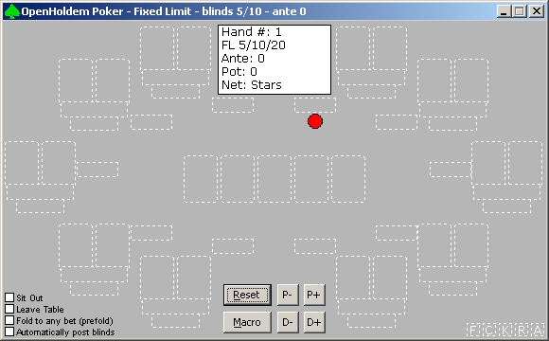
Figure 6.1-63 ManualMode main window

The ManualMode interface is quite intuitive. All relevant elements on the poker table are visible at all times, either populated with objects (like cards or bets), or outlined in white dashed lines if not populated. Each game state element is interacted with slightly differently and is discussed below. In general, however, right-clicking on any element will bring up a list of options you can take to set that element’s state.

- Common Cards: Right-clicking on each common card will bring up a context menu allowing the selection of rank/suit, or “no card”.
- Sit Down/Stand Up: OpenHoldem recognizes the difference between sitting in at a chair, and sitting in a game and being dealt a hand. Right-clicking on either of a player’s cards will bring up a context menu allowing the player to Sit Down or Stand Up from the selected chair.
- Sit In/Sit Out: OpenHoldem recognizes the difference between sitting in at a chair, and sitting in a game and being dealt a hand. Once you have “Sat Down” at a chair, right-clicking on either of a player’s cards will bring up a context menu allowing the player to Sit In to the game or Sit out from the game.
- Player Cards: Right-clicking on either of a player’s cards will bring up a context menu allowing the selection of rank/suit, “cardbacks” or “no card”. Note: prior to assigning cards, a player must have “Sat In” the game.
- Player Names: Right-clicking on the player’s name rectangle will pop up a window prompting for a string to use as the player’s name. Note: prior to assigning names, a player must have “Sat Down” at the table.
- Player Balances: Right-clicking on the player’s balance rectangle will pop up a window prompting for a string to use as the player’s balance. Note: prior to assigning balances, a player must have “Sat Down” at the table.
- Player Bets: Right-clicking on the player’s bet rectangle will pop up a window prompting for a string to use as the player’s bet. Note: prior to assigning bets, a player must have “Sat In” the game.
- Dealer Button: Right-clicking on either of a player’s cards will bring up a context menu allowing the assignment of the dealer button to the selected chair. The “D-” and “D+“ buttons can also be clicked to move the dealer button around the table anti-clockwise or clockwise.
- Blinds/Limits: Right-clicking on the center information box will pop up a window in which the small blind, big blind, big bet, ante, game type (FL, PL, NL), network (useful if integrating with {PokerTracker}), and tournament indicator can be set.
- Buttons: Left-clicking on any game-state button on the table will toggle its state from on to off. These include the FCKRA buttons on the bottom right (fold, call, check, raise, allin), and the “play” buttons on the lower left (sit out, leave table, prefold, autopost).

There are some shortcuts built into ManualMode to allow easier setup of game states:
- “P-“ and “P+” buttons: These buttons will remove and add players from the table. As players are added, they will Sit Down, Sit In, and will be assigned a name and balance. Players will be added from chair 0 to chair 9, depending on what is open, and removed in reverse order.
- Macro: Right clicking on the “Macro” button will open a window allowing for a string to be entered. Left clicking on the “Macro” button will execute that macro. The format of the macro string is described here: {Macros}
- Betting: Left-clicking on a player’s bet rectangle will call the current bet. Shift-left-clicking on a player’s bet rectangle will raise. (right click to set a specific SWAG).

Note: When ManualMode detects a betting round change (i.e. 0 to 3, 3 to 4 or 4 to 5 common cards), then all player bets will be collected into the pot, and all player bets will be reset to zero.

ManualMode Options
Clicking on the System Menu (green spades symbol) on the ManualMode window will bring up the system context menu. On that menu is an entry for “Options…”. Selecting this entry will bring up the following window:

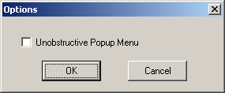
Figure 6.1-64 ManualMode options

On this window is only one option at the moment, to move the right-click popup menu so it does not show up on top of the ManualMode window. The reason for this is that the popup menu will overlay the game state elements, and cause havoc if you have connected an OpenHoldem instance to this ManualMode window. The drawback is that the popup menu appears in a different location from where you right-clicked, and is somewhat disconcerting until you get used to it. Thus the choice it yours – pick whichever method annoys you the least.

Macros
A macro string is a series of characters executed one at a time, left to right. The meaning of each character is as follows:

Character | Meaning
R (uppercase) | Reset the game state
P (uppercase) | Sit in a player at this chair, default name, default balance, and cardbacks.
p (lowercase) | Unseat a player at this chair.
b (lowercase) | Set the small blind at this chair
B (uppercase) | Set the big blind at this chair
23456789tjqka | Set the rank of the players cards at this chair, or common cards (player first, common next)
cdhs | See the suit of the players cards at this chair, or common cards (player first, common next)
n | Set the dealer to this chair

The default macro provided (“RPPPPPPPPPPbB”) will reset the table, set 10 players, and set chair 0 as the small blind and chair 1 as the big blind.

A macro of “RPPnAhAsPbPBPPP” will reset the table, seat 7 players, assign the user to chair 1 with the button and deal Ah As as hole cards, assign chair 2 to the small blind and assign chair 3 to the big blind.

OHReplay

Description
OHReplay is an application for displaying {Replay Frames}. That’s all it does. The nice thing is that OHReplay displays frames exactly as they are displayed by the casino’s poker client. That means that once a frame is displayed by OHReplay, you can connect OpenHoldem to that displayed frame just as if you were connecting to the native poker client window. This allows for easy debugging of your Table Map and bot logic while offline.

Familiarizing yourself with OHReplay
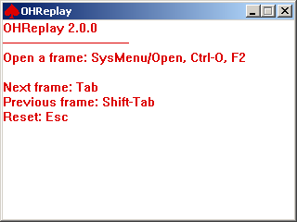
Figure 6.2-65 OHReplay main window

The initial window displayed by OHReplay when it starts up contains all the information you need to know to navigate the program:
- To open a frame, use the System Menu, the Ctrl-O keystroke combination (that is a capital oh, the letter between N and P), or the F2 key. Any of these choices will open the standard Windows file open dialog, from where you can choose the HTML file of the frame to open.
- To navigate between frames, use Tab or Shift-Tab to move to the next or previous numerical frame.
- To return to the initial screen, press Esc.

OHReplay Options
Clicking on the System Menu (red spades symbol) on the OHReplay window will bring up the system context menu. On that menu is an entry for “Open…”. Selecting this entry will bring up the same file open dialog as using F2 or Ctrl-O.

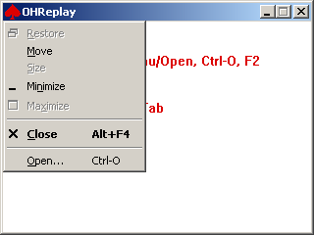
Figure 6.2-66 OHReplay options

Stealth
An important consideration for any botter is that of stealth. Many casinos will attempt to detect the OpenHoldem software on your computer, and will either warn you or seize your account’s funds if they find it. There are two general approaches to addressing this problem, a “Single System” solution and a “Dual System” solution. OpenHoldem provides a number of facilities for achieving both of these setups and obscuring the program from detection.

Note that a “System” as discussed in this chapter can refer to a physical machine or a virtual machine. VMware Workstation is a popular choice for consumer system virtualization, but certainly you can make use of the other consumer virtualization products available, such as VirutalPC or VirtualBox. Addtionally, dasta center-class, bare metal hypervisor products such as VMWare ESX or Citrix XEN will work fine as well. See the {VMWare} section for information on configuring VMWare Workstation. Configuration of other virtualization platforms is not discussed in this documentation.

OpenHoldem Single System Configuration
In this scenario, both the poker client software and OpenHoldem reside on the same machine. In this case, reference the {Registry}, {Obscure Preferences} and {Ninja Folders} sections at a minimum. Review of the {Rootkits} section is recommended.

OpenHoldem Dual System Configuration
In this scenario, the poker client software resides on “System A”, and the OpenHoldem software resides on “System B”. As the OpenHoldem software resides on a wholly different machine than the poker software, less thought needs to be given to protecting detection of the OpenHoldem software. OpenHoldem connects to the poker client windows using the {Bring} software as an intermediary. It should be obvious, but in order to make this scenario work, you either need two physical machines or two virtual machines. {Rootkits} still may be needed to obscure the network ports and traffic between the two systems.

Registry
By default, OpenHoldem will store its preferences and settings in Windows’ registry. Unfortunately, a quick registry scan of these known keys will alert the casinos to the presence of OpenHoldem on the machine. It is highly recommended that you make use of the “/INI” command line option to save these preferences and settings in a “.ini” file, that you name this file something clever and store it in a location that is not predictable. See the {Command Line Options} section for more information.

Obscure Preferences
By default, OpenHoldem uses names for window titles, mutexes, and class names that are easily detectable. It is highly recommended that you change these settings in {Preferences} to something non-obvious.

Bring
“Bring” is a software program developed by Ray Bornert and can be found here: http://www.winholdem.net/bring/index.html

The sole purpose of Bring is to enable a dual-system configuration, and allow the casino’s poker windows from “System A” to be displayed on “System B” where OpenHoldem can connect to them.

Ninja Folders
Original post here: http://forum.winholdem.net/wbb/viewtopic.php?t=4749
This article explains the basic steps for creating a windows folder that will be as secure as it can possibly be under the NTFS file system.
The general goal is to create a folder that is owned by a single windows user account such that no other user account may access the folder - not even the system or the admin account.
Prerequisites:
1) knowledge of creating/modifying user account
2) knowledge of windows explorer
3) knowledge of NTFS permissions
It is assumed that the reader understands how to create/modify a user account and how to use Windows Explorer to navigate folder space and how to modify folder properties/permissions.
Step 1 - login to your admin account
Step 2 - create/decide target account (from admin account)
This account will own the hyper-safe folder. For the purpose of this example, the account name "ninja" will be used. The "ninja" account must meet the following requirements:
a) it cannot be the Administrator account
b) it cannot be part of the Administrator group
c) it cannot be part of any group except the default users group.
If you need/want to create a special "ninja" account then do that first according to the restrictions above. If the account already exists then make sure it meets the requirements above.
Step 3 - create the target folder (from admin account)
Your goal here is to create/decide the target folder. In an ideal world you would create a top level folder on an empty local (non-shared/not-networked) hard drive where "ninja" has full control over that disk. If this is not possible then the next best thing is a top level folder on a non-shared drive. If this is not possible then you must select a location where "ninja" will have access to the parent folder so that it can access its private folder.
Step 4 - permissions (from admin account)
Select the properties for the folder and select the security tab add "ninja" to the access list and grant "ninja" full control. Remove all other users/groups from the access list, which will effectively shut out the entire world. There should be exactly one account in the access list and that account should be “<host>/ninja"
Uncheck/unselect "Allow inheritable permissions from parent to propagate to this object". The reason for this is that you want this folder and it's permissions to be the root node for all children below it. If you do not do this then permissions defined for the parent above your root folder will filter down to your folder and the children in your folder and you do not want that. Note that you cannot give ownership of objects in NTFS, you can only "take" ownership with the account you're currently using. You will take ownership of the folder later when you login to the "ninja" account.
Step 5 - logout of the admin account
Step 6 - login to your "ninja" account
Step 7 - ownership (from ninja account)
Select the properties for your "safe" folder and verify that "ninja" is the only account in the access list. Click the advanced button and goto the owner tab and select the "ninja" account. Check "Replace owner ..." and click "Apply". You should now be the full owner of your "safe" folder and everything below it.
Step 8 - permissions (from ninja account)
Click the permissions tab and check "Reset permissions on all child objects ...". Uncheck "Allow inheritable permissions from parent ..." (note this should already be unchecked since you did that from the admin account), then click apply. This will go quickly if the folder is empty. It can take seconds or minutes or more depending on the children folder tree below you.
Step 9 - verify
Create a test child folder inside your "safe" folder, view the properites and verify that "ninja" is the owner with full control and that no other account has access. If this is not the case then you missed a step above (probably the "Allow inheritable permissions ..." in step 4).
Step 10 - logout of the "ninja" account
Step 11 - login to the admin account
Step 12 - verify
Try to access the "safe" folder. You should not be able to access the contents of the folder nor modify the folder properties/permissions. As an admin you can still take ownership of the folder but until then the admin access is denied.
Other thoughts
If you have the resources and you want the best possible solution then you should dedicate an entire physical hard drive to your stealth department. That drive should not be the bootable system drive, but should be a secondary drive. You should consume all 4 primary partitions on your stealth drive by creating 4 primary partitions of roughly equal size. Each partition should be formatted with NTFS only (not FAT or FAT32).
You should then make the "ninja" account the owner of all 4 partitions and the sole account with access. There should be no other accounts listed in the access list. The drives should not be networked or shared. If you do this you will notice that your admin account cannot even read the device label and that the 4 hard drives will be seen only as "local-drive". All access from any accounts other than "ninja" will be denied.
The benefit of this setup is that once you construct a hard drive like this you dont have to worry about permissions ever again in the context of that drive - you know that anything you do on that drive must be done from the "ninja" account and that any folder/files created on that drive are entirely safe.
Casino software
If the casino software demands admin privs to install/update/run, and if you've successfully accomplished all 12 of these steps, then their software running as admin cannot automatically read your stealth drive(s) / folder(s) - the contents are very much private. However, if they are running as admin they could physically take ownership of the folder in order to gain access.
In this context, it must be said that such an event could be viewed as a criminal act in that there is absolutely no need whatsoever for their software to decide to "take" physical ownership of a folder just because it wants to.
An advanced step (not covered in this article) is to install/enable file/folder monitoring/auditing that will allow you to track anything that happens to your "safe" folder. Note that doing this would not stop admin/casino software from taking ownership but you'd have a record of the event which is better than nothing.

VMWare
Original post by Tammelinn here: http://forum.winholdem.net/wbb/viewtopic.php?t=11894

Guide to using OpenHoldem with VMware in 21 easy steps
by Tammelinn
This is a guide to show you how to get OpenHoldem running securely on a single computer using the VMware Server application as a second, "virtual" computer.
The guide assumes no special knowledge, but you will need some basic computer skills. You will need to know how to install software, how to rename files, how to navigate folders and so on.
I am also assuming that you are using the same operating system as me. If you are using Windows XP Media Centre Edition or Windows XP Professional, you can use this guide. If you are using some other brand of Windows (including Vista), the guide might not be reliable. I have only tested these instructions with XP.
Much of this information is already available elsewhere. In many cases, all I have done is to reword it a little.
Definitions
The "real" computer is the one that is sitting on your desk or on your lap. It has its own operating system. The "virtual" computer is the one we are going to create using VMware Server. We can think of the "virtual" computer as a separate computer with its own operating system, even though it is physically part of the "real" computer.
Step 1 - Download VMware Server
VMware Server is a free download from http://www.vmware.com (you will need to provide VMware with a valid e-mail address to get a serial number). I used version 1.0.3 while writing this guide.
You will also need a Windows installation disk. I am using a Windows XP Professional installation DVD, which I'm going to install as my "virtual" operating system.
While you wait for the download to finish, you should read the whole of this guide and make sure that you understand it. It would be a good idea to print it out, if you can.
DO NOT INSTALL ANY SOFTWARE until you are told to.
Step 2 - Install VMware Server on your real computer
Double-click on the VMware Server file you downloaded and it will begin installing itself. When you are asked if you want a "complete" or "custom" installation, choose "complete". A big window with some warnings about "IIS" might appear. We don't need IIS, so just click “OK”. When the installer asks for Internet access, grant it. Wait for the installation to complete before moving on to the next step.
Step 3 - Configure VMware Player
Double-click on the "VMware Server" icon that should have appeared on the desktop of your real computer. VMware Server will start for the first time. A Pop-up window asks you to choose between a local host and a remote host. Choose "local host" and click "OK".
Click the "New Virtual Machine" icon and a window will appear. Choose "typical" and click "next". Now choose which operating system you want to install on your virtual computer. Here, I selected the "Microsoft Windows" option, and the version I selected was "Windows XP, Professional".
The next window gives you two boxes to fill in. The first box gives you a chance to name your new virtual computer. Choose any name you like.
The second box ("Location") allows you to choose where the Virtual computer will be saved on your hard drive. You probably don't need to change the contents of this box. (The virtual computer is actually a single file which exists on the hard drive of your real computer. If you want this file to be in a different folder or even on a different partition, you can tell VMware now.)
Next you must choose the type of network. Choose "Use bridged networking".
The next window asks you to decide how big the virtual computer's virtual hard drive is going to be. The suggested 8GB is quite enough for the purposes of playing poker. Click "Finish" when you are ready.
VMware will spend quite a few minutes creating the virtual computer.
Step 4 - Install an operating system on the virtual computer
When VMware is ready, you'll see a new window with some details about the virtual computer. Find "Start this virtual machine" on the left and click it. VMware will now look for the Windows installation disk in your CD/DVD drive. Put the installation disk in the drive and Windows will begin installing onto your virtual computer.
Soon, Windows will ask you if you want to format your hard drive. Only the virtual hard drive of the virtual computer is going to get formatted, so you don't need to worry about the data on your real hard drive. It is perfectly safe. If you asked how you want to format the virtual hard drive, make sure you choose one of the NTFS options. (Do not choose any option with FAT16 or FAT32).
Eventually, Windows will ask you to enter your full name. We are going to create three seperate users, so choose a name for the first user ("Jessica", for example) and enter it here. This user will have permanent administrator privileges.
Next, enter an administrator password for this user. Write down the name and password now.
ADMINISTRATOR NAME AND PASSWORD _________________________
Later, Windows will ask you to enter up to five user names. The first user - the box labelled "your name" - should be the same as the user you entered above ("Jessica"). Don't fill in the other boxes yet.
Wait until the installation is complete. You should be looking at a brand-new installation of Windows XP. If you can run Solitaire (click "Start - All Programs - Games - Solitaire") then you are ready to move on to the next step.
Step 5 - Install VMTools, Firewall and Antivirus on virtual computer
VMTools is a package which, among other things, gets the mouse to move smoothly between the real and the virtual computer. You need to install it now, so press CTRL+ALT to restore mouse control to the real computer. Then, on the VMware Server window, click on the menu option VM, and then choose "Install VMTools..." VMTools will now install itself inside the virtual computer. The virtual computer will need to reboot.
After the reboot, find the VMTools icon in the system tray, next to the clock. It looks like three small interlinked squares. When you have found it, double-click on it.
A window appears and the "Options" tab is already showing. Find the line "Show VMware Tools in the taskbar" and click on it, so that there is no longer a tick next to it. Click “OK” to save your changes. This measure prevents the casino from seeing that you're using VMware - just in case they take a screenshot of your desktop.
Now, your virtual computer is connected to the Internet, so it needs firewall software and antivirus software, just as your real computer does. Install the software (connect to the Internet to download it, if you have to), and then run a scan to check that your virtual computer is free from viruses.
(You could use AVG Antivirus from http://free.grisoft.com, and Zonealarm Firewall from http://www.zonealarm.com)
Step 6 - Check that the real and virtual computers can communicate
If the real computer and the virtual computer can't communicate with each other, all your efforts in securing them will be wasted. Let's check the communications now.
The traditional way to test a network is to have one computer "ping" the other. A ping is a short signal which one computer sends to another. The signal will get bounced back if the network is running as it should.
Before pinging anything, you need to turn off the firewalls on both computers. If you have installed a firewall such as Zonealarm, switch it off. Now click "Start - Control Panel - Security Centre". At the bottom of the window is an option to "Manage security settings for: Windows Firewall". Click on "Windows Firewall" and make sure it is off. Do this on both computers.
Now you need to find out the IP address for both computers. (An IP address is a numerical address which computers on a network use to identify each other.)
On your real computer, click "Start - Run". Type "cmd" in the box and press return.
A new window appears. Type “ipconfig" and press return. You will see a series of numbers, some of which are marked "IP address". Find the one that corresponds to the type of Internet connection you have - for example, the one labeled "wireless connection" if you connect to the Internet through a wireless router.
The IP address of my real computer is 192.168.1.4 - yours probably looks almost the same. Write it down now.
REAL COMPUTER IP ADDRESS _________________________
Now do the same thing on your virtual computer. Find the IP address and write it down. The IP address of my virtual computer is 192.168.1.7 - yours will be similar.
VIRTUAL COMPUTER IP ADDRESS _________________________
On your real computer, find the new window again and type "ping x.x.x.x", then press return. Replace x.x.x.x with the IP address of your virtual computer. You should see something like this...
Pinging 192.168.1.7 with 32 bytes of data:
Reply from 192.168.1.7: bytes=32 time<1ms TTL=128
Reply from 192.168.1.7: bytes=32 time<1ms TTL=128
Reply from 192.168.1.7: bytes=32 time<1ms TTL=128
Reply from 192.168.1.7: bytes=32 time<1ms TTL=128
Ping statistics for 192.168.1.7:
(and so on)
This dialogue means that the real computer sent a signal to the virtual computer four times, and each time it got a response.
If the network isn't set up properly, you will see something like this...
Pinging 192.168.1.7 with 32 bytes of data:
Request timed out.
Request timed out.
Request timed out.
Request timed out.
Ping statistics for 192.168.1.7:
(and so on)
This dialogue means that the real computer sent a signal to the virtual computer four times, but received no response.
Go to your virtual computer and do the same thing. This time, type "ping x.x.x.x" replacing x.x.x.x with the IP address of your real computer. If you get a response, your network is set up properly and you can continue to the next step. If the network isn't set up properly, you should seek help from someone who understands networks.
Don't forget to TURN YOUR FIREWALLS BACK ON AGAIN when you finish this step. If you have a good firewall such as Zonealarm, you can leave the less powerful Windows firewall turned off permanently (on your real computer as well as your virtual computer).
Step 7 - Set up user accounts on virtual computer
Click "Start - Control Panel - User Accounts".
You had already set up one user while installing Windows. This user already has admin privileges. We'll call it the "admin" user. We need to give this user a password. It can be the same password you used in step 4. Click on the user, then click on "create a password". Enter the password into the boxes and click on "create password". The next window asks you if you want to make your files and folders private. You certainly do, so click "Yes, make private". Click on "Back" to return to the user accounts window.
Now we'll set up two new users with fewer privileges. You will be logged in as the second user whenever you connect to a casino. We'll call this the "casino" user. The third user will be created to hide things from the casino. We'll call this the "stealth" user.
Choose names and passwords for these users, and write them all down now.
ADMIN USER _________________________
CASINO USER _________________________
STEALTH USER _________________________
The casino user will have restricted privileges initially. Click "create a new account", enter the name of the casino user and click "next". Click on "limited" and then click on "create account". The casino user will appear next to the admin user. Click on the casino user and give it a password.
The stealth user will have restricted privileges permanently. Click "create a new account" and set up the stealth user in the same way you set up the casino user.
Click "create a new account". Choose a name and then click on "limited account".
That completes this step. If there is a "guest" user shown, you can ignore it. Close the "user accounts" window.
Step 8 - Create a protected folder on virtual computer
You should still be logged in as the admin user. Stay logged in as this user throughout step 8.
We need to create a folder to hide some sensitive information. The best place for this folder is inside the root folder (click Start - My Computer - Local Disk C:. Then click on "show contents of this folder").
Create a new folder in this window and give it an innocent name. ("Files" would be a good name.) From now on, this folder will be referred to as the "Ninja" folder.
Click "Start - Control Panel - (Appearances and Themes) - Folder Options". Click the "View" tab. In the "Advanced Settings" window, find the line "Use simple file sharing (recommended)". If there is a green tick on this line, click on it to remove it. Click on the big "OK" button to save your changes.
Now, right click on the Ninja folder and choose "Properties". Click on the "Security" tab. In the "Group or user names" box you will see a list of users, but the stealth user should not be one of them.
We want to change the folder's settings so that the stealth user is the only user who can see inside it. (Not even users with admin privileges should be able to see inside.) Click the “Add" button. In the "Enter the object names to select" box, type in the name of the stealth user (for example, my stealth user is called James). Click the "OK" button. There should now be a new entry in the list. My stealth user shows up as “James (XPPRO/James)" in that list.
Now we need to remove every user except the stealth user from the list. Click the "Advanced" button. Find the line which says "Inherit from parent the permission entries..." and click on it. A warning pop-up appears; click on the "Remove" button. The line which says "Inherit from parent the permission entries..." should no longer have a tick next to it. Click the “OK” button. Another warning pop-up might appear. If it does, click "Remove", then “OK”. The list of users should now have only one user in it, the stealth user.
Find the "Full control" line. In the "allow" column, there is a small box. Click on it, and a column full of ticks will appear. If everything has gone to plan, there will be one user with full control over the Ninja folder. If you're happy, click "OK". If something seems to be wrong, click "Cancel" and go through the last two paragraphs again.
Step 9 - Take charge of the protected folder
Log out from the admin user account and login as the stealth user (click Start - Log off - Switch User). Go to "My Computer" again and find the Ninja folder. Right click on the folder and choose "Properties". Click on the "Security" tab. Check that the stealth user is still the only user in the list.
Click the "Advanced" button and click the "Owner" tab. Left click once on the stealth user so that it changes colour to blue. Find the "Replace owner..." line and click on it, so that a green tick appears next to it. Then click on "Apply".
The user in the box "Current owner of this item" should have changed to the stealth user.
Now click on the "Permissions" tab. Find the "Inherit from the parent permission entries..." line; there should still be no tick next to it. Just below, find the "Replace permission entries on all child objects..." line; click on it so that there is a green tick next to it. Click the "Apply" button. A warning pop-up appears; click the "Yes" button. Click on the “OK” buttons twice to save your changes.
Let's check that everything is set up correctly. The stealth user is the only one who should be able to see the Ninja folder and ANYTHING it contains.
Open the Ninja folder (by double clicking on it) and create a folder called "test" inside it. Right click on the "test" folder, choose "Properties" and click on the "Security" tab. If the stealth user is the only person in the list, everything is as it should be.
Close all the windows and log out from the stealth user account.
Step 10 - One more check
Log in as the admin user. Find the Ninja folder, and try to look inside it. Your attempt to see inside this protected folder should be denied. When you run casino software, it will not be able to see inside this folder (unless it tries to take ownership of the folder - but this would be a CRIMINAL act.)
This setup is not 100% secure, but it is probably secure enough.
Step 11 - Install Bring on your virtual computer
You now have a real computer and a virtual computer. OpenHoldem is going to run on the real computer. The casino software is going to run on the virtual computer.
Now you need to install some software that will allow OpenHoldem (on the real computer) to see what the casino software (on the virtual computer) is doing. There are several ways of doing this. We are going to use a piece of software called "Bring".
On the virtual computer, log in as the stealth user. Now go to the official WinHoldem site (See {Bring}) and download "bring.exe" (from the "stealth" page). Download it directly into the Ninja folder.
The casino software can't see inside the Ninja folder, but it will be able to see Bring being run as a process. (If you want to see all the processes your computer is running, press CTRL+ALT+DEL and then click on the "processes" tab.)
The solution is to rename Bring to something more innocent. Then, if the casino software looks at the processes you are running, it won't be able to find out anything incriminating about Bring.
Rename Bring now. For example, you could rename it to "notepad" or “paint".
Step 12 - Install software on your real computer
You can now install Bring on your real computer. You don't need to rename it; the casino cannot see what is happening on your real computer.
Open a folder on the desktop, call it "Bring", and download into it the files "bring.exe" and “bring.ini".
Click "Start - Control Panel - Folder Options". Click the "View" tab. In the box labeled "Advanced Settings", scroll down and find the line "Hide extensions for known file types". If there is a green tick next to this line, click on it to make the tick disappear. Click "OK” to save your changes.
You should also install OpenHoldem on your real computer now if you haven't already. DO NOT INSTALL OH ON YOUR VIRTUAL COMPUTER.
Step 13 - Configure Bring
Do you remember the IP address of your virtual computer? You're going to need it again now.
On your real computer, go into the "Bring" folder you just created and open the file "bring.ini" in a text editor. (Right-click on “bring.ini”, choose "Open with..." and select "Notepad".)
Find the following lines:
# remotehost port password
--------------------------------
a 192.168.x.x ???? prompt
b 192.168.x.x ???? prompt
--------------------------------
Change them to this:
# remotehost port password
--------------------------------
a x.x.x.x eeee secret
--------------------------------
x.x.x.x should be the IP address of your virtual computer.
eeee is the "port" number. It can be a number of your own choice. 80 would be a good choice, and so would 800, 5000 or 8080.
"secret" is a password. It's not good password, but it is fine for the purposes of testing Bring.
Here are the changes I made to my bring.ini file:
# remotehost port password
--------------------------------
a 192.168.1.7 80 secret
--------------------------------
Step 14 - Start Bring
Now we're going to test Bring by playing a game of solitaire on the virtual computer, and by attempting to control it from the real computer.
Go to the virtual computer. You should still be logged in as the stealth user. Start the Solitaire programme ("Start - All Programs - Games - Solitaire").
Now open another command prompt (click "Start - Run", type "cmd" and press enter).
The command prompt window is currently looking at the "My Documents" folder. You need to move into the Ninja folder. If you followed the earlier suggestion, the location of your Ninja folder will be "C:\files". To move into this folder, simply type “CD C:\files" and press return. (If this doesn't work you will need to learn how to use the command prompt. Do an Internet search for "DOS command prompt".)
Now type the following command and press return. Instead of bring, you should type the name of your renamed file. Instead of 80, you should type the port number you chose in the previous step, and instead of "secret" you should type the password you chose.
bring -s 80 secret
A small pop-up will appear to show you that Bring has started on your virtual computer. Click "OK".
Now go to your real computer. Go into the Bring folder and double click on "bring.exe".
Another pop-up appears to show you that Bring has started on your real computer. Click “OK”.
Another window appears labeled "Select remote connection". You should see a line that looks exactly like the line you entered in the "bring.ini" file.
a 192.168.1.7 80 secret
Click on this line so that it turns blue, and click the "OK" button.
Another window appears with a list of programs that are currently running on your virtual computer. One of them should be solitaire, so click on it so that it turns blue and then click the "OK" button. Solitaire will launch on your real computer, and if everything is set up correctly, you will be able to play it and watch your mouse clicks affecting both computers at once!
If you are unable to control solitaire from your real computer you definitely won't be able to control a poker table. Before you continue, seek help from someone who understands networks.
Step 15 - Stop running Bring
When you have had enough of playing solitaire, you should shut down Bring.
On the real computer, just close the solitaire window.
On the virtual computer, there are three ways to stop Bring.
1. Log off
2. Stop the Bring process. Press CTRL+ALT+DEL. Two task manager windows will appear, one for the real computer and one for the virtual computer. Find the task manager on the virtual computer and click the "Processes" tab, find “bring.exe" (however you renamed it), click on it to turn it blue, and then click on "End Process".
3. Lock the desktop. This doesn't actually close Bring, but it does halt it and prevent your real computer from communicating with it.
Stop Bring on both computers before you move on to the next step.
Step 16 - Set up the "run as a different user" facility
When you connect to the casino's Internet site you should always be logged into your virtual computer as the casino user. However, you will be running Bring AS IF you will logged on as the stealth user. In this way, the casino won't be able to detect that you are using Bring. Here's how to do it.
On the virtual computer, log in as the casino user. Right-click on the desktop and choose "New", then choose "Shortcut". A window will appear. In the box, type "cmd". Click "Next" and then click "Finish".
A new icon, “cmd.exe", will have appeared on your desktop. It's actually a shortcut to the command prompt that you have used a few times before. Right-click on this shortcut and choose "Properties". A window appears and the "Shortcut" tab should already be showing. Click the "Advanced" button. Find the line which reads "Run with different credentials". Click on it so that a tick appears next to it. Click the "OK" buttons twice. "Run with different credentials" actually means "run this program as a different user".
Start solitaire again. Double click the “cmd.exe" shortcut and a window will appear, asking you which user you want to use to run the program. Click on the line "The following user". Then, enter the stealth user's name and password, and click “OK".
The command prompt window appears. It is running as if you were logged in as the stealth user. We can safely run Bring from this window. Go into the Ninja folder (perhaps by typing "CD C:\files”). Type the following command, changing the words "bring", "80" and "secret" exactly as you did in step 14.
bring -s 80 secret
Bring's pop-up window appears, so click the “OK” button.
Now go to the real computer and start Bring there. Try to open the solitaire window, just as you did before.
Go back to the virtual computer. Press CTRL+ALT+DEL to make the task manager appear in both windows. Find the virtual computer's task manager and select the "Properties" tab. Check that "bring.exe" (however you renamed it) is running under the stealth user, even though you are logged in as the casino user. Check that "sol.exe" - the solitaire process - is running under the casino user.
Step 17 - Check security with Gaze
We're going to make one more security check using the program Gaze. It can be downloaded from the forums at the WinHoldem official site. (http://forum.winholdem.net/wbb/viewtopic.php?t=1114)
Still on the virtual computer and still logged in as the casino user, go to the WinHoldem site. There should be two files - "gaze.cpp" and “gaze.exe". Download both of them to the virtual computer's desktop.
Double click on “gaze.exe” to run it. A window will appear, and shortly afterwards a pop-up labeled "Windows - no disk" will appear. Click the "Cancel" button, and close the Gaze window.
The results of the test have been saved to a file on the desktop called "gaze”. Confusingly, there are now two text files on the desktop with the same name. Double click one of them to open it in a text editor. If the first few lines don't look like this, you've got the wrong file.
Sat Jun 23 17:40:42 2007
==
PROCESSES
==
==
PROCESS NAME: [System Process]
--
WARNING: OpenProcess failed with error 87 (The parameter is incorrect)
process ID = 0x00000000
thread count = 1
parent process ID = 0x00000000
Priority Base = 0
You want to read the report on “bring.exe" (however you renamed it). Press CTRL+F to do a search for this file. When you find it, it should look like this...
==
PROCESS NAME: bring.exe
--
WARNING: OpenProcess failed with error 5 (Access is denied)
process ID = 0x00000EE8
thread count = 1
parent process ID = 0x00000EDC
Priority Base = 8
WARNING: CreateToolhelp32Snapshot (of modules) failed with error 5 (Access is denied)
THREAD ID = 0x00000EEC
base priority = 8
delta priority = 0
If you can see the message "OpenProcess failed with error 5 (Access is denied)", then you will know for sure that the casino user can't find out anything incriminating about Bring. Your security checks are now complete.
Close Notepad, solitaire and the “cmd.exe" shortcut. Delete Gaze from your desktop and empty the recycle bin. Terminate the Bring process. Reboot the virtual computer.
Step 18 - Install the casino software
You can now install the casino software. On the virtual computer, log in as the casino user. Create a new folder on the desktop called "poker". It's a good idea to install all your casino software in a single folder.
The casino user currently has restricted privileges. Some casinos insist that you install their software when logged in as a user with administrative privileges. Some casinos also insist that you run their software when logged in as a user with administrative privileges. Preferably, we would like to install and run the software while logged in as a user has restricted privileges.
Here is how to set up a typical casino's poker software.
Still logged in as the casino user, go to the casino web site. Download their software directly into the poker folder you created moments ago. Go into the folder and double click on the software. It will begin installing. When the install asks where you would like to install the software, choose the "poker" folder you created moments ago. Don't let the install the use the default folder.
If the installation completes without complaints, all is well. However, if the installation complaints that it needs administrative privileges, this is what you must do:
Log out from the casino user's account and log in to the admin user's account. Open the "User Accounts" window just as you did before. Click on the casino user act and then click on "Change the account type". Click on "Computer Administrator" and then click the "Change Account Type" button. Log out from the admin user's account and log back into the casino user's account.
Try to install the software again. This time it should install without complaints. Now log out of the casino user's account and go back to the admin user account. Change the casino user's account type back to "limited". Log out of the admin user account and log back into the casino user's account.
Now try running the software. If the software complaints that it needs administrative privileges to run, change the casino user's account to "Computer Administrator" just as you did above. It's unfortunate that you have to run the software with administrative privileges, but it's not the end of the world.
Step 19 - Change your video settings
OpenHoldem is quite fussy about which desktop theme you are using. Currently, only the Windows XP default style and the Windows 2000 classic style are supported. You must change your desktop theme to one of these styles on both the real computer and the virtual computer. Click "Start - Control Panel - (Appearances and Themes) - Change the computer's theme" to do this.
Step 20 - Start playing poker
On the virtual computer, start Bring by using the “cmd.exe" shortcut. Start the casino software and choose the table. Make sure the table's window is not obscured by any other Windows.
Now go to your real computer, start Bring and try to get the table to appear in a window. If everything has been set up properly, you should be able to control the table from your real computer.
Now start OpenHoldem. Press OpenHoldem’s “Green Circle Button” button and you're ready to make money!
Step 21 - How to play in the future
Every time you use OpenHoldem to play poker for you, you must follow this simple checklist.
1. Boot up your real computer. Start OpenHoldem.
2. Boot up your virtual computer and log in as the casino user.
3. On the virtual computer, use the “cmd.exe” shortcut to run Bring.
4. Start the casino software. Select a table. Make sure this window isn't obscured by any other windows.
5. On the real computer, start Bring. Find the window with the poker table.

Rootkits
Rootkits are generally considered to be the subject of viruses, malware and other anti-social computer topics. (http://en.wikipedia.org/wiki/Rootkit) In the case of poker botting, however, we can use rootkits to our advantage. Specifically, since rootkits can hide such things as viruses, they can also hide OpenHoldem programs, registry entries, network ports (Bring traffic), files, etc.

This document will not give you specific steps for configuring and using a rootkit. That is up to you. However, a Google of “hacker defender” may or may not turn up some interesting results.

Note: Your anti-virus software will go nuts if you try to run a rootkit while your anti-virus software is operating. If you can configure your anti-virus software with a white list, then this may help the situation. Otherwise, you may need to uninstall your anti-virus software to use a rootkit.

Automation
Alright, so you have made it through the previous sections, and have a working Table Map, a set of bot logic for your target game, and a fully-stealthed out configuration. You may have just started to realize what a pain it is to have to manually start the software, select a table, sit at the table, connect OpenHoldem, leave the table, start a new table, etc. This becomes even more oppressive if you want to run multiple simultaneous tables.

The answer is automation. Automation will do these opening, selecting, moving, and clicking activities for you, and allow you to ultimately sleep while your poker bot plays for you. Nothing better than making money while you sleep!

The general tool of choice for automation is AutoIt (http://autoitscript.com). AutoIt is a free (as in beer – this is not an open source program) Windows scripting language and execution engine. From the web site: “AutoIt is a freeware Windows automation language. It can be used to script most simple Windows-based tasks (great for PC rollouts or home automation). AutoIt has been in popular use since 1999 and continues to provide users and administrators with an easy way to script the Windows GUI. In February 2004 the latest version of AutoIt - known as AutoIt v3 - was released and added powerful scripting features.”

Automation of poker botting is one of those “simple Windows-based tasks” that AutoIt is great for. The challenge is that now you have a new language to learn (does it ever end?), but the support for AutoIt on their forums is astounding, and you can also get help on the OpenHoldem forums.

As a starting point, the “Scout” hopper (hopper is the name generally given to AutoIt scripts that automatically start and connect poker windows for you) can be found here: http://scout-poker-bot-hopper.googlecode.com/files/Scout2.68.zip

Scout will not work out of the box, guaranteed, but it can serve as a possible starting point for your script for your casino. This is an important point – hoppers, like Table Maps, are very specific to a given casino. Think about the actions you take to join a table on different casinos – the actions to do that all differ ever so slightly!

Extensions

User DLL
A User DLL provides the ability to extend the functionality of OpenHoldem. More details on User DLLs can be found here: {User DLL}

Mouse DLL
The mouse DLL extension provides for a user-specified handling of mouse actions. The standard, reference mouse.dll that is shipped with OpenHoldem performs very un-human-like mouse activities. For example, instantly warping the mouse pointer to a location on the button and clicking is unlikely to be human behavior. A human is more likely to start the mouse moving, accelerate to the target, then decelerate as the pointer nears the position of the button. Simulating mouse movements that are more human-like may help to avoid detection by casions.

The mouse DLL extension is available if you would like to implement custom mouse action behavior. The source code for the reference mouse.dll implementation can be found on Google Code in the source code repository.

Two methods must be exposed in your mouse.dll in order to interface properly with OpenHoldem.

“MouseClick” is called when OpenHoldem wants to click a mouse button on a specific location on the screen. The prototype for the “MouseClick” method is:

MOUSEDLL_API int MouseClick(const HWND hwnd, const RECT rect, const MouseButton button, const int clicks, const HWND restore_focus, const POINT restore_cursor)

“MouseClickDrag” is called when OpenHoldem wants to click a mouse button at a specific location on the screen, hold it, drag the cursor to another location, and then release it. Dragging is from rect.left to rect.right, halfway between rect.top and rect.bottom. The prototype for the “MouseClickDrag” method is:

MOUSEDLL_API int MouseClickDrag(const HWND hwnd, const RECT rect, const HWND restore_focus, const POINT restore_cursor)

Parameters:
- hwnd (in) – the HWND of the window to take the mouse action on
- rect (in) – the bounding rectangle of the area to take action on – this generally corresponds to a Table Map Region record rectangle, like those that define button click areas; this rectangle is in relative client context
- button (in) – the mouse button to be clicked, this is an enum: “enum MouseButton { MouseLeft, MouseMiddle, MouseRight }”
- clicks (in) – the number of clicks of the specified button
- restore_focus (in) – the HWND of the window to return focus, active and foreground to, after the action has been taken; if this is NULL, no focus resotre is requested
- restore_cursor (in) – a POINT to return the cursor to, after the action has been taken; if POINT.x and POINT.y are set to -1, then no cursor return is requested

Keyboard DLL
The keyboard DLL extension provides for a user-specified handling of keyboard actions. The standard, reference keybaord.dll that is shipped with OpenHoldem performs very un-human-like keyboard actions. For example, there is no delay between keystrokes. When SWAGing, a human is likely to have somewhat random delays between keypresses as the SWAG amount is entered into the SWAG box. Simulating keyboard actions that are more human-like may help to avoid detection by casions.

The keyboard DLL extension is available if you would like to implement custom keyboard action behavior. The source code for the reference keyboard.dll implementation can be found on Google Code in the source code repository.

Two methods must be exposed in your keyboard.dll in order to interface properly with OpenHoldem.

“SendString” is called when OpenHoldem wants to send a string to the poker client. Generally, this method is expected to click in the specified rectangle first, to activate it. The prototype for the “SendString” method is:

KEYBOARDDLL_API int SendString(const HWND hwnd, const RECT rect, const CString s, const bool use_comma, const HWND restore_focus, const POINT restore_cursor)

“SendKey” is called when OpenHoldem wants to send a single key to the poker client. Generally, this method is expected to click in the specified rectangle first, to activate it. The prototype for the “SendKey” method is:

KEYBOARDDLL_API int SendKey(const HWND hwnd, const RECT rect, UINT vkey, const HWND restore_focus, const POINT restore_cursor);

Parameters:
- hwnd (in) – the HWND of the window to take the mouse action on
- rect (in) – the bounding rectangle of the area to click in to activate – this generally corresponds to a Table Map Region record rectangle, like the chat box or the SWAG field; this rectangle is in relative client context; if the members of the RECT struct are {-1,-1,-1,-1} then do not click in the rectangle first
- s (in) – the string to be sent to the poker client
- use_comma (in) – if true, then use a “comma” instead of a “dot” as the decimal separator
- vkey (in) – the VKEY code of the key to send to the poker client
- restore_focus (in) – the HWND of the window to return focus, active and foreground to, after the action has been taken; if this is NULL, no focus resotre is requested
- restore_cursor (in) – a POINT to return the cursor to, after the action has been taken; if POINT.x and POINT.y are set to -1, then no cursor return is requested

Scraper Override DLL
The scraper override DLL extension provides for a user-specified override of the output of the screen scraper engine. Sometimes, better game state information can be retrieved from poker client controls that are not scrapable by the pixel-driven scraper engine in OpenHoldem, such as by parsing the chat box. Parsing the chat box would require direct memory reading of the poker client, or DLL injection. The approach for such a chat box parsing is beyond the scope of this document, but a good discussion on the topic can be found here: http://www.codingthewheel.com/archives/how-i-built-a-working-online-poker-bot-7

Immediately after the screen scrape is complete, OpenHoldem will pass a pointer to a structure containing the results of the scrape to your override DLL. This is not a const pointer reference, so any of the members of the struct can be changed directly. The prototype for the method called by OpenHoldem is quite straightforward:

SCRAPERDLL_API void OverrideScraper(SScraperState *state)

No casting required. The members of the SScraperState struct are as follows:

struct SScraperState
{
char title[512];
unsigned int card_common[5];
unsigned int card_player[10][2];
unsigned int card_player_for_display[2];
bool dealer[10];
bool sitting_out[10];
CString seated[10];
CString active[10];
CString name[10];
double balance[10];
bool name_good_scrape[10];
bool balance_good_scrape[10];
double bet[10];
double pot[10];
CString button_state[10];
CString i86X_button_state[10];
CString i86_button_state;
CString button_label[10];
double sblind;
double bblind;
double bbet;
double ante;
LimitType limit;
double handnumber;
bool istournament;
};

Any of these can be changed like so (which will give you four-of-a-kind Aces)

SCRAPERDLL_API void OverrideScraper(SScraperState *state)
{
state->card_common[0] = StdDeck_MAKE_CARD(StdDeck_Rank_ACE, StdDeck_Suit_HEARTS);
state->card_common[1] = StdDeck_MAKE_CARD(StdDeck_Rank_ACE, StdDeck_Suit_DIAMONDS);
state->card_common[2] = StdDeck_MAKE_CARD(StdDeck_Rank_ACE, StdDeck_Suit_SPADES);
state->card_common[3] = StdDeck_MAKE_CARD(StdDeck_Rank_ACE, StdDeck_Suit_CLUBS);
}

And on return, OpenHoldem will instantly use the changed values instead of the scraped values.

Appendix A – OpenScrape Font collection example
This example on collecting fonts was reproduced from here: http://www.maxinmontreal.com/wiki/index.php5?title=Collecting_text

We start with nothing except a table that we need to extract fonts from, here I am using a Notepad doc for simplicity.

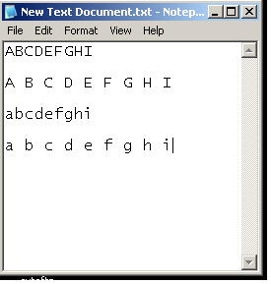
Figure 9.4-67 Font collection example - notepad
Next we fire up OpenScrape, and attach it to our "Table". Then we build a region around the area we are working on. "New" / "Region" / name it characters / Use the coordinate editor to enclose the Region. You can also "shift-drag" the rectangle around to place it.

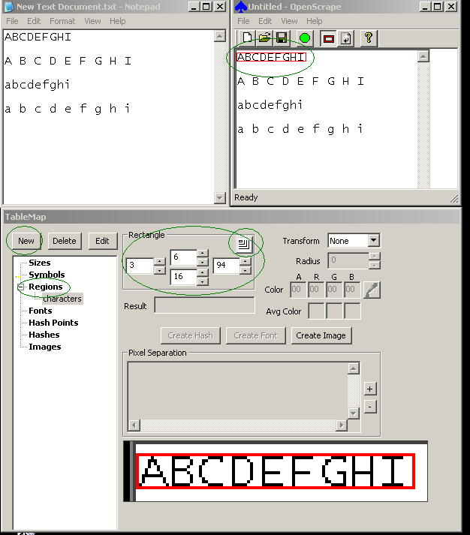
Figure 9.4-68 Font collection example - region

Set the region to the correct "transform", Type 0 in this case. Use the eyedropper to highlight the foreground pixels until we have nice seperation in the "Pixel seperation" field. Press "Create Font". We are presented with the "Add font characters" window.

Highlight each "?" in turn and enter the correct character. "OK" to save. "Sort" when done here, then "save" on main GUI.

If you hit the problem of openscrape seeing two letters as one because they have touching pixels then you will need to collect them seperately. Make a new temporary region that only encloses one character (call it char), capture the problem characters individualy and all should be good.
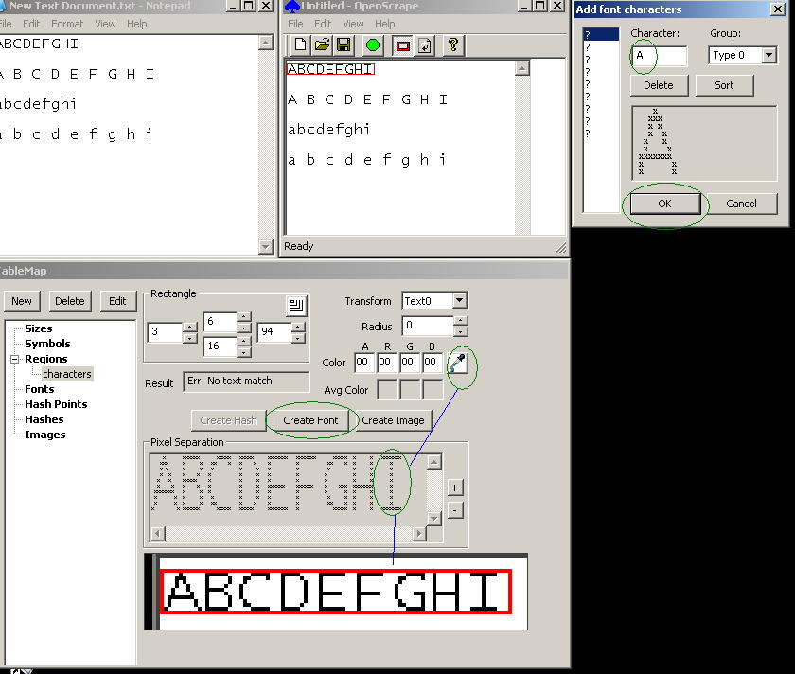
Figure 9.4-69 Font collection example - add characters

Here is the result after collecting only "A", you can see this by clicking inside the "characters" Region.
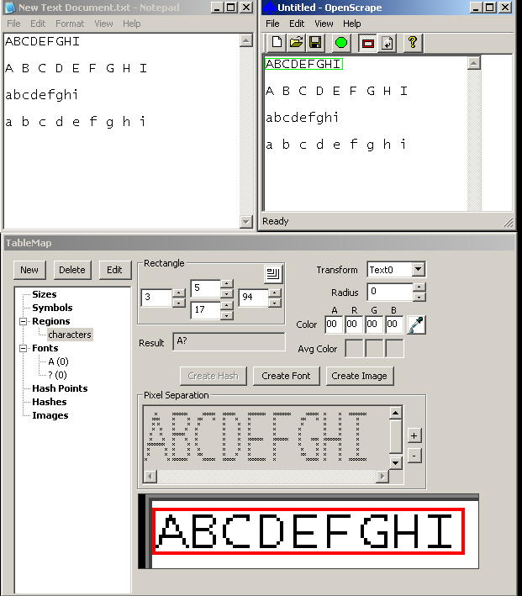
Figure 9.4-70 Font collection example – “A” collected

Note "A,B,C" are already present in the Table Map.
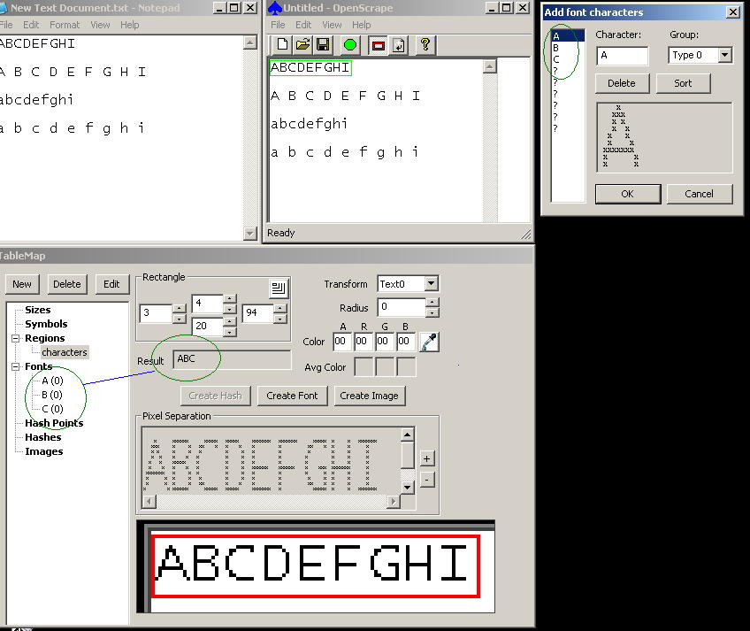
Figure 9.4-71 Font collection example - "ABC" collected

So on we go collecting fonts, here we collect "D" .
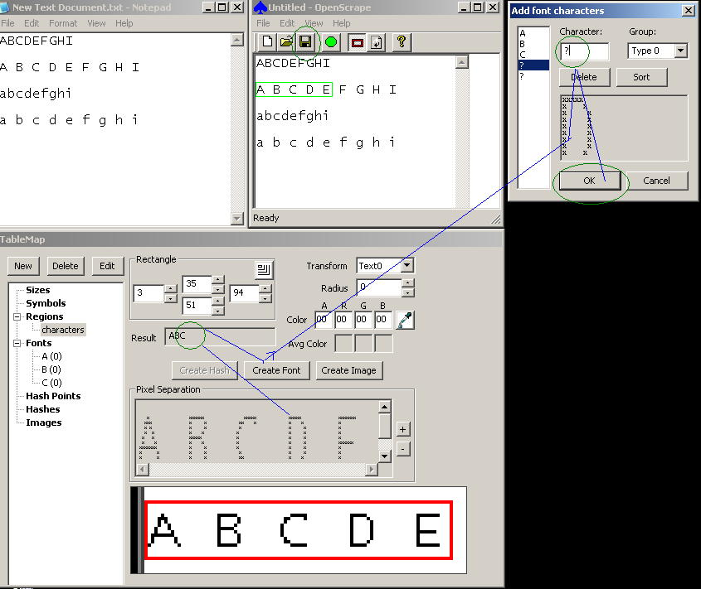
Figure 9.4-72 Font collection example - collecting "D"

Appendix B – Future TODOs
- Move Edit/Preferences/Use Comma or Dot setting to the Table Map.

